

Teachers’ Notes

**Formula for Thrills**

**1/11**

**Introduction**

The Formula for Thrills suite of KS3/KS4 resources provides students with an opportunity to use mathematics in a real world environment through a variety of stimulating contexts based on a theme park. Each context presented aims to help students understand how real-life mathematical thinking is used by the engineers, designers, mechanics and planners whose job it is to entertain and thrill people, keep them safe and to look after their needs while enjoying the park.

Formula for Thrills supports the mathematics curriculum for pupils aged 12-16yrs and the science curriculum for pupils aged 14+. It has been developed in collaboration with theme park operator THORPE PARK Resort using realistic figures, statistics and situations as far as possible. Although there has been some modification to make the situations accessible to students, they are authentic and recognisable to people working in

the industry.

The materials do not present problems in a purely mathematical way; instead students are required to use and develop their skills to identify situations in which the effective use of mathematics enables the development of solutions to problems. Students must consider and check their responses are realistic and practical as well as being technically correct.

The extension activities also link to the Totally in control Scheme of Work learning objectives. In these, students identify how sequences of commands can be used to run equipment, understand features of a system in terms of how its design responds to a detailed brief and also how a system can be modified to improve its performance.

**About the resource**

Formula for Thrills comprises two elements:

**1.** An interactive learning tool with a link to downloadable Teachers’ Notes.

**2.** Supporting materials: An introduction, Formulae Tasksheets and a set of six Extension Activities.

**The interactive learning tool**

This is based on the design of a rollercoaster and track styles, and involves students finding out how it can be made to thrill and yet still finish at a safe speed by altering various factors. At Levels 1 and 2 this is done empirically; at Level 3 students need to calculate values from formulae.

**Level 1**

Students alter the height of the start and the end of the ride. The objective is to set the track up so that the train reaches the end at a safe low speed. This depends upon the difference in height between the start and the end; there is a range of combinations of heights (all of which have similar variations) which will satisfy this.

Students experiment with different values to find out what will work. To assist, there are speed cameras; these show the target speed and the actual speed, and will guide students in selecting values. Some of the tracks involve an intermediate increase in height, such as humps or a loop. As long as these aren’t set up to be higher than the start point they, in fact, make no difference to the speed at the end.

**Level 2**

A further variable is introduced - that of horizontal distance. Students now need to ‘trade off’ one variable against another. If the length is increased, friction will cause more energy to be dissipated, which will need to be compensated for by increasing the difference in height between the start and the finish.

In association with



Teachers’ Notes

**Formula for Thrills**

**2/11**

**Level 3**

The challenge increases as students are guided through making a series of calculations. The accompanying Formulae Tasksheets structure calculations for students, guiding them from selecting the height of each section of track to working out the speed of the train at various points. This enables students to predict the speeds and therefore decide if the design is a good one. An unsatisfactory design is one in which either the train stalls en route or reaches the end at a velocity (speed) of more than the limit indicated. Students may need to change the heights and recalculate the speeds in order to come up with a satisfactory design.

**Supporting materials**

The Formulae Tasksheets and six Extension Activities are based on different aspects of the planning and operation of a theme park. They all involve students in having to understand a context, assimilate information and develop a response. Some are relatively closed but others are open-ended and this is intentional. Part of being a mathematician is recognising what is known and can be responded to definitively and also what is not defined and can therefore only be answered in more general terms.

•

•

•

•

•

•

•

•

•

Teachers’ Notes

Curriculum Links

Formulae Tasksheets for use with Level 3 of the interactive learning tool Extension Activity 1 - Shape and structure: Design a ticket booth Extension Activity 2 - Structures and strength: Design a rigid shape Extension Activity 3 - Planning a business: Aiming for profit

Extension Activity 4 - Running a business: Organising the staff

Extension Activity 5 - Plans and maps: Setting out amenities Extension Activity 6 - Running a theme park: Managing the rides

**Extension Activity 1** - Shape and structure: Design a ticket booth

Consideration of what data is needed in order to choose the dimensions of a ticket booth and how that translates into a finished shape. Communicating what that shape looks like is an important part of the process.

**Extension Activity 2** - Structures and strength: Design a rigid shape

Use of simple construction materials to test shapes such as triangles and squares for rigidity, analysis of the findings to draw general conclusions about rigidity and the use of cross-bracing to make light structures strong.

**Extension Activity 3** - Planning a business: Aiming for profit

Consideration of the cost of a rollercoaster not within a theme park and charging per ride. This will allow for getting a feel for the profit margins and other issues which will also apply to some extent to rides inside a theme park, and estimating likely numbers of people using the rollercoaster.

**Extension Activity 4** - Running a business: Organising the staff

Staff involved with providing other services in a theme park, such as refreshments. Staffing as a major area of expenditure against highly-variable demand: people becoming hungrier later in the day and the kind of refreshments opted for depending on age and weather.

**Extension Activity 5** - Plans and maps: Setting out amenities

How mathematics is used in the design of the theme park and what mathematics can be done in context around the park.

In association with



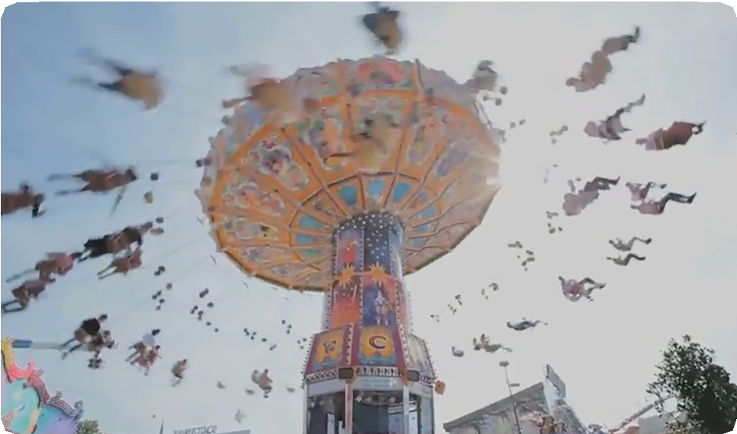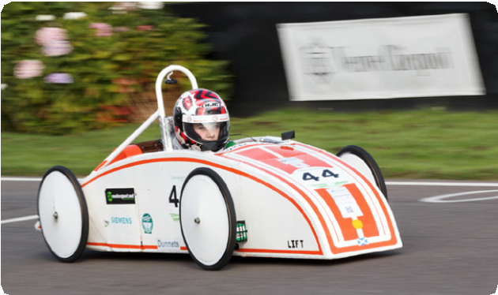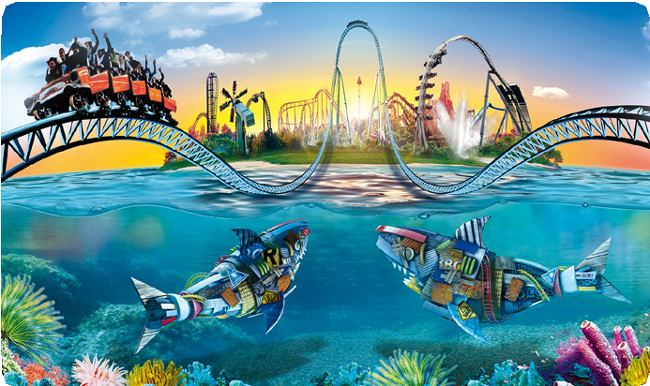

Teachers’ Notes

**Formula for Thrills**

**3/11**

**Extension Activity 6** - Running a theme park: Managing the rides

Running a rollercoaster: thinking about a ride and how it is managed. How systems are designed and have to be made to work with people in real situations. The challenge is both to understand how the system works and to consider the implications for passengers and staff.

**How to use**

This suite of materials has been designed to be used in a variety of ways. Teachers may need to modify and customise materials to fit a range of situations, depending upon class size, attainment, prior experience, interest and curriculum model.

The Formula for Thrills interactive learning tool is designed to be used by students working individually or in pairs. The model is a simplified one and increases in challenge from Level 1 through to Level 3.

The extension activities are based on other theme park contexts and develop different skills. Each one is supported by teacher and student resources in the form of learning objectives and outcomes, and learning activities.

**Further resources**

Find out more about how Siemens technology provides a formula for thrills:

Totally in control Scheme of Work: students identify how sequences of commands can be used to run equipment, understand features of a system in terms of how the design of a system responds to a detailed brief and how a system can be modified to improve its performance.

GreenPower Challenge**:** an annual engineering challenge where teams of young people design and build electric racing cars before competing in a low octane, high speed race to the finish!

Solid Edge: Free design and engineering software for students. Industry-leading mechanical design software, Siemens Solid Edge Student Edition is available at no cost (**free**) to students of all ages for use outside the classroom in support of their studies or extra-curricular activities such as the Greenpower Challenge. To obtain the Solid Edge Student Edition register at [www.siemens.com/plm/solid-edge-student.](http://www.siemens.com/plm/solid-edge-student)

THORPE PARK Resort is celebrating the start of the academic year by launching a new set of tools to help teachers and inspire students. Alongside their existing KS4 Science resources and KS4 and KS5 Business Resource Pack, they will be producing some fantastic learning trails in Business and Physics. These simple visual guides are being designed to complement their thrilling rides and offer key curriculum elements to look out for while navigating the Resort.

In association with



Curriculum links

**Formula for Thrills**

**4/11**

**Maths KS3**

Through the mathematics content, students should be taught to:

**Develop fluency**

* select and use appropriate calculation strategies to solve increasingly complex problems
* substitute values in expressions, rearrange and simplify expressions, and solve equations.

**Reason mathematically**

**Maths KS4**

Through the mathematics content, students should be taught to:

**Develop fluency**

•

consolidate and extend their numerical, algebraic, geometric and graphical understanding

apply appropriate reasoning strategies and degrees of accuracy to increasingly complex problems

increasingly evaluate situations based on the underlying mathematical properties rather than on surface features

increasingly understand the world of finance and apply arithmetical and graphical methods in this and other contexts.

•

•

•

extend and formalise their knowledge of ratio and proportion in working with measures and geometry

make and test conjectures about patterns and relationships; look for proofs or counter-examples

begin to reason deductively in geometry, number and algebra, including using geometrical constructions

interpret when the structure of a numerical problem requires additive, multiplicative or proportional reasoning.

•

•

•

**Reason mathematically**

•

select and use other forms of reasoning as appropriate: algebraic, geometric, statistical, probabilistic and logical, and know when to express their arguments informally or formally, including working directly from definitions.

•

**Solve problems**

**Solve problems**

•

develop their mathematical knowledge, in part through solving problems and evaluating the outcomes, including multi-step problems

develop their use of formal mathematical knowledge to interpret and solve problems, including in financial mathematics

begin to model situations mathematically and express the results using a range of formal mathematical representations

select appropriate concepts, methods and techniques to apply to unfamiliar and non-routine problems.

•

use mathematical knowledge to solve problems within and outside mathematics, including financial mathematics and mechanics; particularly problems that are unfamiliar in presentation and context, and that embed mathematical ideas which have not yet been formally taught

develop mathematical knowledge, in part through problem solving and evaluating the outcomes.

•

•

•

**Science KS4**

Students should be taught about:

* energy changes in a system, calculating the stored energies and energy changes involved
* conservation of energy in a closed system, dissipation.

•

In association with



Formulae Tasksheets for use with Level 3

**Formula for Thrills**

**5/11**

**Important concepts:**

•

The rollercoaster starts from a high point and rolls from the start of the track to the end. It’s only supply of energy is due to it being high up at the start. From this we can work out its speed at various points.

Gravitational potential energy (GPE) is related to the height above ground. The higher up, the more GPE. At ground level, the object has no GPE.

GPE is calculated from mgh:

•

•

-

-

-

**m** stands for the mass of the train and is 5000kg

**g** stands for gravitational attraction and is 10m/s2

**h** stands for vertical height above ground level, is measured in metres and will be different at various points along the track

•

Kinetic energy (KE) is related to speed. The faster an object moves, the more KE. Stationary objects have no KE.

KE is calculated from ½ mv2, in which:

* **m** stands for the mass of the train and is 5000kg
* **v** stands for velocity, is measured in metres per second (m/s) and is what you will be working out most of the time.

At any point the total mechanical energy is the sum total of GPE and KE.

As the train progresses, some of the energy is dissipated through friction and sound, so less is retained as mechanical energy. The percentage retained becomes less at each stage and you are told how much.

It is useful to calculate the amount of GPE and KE at the top and bottom of each slope. For this we can use the two formulae:

•

•

•

•

Although we can calculate the speed at intermediate points, these don’t actually make any difference to the speed at the end. The only thing that affects that is how much height has been lost from the start. The greater the overall drop, the faster the train will go at the end. However, the intermediate points can be no higher than the starting point (in fact, they can’t even be close to it due to the energy losses).

In association with

GPE = mgh KE = ½ mv2



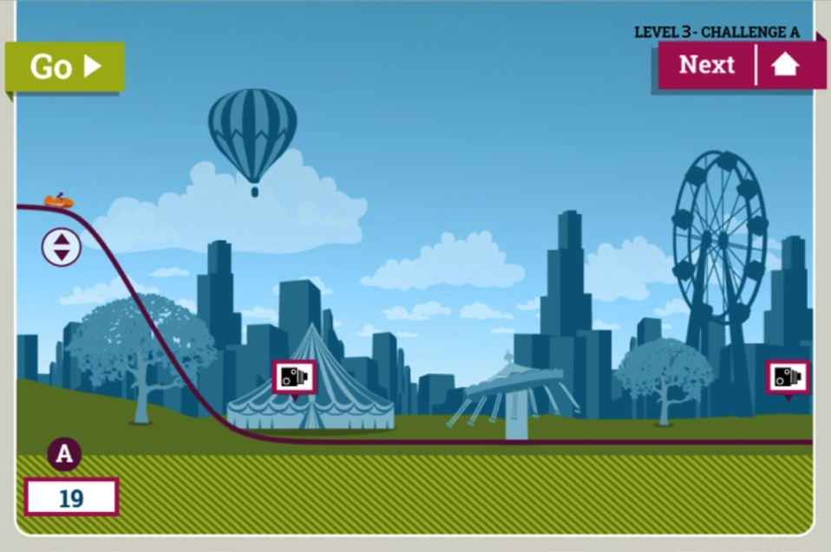

Demon drop

**Formula for Thrills**

**6/11**

In association with

# At the top of the slope:

Total energy = GPE + KE

Calculate GPE using the selected height. GPE = J

KE = J (What will the KE of a stationary object be?)

Therefore total mechanical energy = J

# At the bottom of the slope:

Total energy = 82% of that at the top (18% lost through heat and sound) = J Total energy = GPE + KE

GPE = J (What will the GPE of an object at ground level be?) Therefore KE = J

As KE = ½ mv2, we can calculate v. v= m/s

**c. At the end of the ride:**

Total energy = 58% of that at the top (42% lost through heat and sound) = J Total energy = GPE + KE

GPE = J (What will the GPE of an object at ground level be?) KE = Total energy – GPE = J

We can now calculate v. v= m/s



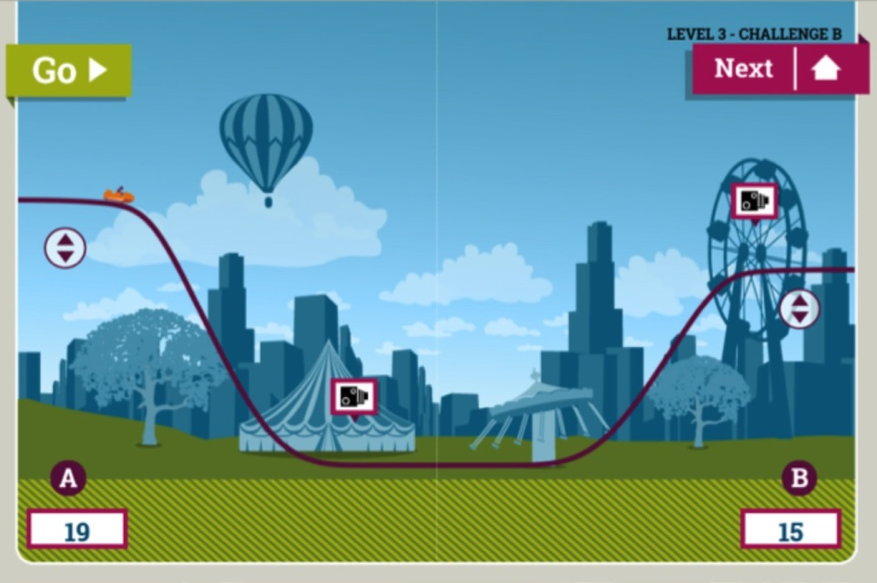

Drop and rise

**Formula for Thrills**

**7/11**

In association with

# At the top of the slope:

Total energy = GPE + KE

Calculate GPE using the selected height. GPE = J

KE = J (What will the KE of a stationary object be?)

Therefore total mechanical energy = J

# At the bottom of the slope:

Total energy = 89% of that at the top (11% lost through heat and sound) = J Total energy = GPE + KE

GPE = J (What will the GPE of an object at ground level be?) Therefore KE = J

We can now calculate v. v= m/s

**c. At the top of the final slope:**

Total energy = 70% of that at the top (30% lost through heat and sound) = J Total energy = GPE + KE

Calculate GPE using the selected height. GPE = J

KE = Total energy – GPE = J

As KE = ½ mv2, we can calculate v. v= m/s



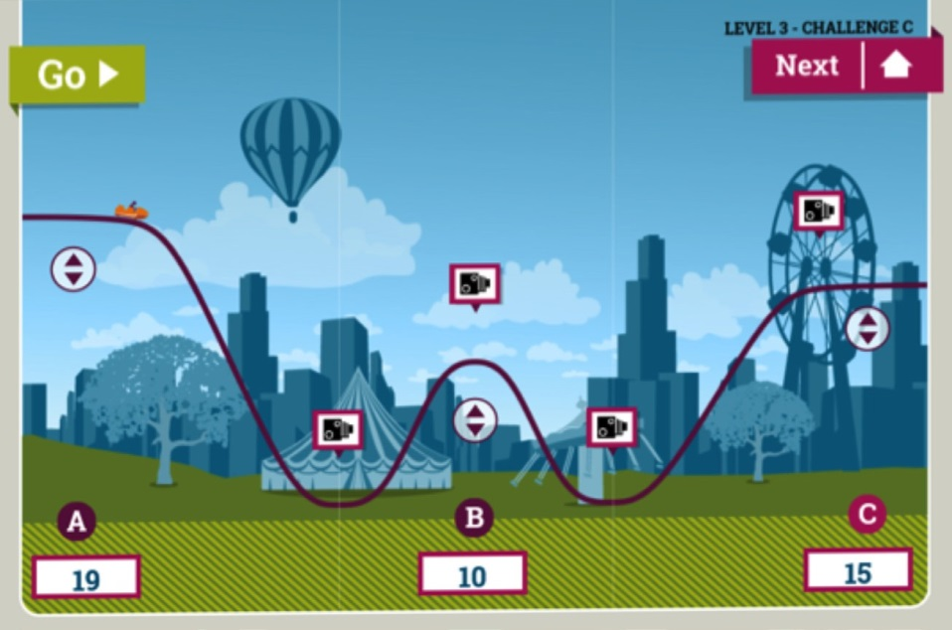

Intermediate rise

**Formula for Thrills**

**8/11**

In association with

# At the top of the slope:

Total energy = GPE + KE

Calculate GPE using the selected height. GPE = J

KE = J (What will the KE of a stationary object be?)

Therefore total mechanical energy = J

# At the bottom of the first slope:

Total energy = 89% of that at the top (11% lost through heat and sound) = J Total energy = GPE + KE

GPE = J (What will the GPE of an object at ground level be?) Therefore KE = J

We can now calculate v. v = m/s

**c. At the top of the intermediate rise**:

Total energy = 82% of that at the top (18% lost through heat and sound) = J Total energy = GPE + KE

Calculate GPE using the selected height. KE = Total energy – GPE = J

We can now calculate v. v = m/s





Intermediate rise

**Formula for Thrills**

**9/11**

**Continued**

In association with

**d. At the bottom of the second slope:**

Total energy = 74% of that at the top (26% lost through heat and sound) = J Total energy = GPE + KE

GPE = J (What will the GPE of an object at ground level be?) Therefore KE = J

We can now calculate v. v = m/s

**e. At the top of the final slope:**

Total energy = 66% of that at the top (34% lost through heat and sound) = J Total energy = GPE + KE

Calculate GPE using the selected height. GPE = J

KE = Total energy – GPE = J

We can now calculate v. v = m/s



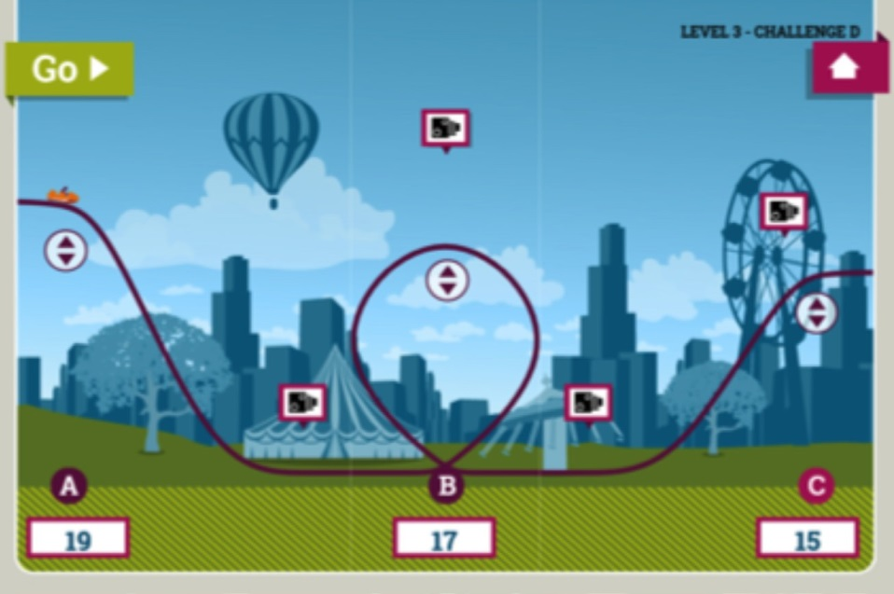

Loop the loop

**Formula for Thrills**

**10/11**

In association with

# At the top of the slope:

Total energy = GPE + KE

Calculate GPE using the selected height. GPE = J

KE = J (What will the KE of a stationary object be?)

Therefore total mechanical energy = J

# At the bottom of the first slope:

Total energy = 89% of that at the top (11% lost through heat and sound) = J Total energy = GPE + KE

GPE = J (What will the GPE of an object at ground level be?) Therefore KE = J

We can now calculate v. v = m/s

**c. At the top of the loop:**

Total energy = 70% of that at the top (30% lost through heat and sound) = J Total energy = GPE + KE

Calculate GPE using the selected height. GPE = J KE = Total energy – GPE = J

We can now calculate v. v = m/s



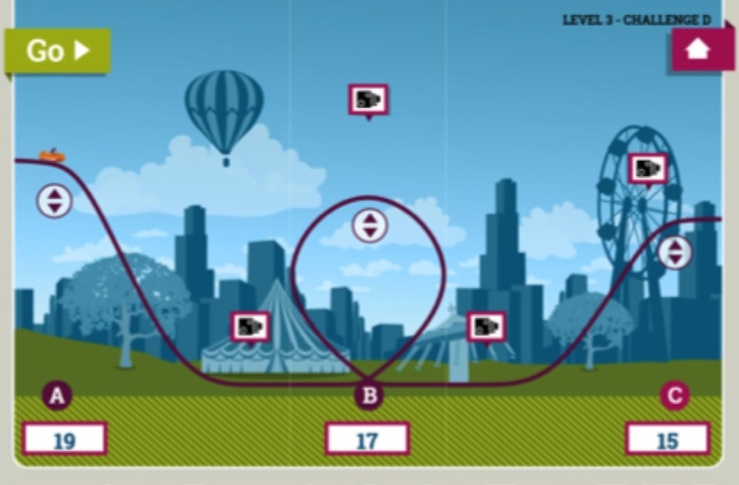

Intermediate rise

**Formula for Thrills**

**11/11**

**Continued**

In association with

d. **At the bottom of the second slope:**

Total energy = 60% of that at the top (40% lost through heat and sound) = J Total energy = GPE + KE

GPE = J (what will the GPE of an object at ground level be?) Therefore KE = J

We can now calculate v. v = m/s

**e. At the top of the final slope:**

Total energy = 54% of that at the top (46% lost through heat and sound) = J Total energy = GPE + KE

Calculate GPE using the selected height. GPE = J

KE = Total energy – GPE = J

We can now calculate v. v = m/s