Levers and Gears homework sheet

Levers
What class of lever is an oar on a rowboat?  Class 1 | 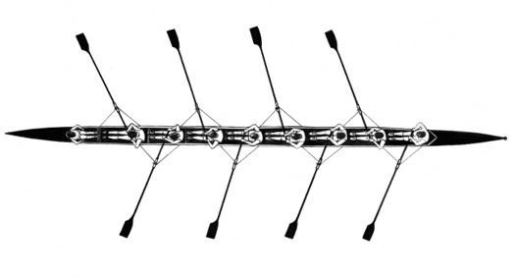
What class of lever is a bicycle hand brake?  Class 1 | 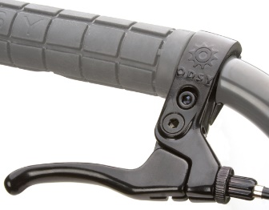
What class of lever is a human arm?  Class 3 | 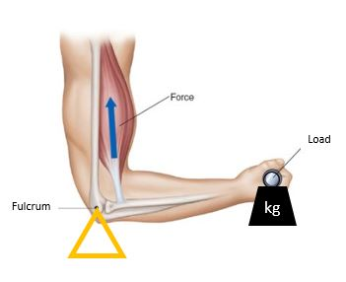
What class of lever is a bottle opener?  Class 2 | 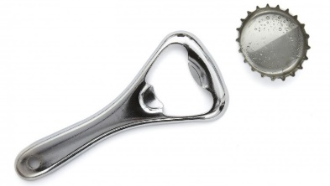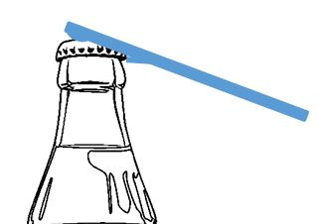
What class of lever is a stapler remover?  Class 3 | 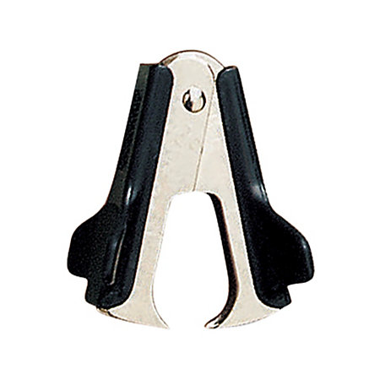

Gears
Gear A is rotating clockwise. In which direction with Gears B and C rotate?  B anti-clockwise  C clockwise | 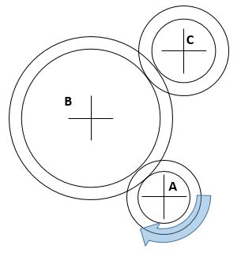
Gear A is rotating clockwise. In which directions will the other gears rotate?  B anti-clockwise  C anti-clockwise  D clockwise | 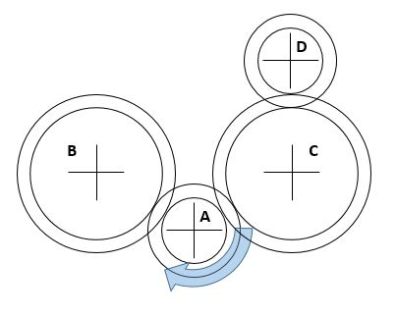
What’s the gear ratio between Gear A and Gear B?  32/16 = 2  What’s the gear ratio between Gear C and Gear D?  42/14 = 3  How many times does Gear A have to turn to result in Gear D competing one revolution  6  If the Driver gear (A) is rotating anti-clockwise which direction is gear D rotating  Anti-clockwise | 