11A Energy can be transferred from one place to another.
Thinking about energy
Engineers and scientists have to understand how to manage those transfers in order to make best use of it.

Greenpower Challenge cars have energy transferred to them by the batteries being charged up. As the car moves, so the batteries run down. Some of the energy used as

Designing for energy efﬁ ciency
the car moves is put to good use; some of it is wasted.

Total
Look at this list of ways in which energy is transferred from the battery:
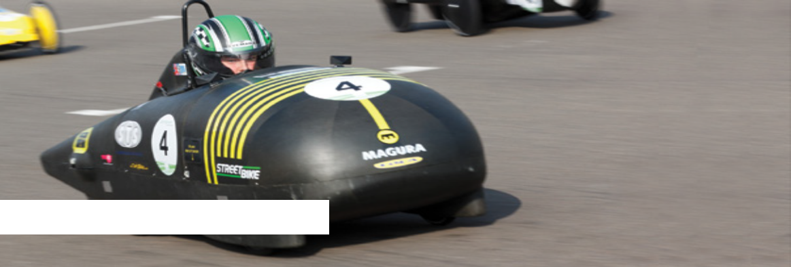• Sound from moving parts
• Heat in the motor and wiring
• Moving the car along the racetrack
• Pushing air in front of the car out of the way
• Heat in moving parts, such as axles

1) Divide these into two lists, useful and wasteful.

2) For each of the wasteful ones, suggest ways in which they could be reduced.

A useful way of showing energy transfers in a system (such as a car) is to use a diagram called a Sankey diagram.

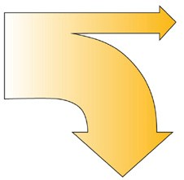Useful
The input on the left is the total energy supplied (in this case the energy in the fully charged batteries). The useful output is shown horizontally, top right. The wasted output is shown vertically, lower right. Either of the outputs can be split into separate arrows if there is more than one. (If we knew the amount of energy we could show this by the width of the arrows but we don’t in this case).

3) Draw a Sankey diagram to show the energy being supplied by the batteries, the useful output(s) and the wasted output(s). Use your answers from Q2 to guide you.

4) Remember that the width of the arrows indicates the amount of energy. What does the Sankey diagram look like for a less wasteful system?

energy in

Wasted energy out
energy out
5) Look at the Greenpower car in the
illustration. What steps have the designers taken to make their car more efficient?

11B Analysing the forces on a car

This car is standing still on a firm level surface. There are two forces acting upon it, weight and a reaction force from the ground (the ground being capable of supporting the weight of the car).

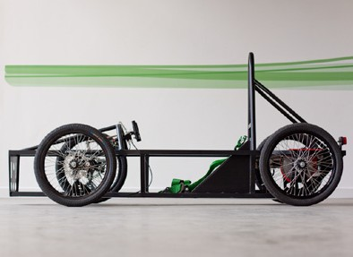1) Draw in those two forces, showing the directions they are acting in.

2) The car isn’t moving: compare the forces in terms of size and direction.

11B Analysing the forces on a car

This car is travelling forwards along a level road at a steady speed and in a straight line. Various forces are acting upon it.

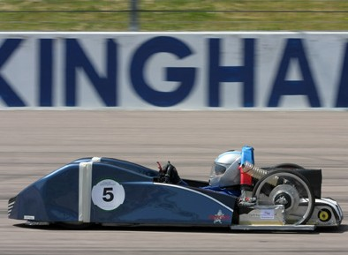1) Draw and label arrows on the picture to show the direction of:
a. The force due to the motor b. Weight
c. Air resistance
d. Friction in the moving parts
e. Reaction force from the ground (the ground being strong enough to support it).
2) Think about the size and direction of the forces.

a. Compare the weight and the reaction force. b. Compare the force due to the motor,
driving it forwards, with the forces due to
air resistance and friction (remember the car is travelling at a steady speed).
c. Think about the forces in Part B. If you wanted the car to travel faster what could you do to the size of those forces?

11B Analysing the forces on a car

This car is accelerating – it is speeding up.

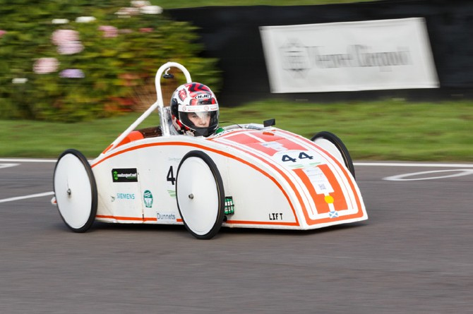1) What can you say about the size of the force from the engine compared with the size of the forces from friction and air resistance if its speed is increasing?

2) What might the designers have done to enable it to travel at a higher speed (remember that all Greenpower Challege cars have the same size motors)?

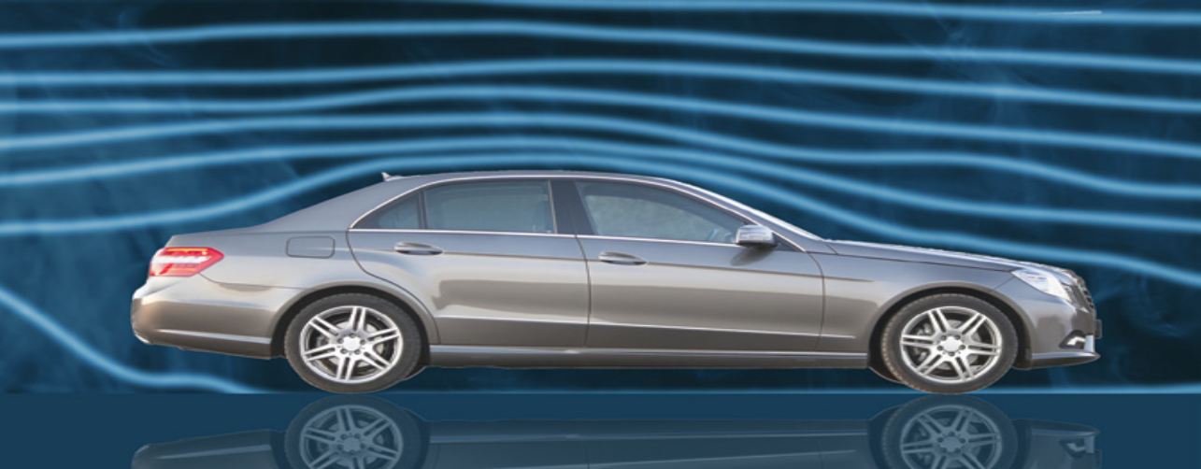 11C Investigating streamlining and drag

Wind tunnel

Car designers (and indeed, any designers who are trying to make an object pass through air quickly) have
to think carefully about the design of the shape, and then test it out. A common way of doing this is to use
a wind tunnel. The car is stationary and air is blown towards it. Streams of smoke are used to show what the
air is doing. The engineers are looking for the least turbulence. In other words they want the air to be disturbed as little as possible. This means the car is slipping through the air with less resistance and therefore
using less energy.
You will need to test various ideas for body
shapes but it’s unlikely you will be able to use
a wind tunnel. Instead we will use the fact that air is a ﬂ uid (it ﬂ ows) as are liquids. If we use a liquid such as water and see how easily a shape slips through it that will give us useful evidence. Devise some ideas for the shape of your car. Keep them fairly simple – this stage is to test general ideas.

1. Decide on the shape to test – look at some past Greenpower Challenge car designs if you need some inspiration.

2. Make the shape out of modelling clay. All teams will use the same mass to make it a fair test. Don’t worry about wheels and the driver; it’s
the outline shape that is being tested.

3. You’re going to test the shape by dropping it down a column of water. You’ll need to make sure the shape faces the right way, so bury a ball-bearing in the front of it. Make sure this doesn’t alter the shape.

4. Now drop the shape into the column of water and time it. A good design will descend rapidly.

11C Investigating streamlining and drag

Now record the results in a table, rather like this:

Shape  number | Sketch of shape | Time to reach bottom | Ideas about why it was (or wasn’t)  successful
1
2
3
4
5
6
7
8
9

11D Selection of Materials

Chassis:

The chassis of a Greenpower Challenge car needs to be strong enough to withstand any impacts on the race track. It also needs to be stiff enough to hold its shape under the weight of a driver, batteries and motor. The material should be light enough so that the whole car can be picked up between two people. This includes the batteries which weigh approximately 5kg each. The aim of the Greenpower Challenge is to use as
many environmentally friendly materials as possible so this should be taken into consideration. The cars will be used more than once so they should be as durable as possible.

Complete the decision matrix below and decide which material best suits the design brief above.

Material | Strong | Flexible | Durable | Weight | Environmentally friendly | Is the material suitable
Oak Wood
Stainless
Steel
Aluminium
Polystyrene
Source: Greenpower, www.greenpower.co.uk

Bodywork:

a) Write a design brief for the bodywork of a Greenpower Challenge car. You should take into account the following properties: strength, weight, durability, flexibility, aesthetics, cost, availability, health and safety, environmental impact.

b) Construct a decision matrix to help you find a suitable material. If more than one material is suitable it may be helpful to rank the materials in order of which property you think is the most important. For example, if you think cost is most important, then the suitable material that is cheapest gets the highest ranking.

