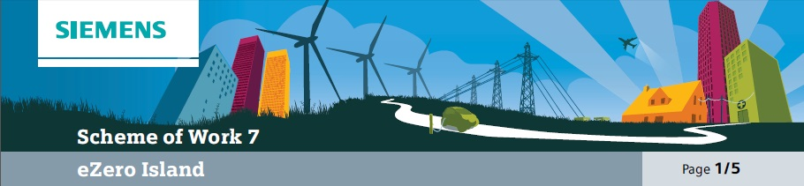

Overall learning objectives

• Investigate how maths can support the modelling of a multi-faceted system using data and logic.
• Apply ideas about energy transfer and sustainability to a novel context to produce a practical overall system.
• Devise technical solutions, appreciate their impact on eco systems and communities and explore how they can be modified to respond to demands.
Overall learning outcomes

• To identify various characteristics to be allowed for in effective energy provision.
• To evaluate different methods of supplying energy for domestic consumption.
• To present and evaluate plans effectively and persuasively.

Curriculum learning objectives
Students should be able to: Maths
• Apply suitable mathematics accurately within the classroom and beyond.
• Know that mathematics is essentially abstract and can be used to model, interpret or represent situations.
• Make and begin to justify conjectures and generalisations, considering special cases and counter-examples.
• Form convincing arguments based on findings and make general statements, communicating findings effectively.

Science
• Use appropriate methods, including ICT, to communicate scientific information and contribute to presentations and discussions about scientific issues.
• Explain how energy can be transferred usefully, stored, or dissipated, but cannot be created or destroyed.
• Explain how human activity and natural processes can lead to changes in the environment.

Technology
• Understand that products and systems have an impact on quality of life.
• Explore how products contribute to lifestyle and consumer choices.
• Evaluate the needs of users and the context in which products are used to inform designing and making.

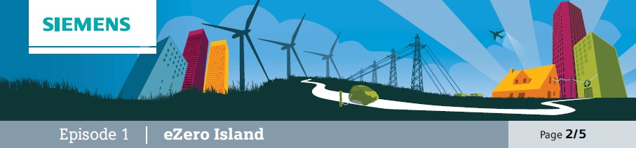
Introduction
This episode is designed to set the scene for the challenge of an island becoming self-sufficient and to stimulate some ideas about not only how but also why they might want to do that.

Learning objectives
• To consider how a group of islanders made their island self-sufficient.
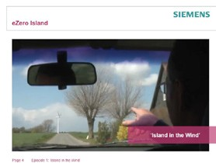• To consider how easily these ideas could be transferred.

Learning activities

1. Show video clip “Island in the Wind”.

2. Ask students for their responses as to why the islanders moved towards being self-sufficient in energy.

3. Ask students to work in groups to consider these questions and formulate responses:
a) How have the islanders made their island self-sufficient?
b) Why do you think they wanted to?
c) Do you think it’s easier or more difficult to do that with an island than with, for example, a large town on the mainland?
d) Which of the techniques they used might work where you live?

4. Take feedback and draw out key points including that the island uses several different sorts of energy provision and that the islanders wanted to reduce their dependency on oil. Explore how transferable the ideas are and emphasise that although this development might be easier to implement on an island, especially one where the energy requirements may be lower and where there is plenty of sun and wind, the ideas can be used in a variety of settings.

Outcomes
• To have presented ideas about how and why an island became self-sufficient in energy.
• To have suggested how those ideas could be used elsewhere.

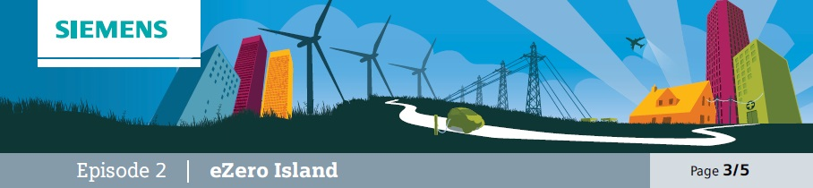
The challenge
To design an energy supply system for an island that doesn’t rely on fossil fuel.
This episode enables students to work in groups to design and test their ideas against a number of criteria and ‘set the scene.’

Learning objectives
• To consider the challenges represented by varied energy requirements.
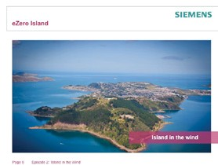• To suggest various ways of meeting these challenges.

Learning activities

1. Show the students a picture of an island and explain that their challenge is to provide the islanders with a power generation system. Say that there will be various alternatives as to how electricity can be generated. Ask them to work in groups to identify a range of typical uses to
which electricity is put in the home (they should not include battery powered devices but they should include mains chargers for battery powered devices).

2. Explain the electricity is very useful as it can easily
be used to produce a range of effects, such as heat, light, sound and movement, but that this may not necessarily be the most efficient method. Then ask them to go through that list and to divide it into two – those devices which have to run on electricity, such as TVs, and functions which could be powered by electricity but don’t have to be, such as water heating.

3. Ask students to think about how the total energy demand in a home varies over a 24-hour cycle. Working in groups, they should sketch the shape of a graph to represent demand and label it to explain the main features. Ask students to identify the assumptions made in drawing the graph and draw out points such as whether the home is empty during the day, whether the temperature
outside is much lower than inside, whether it is insulated and how many people live there.

4. Then ask for suggestions about what would make a good energy source. Students should be encouraged to think about price, pollution, reliability, storage and ease of starting up.

5. Gather ideas together and capture key points for future reference.

Outcomes
• To have identified how energy is used in the home and how this demand varies.
• To explain how these demands represent a challenge for the supply of energy.

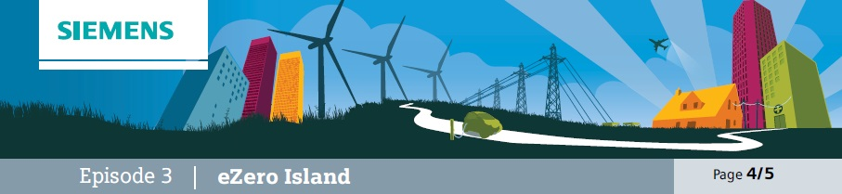
Investigate
In this episode students select an energy plan for the island from a number of alternatives. As well as making decisions about how to provide energy they have to consider the pollution caused, the reliability of the supply, how easy it is to store and how easily it can be regulated to allow for fluctuating demand.

Learning objectives
• To weigh up a number of factors and decide on the best way of providing energy for the island.
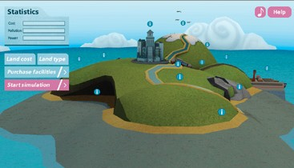• To justify the decisions made.

Learning activities

1. Explain that the task they are to undertake is to provide for the energy needs of the islanders. They will have to make decisions about the fuels to use, whether to generate electricity or to use it directly. The plan will have to allow for fluctuating, demand, ease of storage and use, and pollution.
Say that because this is an island, options that only work on a large scale, such as fossil or nuclear power stations aren’t available.

2. Provide each group with a map of the island and a set of energy card student support sheets
7 and 7A. Each energy card represents the same number of units of energy; it shows the cost, advantages and disadvantages of that energy source. Groups are given a weather forecast and a prediction of the energy requirements. They decide what combination of energy resources
to use.

3. Each group then prepares a labelled poster based on their plan. It should show:
a) The types of energy being used. b) The cost of the plan.
c) The pollution caused.
d) How responsive the system would be if the demands upon it changed. e) The good features of the plan.
f) The weaker features.

Outcomes
• To have developed a plan for energy provision allowing for a number of factors.
• To have presented ideas in a clear and coherent way.

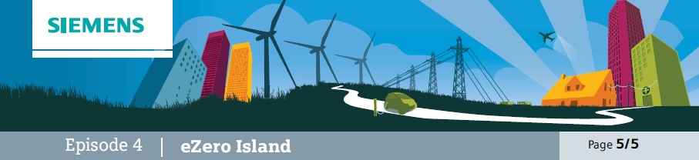
Solutions
Students present their ideas. The learning activity indicates that three or four teams will present their plans (this will work well if the plans are significantly different) and other students will be involved in assessing and providing feedback. If desired (and time allowing) teams in one half of the group can present to the other
and then vice versa.

Learning objectives
• To consider how particular features of different ways of providing energy have certain advantages and will appeal to certain interests.
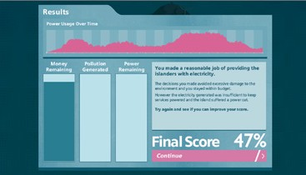• To present ideas convincingly and effectively.

Learning activities

1. Three or four teams are selected to
‘make a pitch’ for the contract of supplying the island with its energy. The teams should have had their poster presentations on display.

2. Each team gets, three minutes to present the key features of the energy provision plan to the governor of the island (possibly played by the teacher) and to groups of islanders (students not making
presentations – best in groups of two or three). The audience should think through what they would be looking for, example:
a) Islanders: happier if costs lower, less mess, energy needs met.
b) Governor: happier if less pollution, island looking attractive to tourists, islanders happy.

3. Say that the last contractor didn’t make a good job of it and there were some instances where the power went off. Both the governor and the islanders can ask questions.

4. At the end the groups of islanders explain which plan they prefer and why. The governor then provides a summing up, offering a broader perspective and ensuring that strengths from all bids are recognised. It may be considered appropriate for the governor to award the contract to a particular team.

Outcomes
• Either to effectively communicate key features of an energy provision plan and answer questions effectively or to scrutinise plans effectively and make considered decisions.

