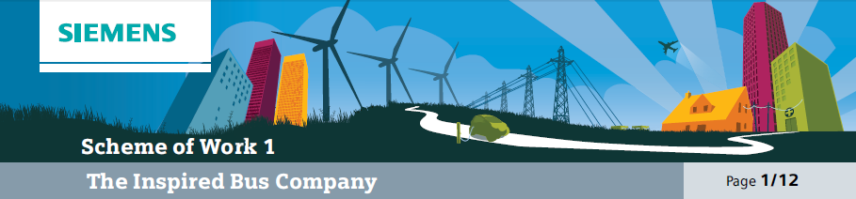

Overall learning objectives

• To explore the challenges facing bus designers when producing a bus for an urban environment.
• To investigate how different solutions can be identified and evaluated.
• To collaborate to present recommendations for an effective solution.
Overall learning outcomes

• To have investigated and summarised key features of alternatives.
• To have presented a well evidenced case for a solution.

Curriculum learning objectives
Students should be able to: Maths
• Select mathematical information, methods and tools to use.
• Identify and classify patterns, record methods, solutions and conclusions, and estimate, approximate and check working.
• Look at data to find patterns and exceptions, and relate findings to the original context, identifying whether they support or refute conjectures.
• Communicate findings effectively and engage in mathematical discussion of results.

Science
• Explore how the creative application of scientific ideas can bring about technological developments and consequent changes in the way people think and behave.
• Share developments and common understanding across disciplines and boundaries.
• Use a range of scientific methods and techniques to develop and test ideas and explanations, assess risk and work safely in the laboratory, field and workplace and plan and carry out practical and investigative activities, both individually and in groups.
• Obtain, record and analyse data from a wide range of primary and secondary sources, including ICT
sources, and use their findings to provide evidence for scientific explanations.
• Use appropriate methods, including ICT, to communicate scientific information and contribute to presentations and discussions about scientific issues.
• Know and understand that energy can be transferred usefully, stored, or dissipated, but cannot be created or destroyed, and that electric current in circuits can produce a variety of effects.

Technology
• Understand that designing and making has aesthetic, environmental, technical, economic, ethical and social dimensions and impacts on the world.
• Make links between principles of good design, existing solutions and technological knowledge to develop innovative products and processes.
• Analyse existing products and solutions to inform designing and making, evaluate the needs of users and the context in which products are used to inform designing and making, and explore the impact of ideas, design decisions and technological advances and how these provide opportunities for new design solutions.
• Understand users’ needs and the problems arising from them and the criteria used to judge the quality of products, including fitness for purpose, the extent to which they meet a clear need and whether resources have been used appropriately.

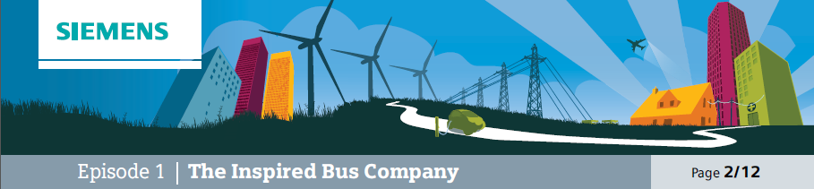

Introduction
This episode is designed to set the scene and place the topic in a social as well as technical context.
The video clip introduces the bus as something which is essential to a wide range of people and is a real benefit. It also indicates how it is working in an urban environment and introduces the notion that the power system has been developed to reduce the environmental impact. The aim here is for students to understand the setting of the challenge.

Learning objectives
• To introduce the topic to students.
• To explore the key factors in the design of buses to operate in an urban environment.

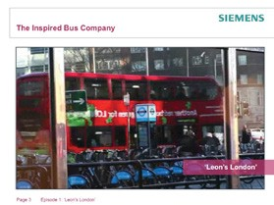
Learning activities

1. Show video clip “Leon’s London”.

2. Ask students to work in groups to consider the following questions:
a) Why does Leon get different kinds of passenger on the bus at different times of the day?
b) What kinds of places are on Leon’s bus route?
c) What impact do you think that traffic congestion has on his journey?
d) Why is traffic pollution going to be an important factor in the design of the bus?
e) What would be the problem with using a bus that simply had a diesel engine driving the wheels?

3. Take feedback and draw out the following points:
a) A whole range of people use the bus, including children, elderly people, people going to and from work, people going to and from hospital, etc. A number of these people would be particularly susceptible to the negative effects of pollution.
b) The route includes schools, hospitals, houses, shops and places of work. These are all places that people may spend significant amounts of time.
c) The congestion will vary but could be significant at times, so the bus could be stationary in a queue or moving slowly.
d) A bus could produce a significant amount of pollution, close to where people are.
e) A diesel engine produces exhaust emissions which are released directly into the atmosphere.
This is particularly noticeable at low speeds and in built up areas.

Outcomes
• Students will be able to describe the situation in which a bus such as the one featured is operating and will have identified why reducing pollution will be a key consideration in the design of such
a vehicle.

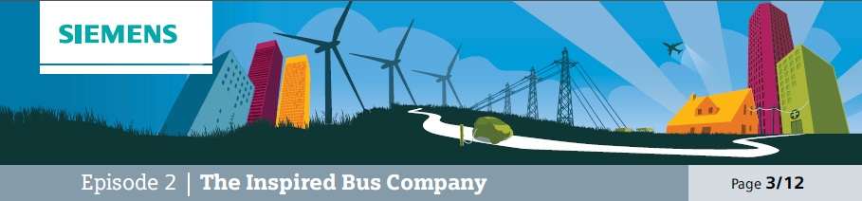

The challenge
To identify the best fuel source for a bus, given the nature of the location and journey.
This episode is designed to start to challenge students with selecting a suitable power system. The idea here is not for them to move straight to a decision but to explore some of the possibilities and constraints. This should be an open discussion in which the challenge is scoped but then draw into focus at the end.

Learning objectives
• To present the challenge in this topic to students.
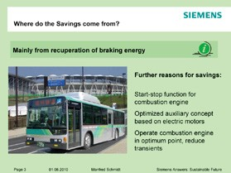• To encourage the development of some initial ideas and first responses.

Learning activities

1. Display the picture of the bus in an urban environment and explain that the challenge
is to select a power system for the bus that will reduce the effects of pollution in the urban environment but will still enable the bus to operate effectively.

2. Ask the students to work in groups and form some initial ideas. These could be captured
on flip chart sheets or using a similar method.

3. Take feedback. It is important at this stage not to
narrow down the discussion by eliminating ideas but rather to model the process of open thinking. Ideas might include:
a) Cleaning the exhaust.
b) Changing the power supply of the bus. c) Changing the mode of transport.
d) Changing the route.

4. Explain that it is important to explore a range of considerations and to be creative in looking at problems. Say that over the next few lessons some of these ideas will be explored. Indicate that whereas buses are often only one of a range of transport systems, that they have certain advantages and that this topic will be looking at how they can be improved.

5. Display a collective response sheet for future reference.

Outcomes
• Students will have worked collectively to generate a range of responses and to collate these to produce a summary of initial ideas.

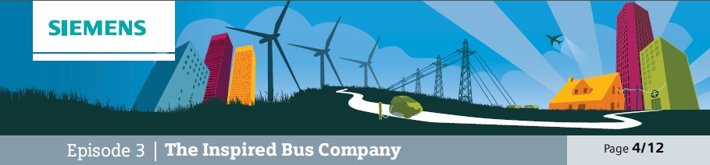

Investigate
In this episode students investigate alternative fuel sources and learn about various power sources; in doing so they need to acquire and manage factual information, which they will then be drawing upon. They should be encouraged to identify what will be of use.

Additional resources required
• Battery powered model vehicle
• Fuel cell demonstration equipment
• Diesel engine vehicle

Learning objectives
• To explore by various means different power sources for a bus and identify key characteristics.
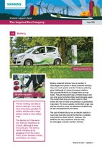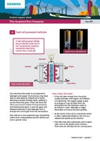• To share and consider these ideas.

Learning activities
This episode could be organised in different ways. One strategy would be for students to work in groups, and for each group to have some members researching each source and then reporting back to the rest of the group. This will develop the skills of collaboration, communication and identification of key features. The other way is for all the students to study all the sources and then to share ideas. This is more straightforward logistically.

1. Explain that to understand any power source it is useful to think about the transfer of energy,
the total amount of energy (as this will determine the range of the vehicle), the environmental impact and the rate of transfer of energy (this is the power output).

2. Source A: battery. Introduce this by means of a battery powered model vehicle and student support sheet 1A. Ask students to read the information, investigate the model and then ask questions about the power source to check their understanding. Ask them to work in groups and discuss these questions;
a) How would the batteries be charged up in a full sized vehicle?
b) Where is energy being transferred from and to?
c) What is the environmental impact?
d) What might affect the range?
e) What are the advantages and disadvantages of this source?

3. Source B: fuel cell. Introduce this by means of (if possible) a demonstration set of equipment and student support sheet 1B. Explain how the fuel cell works, ask students to read the information and then ask them questions about the power source to check their understanding. Ask them to work in groups and discuss these questions;
a) How would this work in a full sized vehicle?
b) Where is energy being transferred from and to?
c) What is the environmental impact?
d) What might affect the range?
e) What are the advantages and disadvantages of this source?

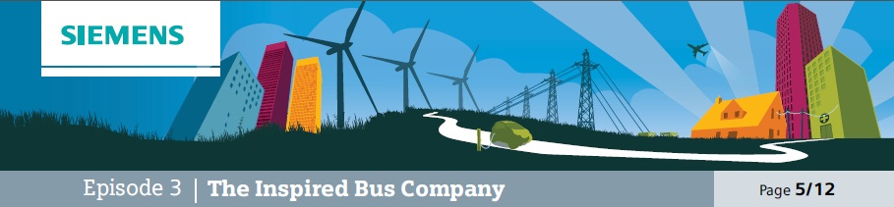

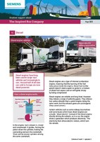Learning activities, cont’d

4. Source C: diesel engine. Introduce this by means of (if possible) a demonstration of full sized vehicle or use of a video clip and student support sheet 1C. Explain how the diesel engine works, ask students to read the information and then ask them questions about the power source to check their understanding. Ask them to work in groups and discuss these questions;
a) Where is energy being transferred from and to?
b) What is the environmental impact?
c) What might affect the range?
d) What are the advantages and disadvantages of this source?

5. Students then need to work in groups to decide how best to record and display the key points about the significant features, advantages and disadvantages of each. This may need some support and discussion; this is worth investing time in as information management is
a key skill.

Outcomes
• Students will have investigated three different power sources for a bus, identified key features and recorded them for future reference.

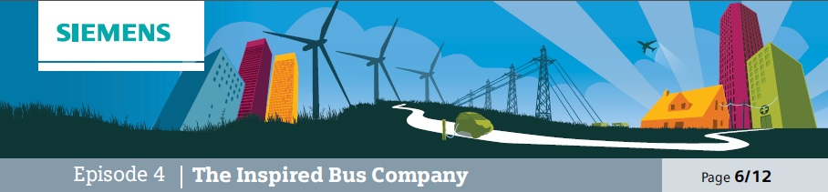

Evaluate
Students work in pairs to evaluate relative merits of systems.
In contrast to the previous episode, this episode is more to do with assimilation of information and
relating it to the brief. There is a strong emphasis upon group work and discussion and sharing ideas about the relative merits of each power system. A key role for the teacher here is in monitoring progress and engagement. It would be useful to question groups on what they’ve established and why they think that.

Learning objective
• Students will collaborate to explore ideas about the advantages and disadvantages of each power source.

Learning activities
Students will collaborate in groups to discuss and explore ideas about the different power sources.

Outcomes
• Students will have explored the relative merits and have produced an overall summary of their ideas.

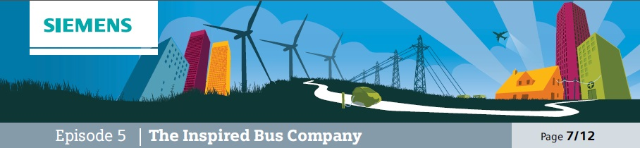

Demonstrate
Teacher input on energy transfer when braking and raising question of how to demonstrate this in the classroom.
This episode opens up a new aspect to the topic, which is that a bus could be made more energy efficient (and therefore less polluting) by utilising some of the energy otherwise wasted. Draw attention to the fact that in a busy urban environment the bus is likely to be accelerating and decelerating repeatedly and that in deceleration energy is lost.

Learning objective
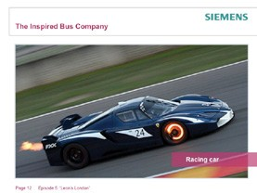• Students explain the energy transfers that take place when a vehicle is braking and consider how to investigate these.

Learning activities

1. Display a photo of a racing car with glowing brake discs from the supporting PowerPoint and ask students to work in groups to generate answers
to these questions:
a) Why is this happening?
b) What is the energy transfer that is taking place?
c) Why is this a challenge for the car designers?
d) Why is this a problem in terms of energy efficiency?

2. Take feedback and draw out these points:
a) The discs are glowing because of the high temperatures, caused by friction as the driver brakes.
b) The energy is being transferred away from the car as it slows down. The kinetic energy of the car is being reduced and released as heat. The heat will escape from the car into the atmosphere.
c) The designers need to make sure the brakes are cooled down. If they overheat they won’t work as well.
d) The energy is transferred away from the car in a way that cannot be used.

3. Discussion question:
a) Challenge students to suggest how the energy might by harnessed. It may be necessary to suggest that heat might not be the most useful form of energy.

Outcomes
• Students will have explored the relative merits and have produced an overall summary of their ideas.

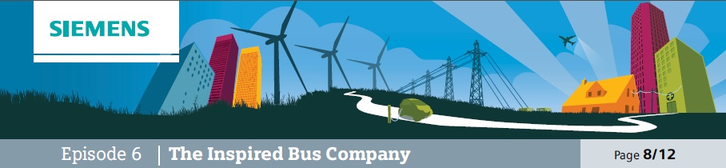

Demonstrate
Students devise a way of demonstrating with a bicycle that energy is transferred to brakes as heat.
This episode is designed to get students to think creatively and imaginatively about devising a way of showing how heat is

Additional resources required
• Bicycle
• Digital temperature probe and screen

produced. Emphasise that it is important not only to have ideas but to be able to develop them and present them. Having devised a method it can then be used to identify critical factors and produce useful information.

Learning objectives
• Students develop and test ways of investigating heat dissipated during braking on a bicycle.
• Students use techniques to explore how the amount of heat is affected by various factors.

Learning activities

1. Ask students to recall from the previous activity episode (5) what happens to the energy that a moving vehicle has when the brakes are applied.

2. Ask students to work in groups to suggest how this could be demonstrated and measured using a bicycle and other equipment. Suggest that ideas are presented as labelled sketches and take feedback.

3. Take feedback and explore ideas. Select a realistic method and use it. (There are several ways of doing this, but one of the best is to arrange for a bike to be supported so that the rear wheel is not in contact with the ground. There will need to be a way of recording and displaying the temperature; a good way of doing this is to use a temperature probe linked to a computer and displaying the temperature on a screen. This may involve adapting a brake pad; ensure this is rectified before using the bike again.)

4. Use the equipment to explore these questions:
a) What happens to the temperature of the brakes if the bike wheel is set in motion and the brakes applied?
b) What happens to the temperature of the brakes if the speed is increased? (If the bike has a speedometer this question can become “What happens to the temperature of the brakes if the speed is doubled?”)
c) What happens to the temperature of the brakes if the speed is held for longer before braking?
d) Where does the energy go when the wheel has stopped?
e) How repeatable are these results?

5. Encourage some discussion about the results. Draw out points including that the brakes heat up, that they heat up more if the wheel was going faster but no more if the speed was held
for longer. The energy is dissipated into the atmosphere. Some students may wish to consider whether there is a pattern in the results as the speed is increased. In fact a vehicle with twice the speed has four times the kinetic energy (which is why speed is so critical a factor in braking distances) but this doesn’t mean you will get four times the temperature increase
(for one thing temperature in oC isn’t starting from zero in terms of energy level and for another the measuring system won’t be able to track all of the energy).

Outcomes
• Students will have designed a way of measuring the effect of braking on the temperature of brakes.
• Students will have used the method to determine the factors that affect the temperature.

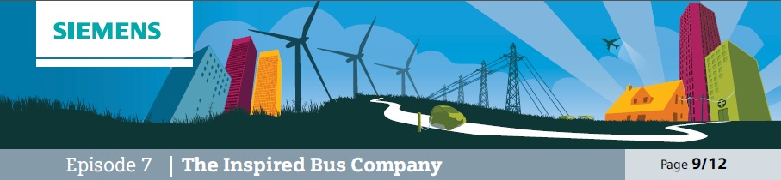

Evaluate
Teacher to ask students to consider how the energy might be used – demonstrate with flywheel and generator, and with hand crank torch.
This episode is also about devising solutions but in this case is

Additional resources required
• Fly wheel and generator
• Hand crank torch/radio or similar

more open ended and doesn’t culminate in a practical demonstration. There is an emphasis upon students critically evaluating each other’s ideas and identifying who has developed something of merit.

Learning objectives
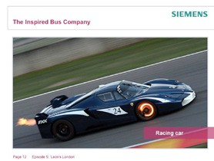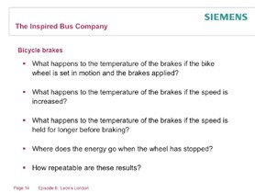• Students will consider how kinetic energy that is being transferred away from a moving object could be utilised.

Learning activities

1. Demonstrate hand crank device such as radio or torch, showing how it is possible to use the crank to charge up the battery and then to use the battery to power the device. Ask students to think about the energy transfers that are taking place, suggest ideas and summarise.

2. Remind students about bicycle braking and car braking, pointing out that in those cases significant amounts of energy were transferred but dissipated in the atmosphere.

3. Challenge students to suggest how bicycle braking might be done in such a way as to charge a battery. Ask students to work in groups to sketch and label how this might be done.

4. Ask students to display their work and then look
at each other’s work. Encourage positive feedback.

5. Take overall views on the kind of solution that might be effective.

Outcomes
• Students will understand how energy being transferred from a moving object can be stored for future use.
• Students will have collaborated effectively to generate effective solutions.

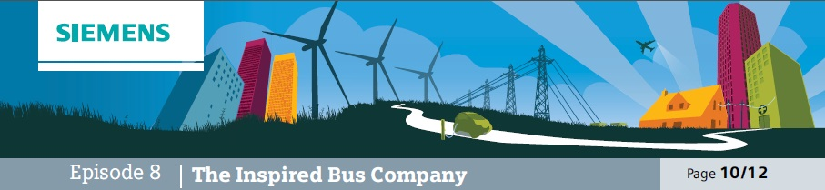

Evidence
This episode is based on the understanding and application of information presented in a graph. The emphasis needs to be upon students understanding of what is being shown and then applying this to various situations.

Learning objectives
Students will be able to:
• Interpret information presented graphically.
• Relate the information to particular applications.
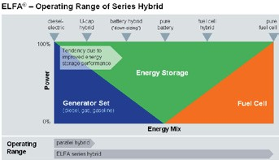• Use the information to relate applications to situations.

Learning activities

1. Display a picture of a London bus and explain that the wheels are actually driven by electric motors. Say that the electricity could come from any of the power sources introduced earlier episode (1) (diesel engine, battery or fuel cell). Explain that in practice a bus wouldn’t have all three; it could have any one or both a battery and either a diesel engine or a fuel cell.

2. Introduce the graph and explain what it shows. (A particular vehicle is at any point on the horizontal axis depending upon the ‘energy mix’ it has. Explain that this means that the designer
has a lot of flexibility when it comes to designing a bus for a particular application.) Point out as well that this kind of graph is a powerful visual summary.

3. Check on students’ understanding by asking questions such as
“Whereabouts on this graph would you place an electric milk float?”

4. Then encourage students to use the graph to suggest the energy mix for various situations.
These might include:
a) Transport around a railway station for passengers with limited mobility. b) A farm tractor.
c) A lawn mower for a domestic garden.
d) A lawn mower for the school playing field.

Outcomes
• Students will have shown how they can interpret the graph and draw useful data from it.
• Students will have applied this to various situations.

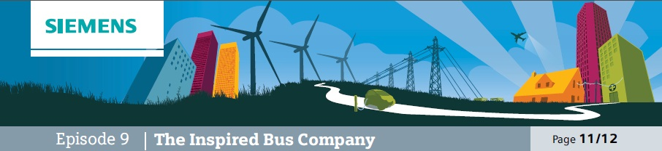
Watch and learn
Use video on Siemens ELFA® hybrid drive system.
This episode is based on students finding out about how a hybrid drive system works and why such a system is useful. Detailed operation is not appropriate, instead place emphasis on what the system does and the why rather than the how.

Learning objectives
• Students will understand how the Siemens ELFA® hybrid drive system is a logical solution to the challenge of alternative drive systems.
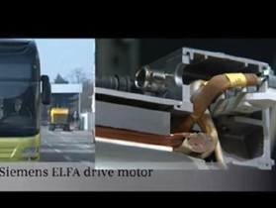• Students will be able to explain how the system is applied.

Learning activities

1. Explain that whereas having more than one drive system offers advantages, it needs to be controlled and managed automatically. Say that this is the kind of system that high tech engineers specialise in doing and the kind of project that well qualified engineers can earn a good income from being involved with.

2. Show the video.

3. Ask students to identify key points about the solution produced.

Outcomes
• Students will be able to explain the advantages offered by the hybrid drive system.

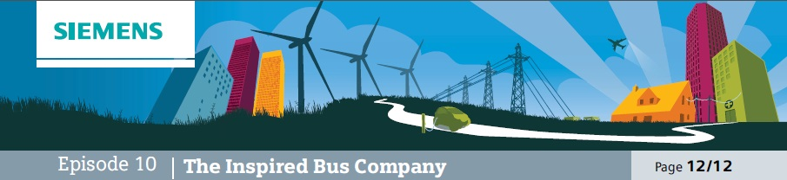

Propose and present
Students work in teams to develop proposals and present solutions for fuel systems for buses for the
Inspired Bus Company.
This is the episode where the topic comes together and students develop a considered response. The emphasis is upon not only what each group has decided but why it has been decided and how it is communicated.

Learning objectives
• Students will be able to draw together ideas from this topic to justify decisions.
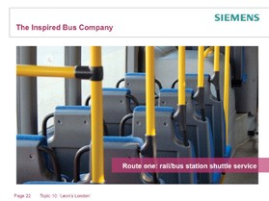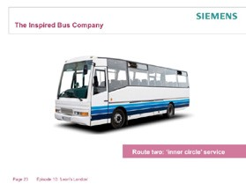• Students will be able to present decisions in a clear and logical way.

Learning activities

1. Students will work in groups to present a case for the power systems for a fleet of new buses. These buses will each be dedicated to a particular route; the routes to be covered are:
a) Route 1: shuttle service between rail and bus stations in city centre.
b) Route 2: ‘inner circle’ service around urban estates.
c) Route 3: airport bus service using urban motorways.

2. The presentation will need to explain how the team evaluated each kind of power system for each route and what their recommendations were.

Outcomes
• Students will have considered for each route the advantages and disadvantages of different power systems and will have justified their final recommendations.

