Introduction

Life without STEM has been developed using five scenarios to provide teachers with a topical and engaging tool for exploring how ideas, developments and discoveries in STEM subjects have changed and improved the world we live in.

The scenarios are not intended to provide a complete ‘potted history’ of the development of the technology portrayed, neither do they purport to reflect the view that man has been capable of technological thinking for thousands of years. Rather they set out to stimulate discussion about the impact that these changes have made.

Each of the five scenarios consists of a series of four animated images/scenes exploring:

Scene | IT | Transport | Communications Energy |  | Healthcare
1 | The use of mobile technology and widespread  provision of wireless networking | Modern car | Mobile telephones | Modern home entertainment and central heating | MRI Scanner
2 | The use of laptops and portable technology with increased battery life | Early car | Landline telephone | Home entertainment and local heating | Endoscope
3 | The use of personal computers with  a significant standalone capability | Bicycle | Telegram | Radio and coal fire | Electrocardiogram
4 | The use of mainframe computers with terminals | Horse | Post mail | Open fire | Manual monitoring

Moving through the scenes progressively removes stages of technological development. The idea is that pupils can see how products and services have been improved and also how this is related to developments and discoveries.

The intention is that pupils, rather than being told what the key developments were, are challenged to suggest from the illustrations what changes have taken place, what enabled those to happen and what the effects have been.

Questions:

Within these resources, questions can be asked at three levels:

• There are overarching questions posed in the illustrations: these are suitable for pupils over a wide range of ages.
• There are supplementary questions suggested in these notes: in some cases these are targeted at pupils of certain key stages.
• From the classroom discussion it is intended that will be elicited, it is likely that teachers will be able to ask further questions, depending on the age, interest and attainment level of the pupils.

Curriculum Links

Science
In KS2 & 3 the national curriculum for science aims to ensure that all pupils are equipped with the scientific knowledge required to understand the uses and implications of science, today and for the future.

Design Technology
In KS2: Pupils learn to investigate and analyse a range of existing products and understand how key events and individuals in design and technology have helped shape the world.

In KS3: Pupils learn to analyse the work of past and present professionals and others to develop and broaden their understanding, investigate new and emerging technologies and understand developments in design and technology, its impact on individuals, society and the environment, and the responsibilities of designers, engineers and technologists

Computing
In KS2 & 3, Computing ensures that pupils become digitally literate – able to use, and express themselves and develop their ideas through, information and communication technology – at a level suitable for the future workplace and as active participants in a digital world.

IT
Exploring the steps:

Step 1 to Step 2: this step-back involves moving from devices with significant wireless access to ones that tend to carry both applications (or programmes) on board and stored content. The touchscreen has gone and text is entered via physical keys as opposed to onscreen keys, which means the single unit has been replaced by a ‘clamshell’ design. The storage

The four scenes relate to:

1. Mobile technology

2. Laptops and portable technology

3. Personal computers

4. Mainframe computers

space is limited and the machines, though portable, are bulkier and have a shorter battery life. Wireless networks are much less common, and expensive to access so data transfer tends to be by cable, disk or memory stick.

Step 2 to Step 3: this corresponds to portability receding to a glimmer in the eye of a few engineers. The computer fits on a desk, but it now doesn’t leave much of the desk for anything else. The components are similar to those of the laptop but aren’t built into a single case and anything else that needs to be added, such as a webcam or loudspeakers, usually means extra components on the desktop. Mains powered and probably connected to a network it can transfer data reasonably quickly but slower processors limit capabilities. Word processing simpler data processing is reasonable but anything as rapid as video or gaming soon shows how slow the processors are. However, like later machines, the processing is carried out in the device in front of you. Just not very quickly.

Step 3 to Step 4: although the computer terminal may look rather like the personal computer, the idea behind it is quite different. The microprocessor that drives later devices doesn’t exist and the keyboard and screen are merely the front end on a far larger machine some distance away, though almost certainly on the other end of a cable. The processing takes place somewhere else in a huge device that is slow and does jobs in strict rotation. You enter your request and wait for a response; you are sharing the machine with many other users. The data is so slow it is always only digits on the screen. Good for doing the payroll and the gas bill. Each machine is so expensive it is only large organizations that can afford them and their main use is data processing.
The common factor within these is, of course, computing capability but the biggest impact has been the uses to which this has been put. The trend is towards a wider range of uses including, for personal use, accessing video content and gaming. These often require high speed processors, long battery life, high resolution displays and portability to allow for users in personal settings.

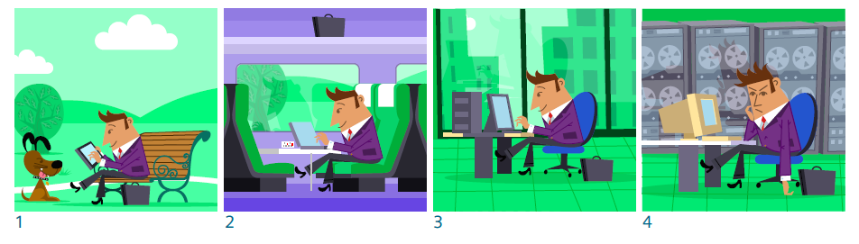

IT
Leading questions:

Scene | Leading questions | Points to draw out
 |  | 7-11 yrs primary | 12-14 yrs secondary
Mobile technology | What kind if device is being used?  What might it be used for? Can you remember this type  Of device first becoming  widely available?  What advantages did it offer over laptops and personal computers?  How important is wireless connectivity when using one of these? | Devices are very portable.  They have a long battery life. They can be used for a range  of applications.  A number of the uses (although by no means all) make use of internet access or mobile phone coverage. | Improvements in battery technology have resulted in smaller lighter batteries that last longer.  Devices that have large illuminated screens need more power.  Faster processors have meant higher quality images and video, so that films and games are of a higher quality. The  resolution of the images are better and the rate at which they can be changed.
Laptops and portable | If you had to replace your smartphone or tablet with a laptop, what could you still do okay and what would become more difficult?  Why does using a tablet PC feel quite different to using most types of laptop PCs? | Compare a laptop to a tablet PC and identify similarities and differences.  Note that the operating system on a tablet PC launches almost immediately whereas that on many  Laptops takes a little while to start up.  See that a laptop may be better suited to applications such as word processing longer documents whereas a tablet PC may be just as good and more convenient for web browsing. | Compare a single unit to clamshell  in terms of portability and suitability. Relate comparative features to particular applications.  Relate the idea of WiFi systems to transmission and reception of radio waves to provide, for example, web access. Compare this to cable links in relation to ease of use, security and reliability.  Explore idea as to whether a tablet PC is more closely related to a smartphone or to a laptop computer.
Personal computers | “A desktop computer is like a laptop but with different parts in different cases” – is this true?  A desktop computer is obviously less portable than a laptop, but why do some people still use them? | It’s easier to modify a desktop computer, if you want to change or replace any of the components.  By designing the computer as one item, it’s easier to make sure the parts work well together. | A computer can be thought of as having various components that make up a system. These include input devices, such as a keyboard, processors, such as the CPU (central processing unit) and outputs, such as a screen. This applies to both laptop and desktop.  Earlier desktop computers had CRT screens, which were quite deep; the invention of a flat screen was essential for laptops.  Systems can be made more sustainable if parts can be replaced; it’s easier to upgrade a desktop. However with computers becoming relatively cheap, for many people the portability is more important.

IT
Leading questions (cont.):

Scene | Leading questions | Points to draw out
 |  | 7-11 yrs primary | 12-14 yrs secondary
Mainframe computers | Why did very early computers have the processor part, which actually does the work of doing calculations, in one room, linked to a number of terminals?  Why were there very few of these early computers compared to modern devices?  They dealt mainly with numbers. What would they have been good at and which things do we  Now use computers for that they wouldn’t have been so good at? | Early computers were  ‘mainframe’ computers, where the processing part was huge and needed a large room of its own.  Terminals were used for putting information in and out of it.  Such computers, although they were large and expensive could do  Much less than a modern computer. Their cost and limitations meant they were used mainly for large  organisations that needed to do large sums. | All computers work in numbers but the faster they become the more useful they are as the numbers can represent things such as colours in a picture or sounds in a piece of music.  One of the things that made miniaturization possible was the invention of the integrated circuit, which consists  of lots of components such as resistors in one device (sometimes known as a ‘chip’).

Thinking about the future

On January 15, 2015, Google announced that it would stop producing the Google Glass prototype. The Glass displays information in a small screen above the user’s right eye. It can also take photos and videos, and get directions, using just voice instructions from the wearer. But some people said there were issues over privacy, while other tech bloggers complained that it wasn’t developing quickly enough.

Think about how people use technology, where they use it, what they use it for. What do you think the future of mobile, wearable technology might be?
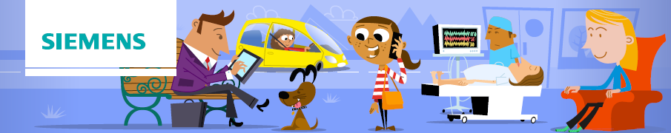

Life without STEM
Notes for Teachers
Page 6/19

Transport
Exploring the steps:

Step 1 to Step 2: this step-back involves moving from vehicles which are relatively non-polluting, reliable, fast, safe and comfortable to ones less well developed. Because cars of previous generations are usually recognizably similar (four wheels, internal combustion engine, steered by driver along roads) the steps in automotive engineering can be overlooked by pupils.

The four scenes relate to:

1. Modern cars

2. Earlier cars

3. Bicycle

4. Horse being ridden

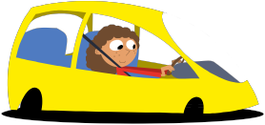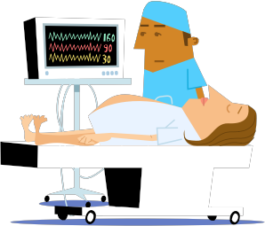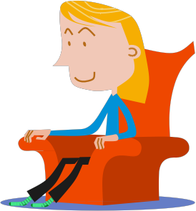Vehicles are now far safer – hitting a brick wall in a modern car at 30mph is likely to result in significantly less serious injuries than in a car of fifty to a hundred years ago. Fuel consumption is massively improved and although the roads are busier than ever before, annual fatalities are fewer.

This has a downside, of course. The more car transport becomes safe, clean and reliable, the more inclined people are to choose cars. Road improvement programmes have shown time and again that improving traffic flow brings about a short term gain but in the longer term increased traffic levels negate the benefit.

Step 2 to Step 3: this corresponds to the absence of the internal combustion engine and a reliance upon a person’s own energy to propel them along. Although other forms of power were used in the early days of cars (and more recently with electric motors and hybrid systems) it was the petrol engine that made the use of cars a practical proposition. Once coupled with mass production, the car became within reach of the masses, along with the personal freedom. A bike may keep you fit but the range, safety and weather protection are, for other than crowded cities and recreation, disincentives for most people.

However, especially in urban areas, traffic levels sometimes reach saturation point. Cars keep people safe and dry and enable them to carry children and luggage but in some instances average speeds are lower than those achieved by a typical cyclist. The car may have become a victim of its own success.

Step 3 to Step 4: prior to the bicycle (remember that before the development of pneumatic tyres and gears, bicycles were less appealing than they are now) personal transport would be by horse. Although riding a horse is less effort than riding a bicycle, having a horse for personal transport only would be beyond the means of most people. However, horses used to be used extensively for public transport and it was estimated in 1893 that there were around 300,000 horses in London alone (needing a fair proportion of the countryside to grow feed and producing huge quantities of waste). These would have been used for taxis, buses and goods transport. The numbers of horses in the UK overall at that time is estimated to have been well over 3 million. A horse would cope with poor surfaces (just as well at that time) and would be reliable. However they need feeding and shoeing.

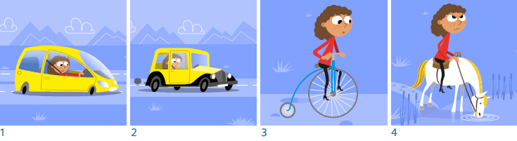

Transport
Leading questions:

Scene | Leading questions | Points to draw out
 |  | 7-11 yrs primary | 12-14 yrs secondary
Modern cars | How have cars improved in recent years?  A modern car uses less fuel to travel a mile and will produce less waste gas as it does so. Why has there been a lot of effort into improving these figures?  Modern cars are safer than ones built 50 or a hundred years ago. What features do they have to help with this?  What else makes a modern car pleasant to use? | Cars use less fuel and produce less waste. They don’t need servicing as often and are less likely to break down. If you’re involved in an accident in one you’re less likely to be badly injured or killed.  Fuel has become more expensive, so fuel economy is important. More vehicles means more pollution  and there’s more awareness of the damage it causes.  Cars now have side impact protection bars and crumple zones at the front and back to absorb energy in an impact.  Modern cars take less effort to drive; they are more comfortable and relaxing. | Energy efficiency has become important in the drive to reduce pollution and the rate at which  fossil fuels are used up. Less energy is wasted in the engine and in moving the car along.  Pollution reductions have lowered the amounts of carbon dioxide, carbon monoxide and nitrous oxides released.  A passenger cage around the occupants protects them in case of an accident and crumple zones at the front and back absorb energy in an impact.  Cars that are easier to drive are less stressful and safer as well as pleasant.
Earlier cars | “People being able to buy and run motor cars is the most important freedom yet discovered.” Is this true?  What does having your  own car make possible that couldn’t easily be done before?  Why was the invention of the petrol (or internal combustion) engine crucial to the development of the car? |  | The very first cars were handbuilt, expensive and needed a mechanic to maintain them. After a few years mass production meant the cost came down. They still needed fixing fairly regularly.  Petrol engines were cleaner than steam engines (some early cars were steam powered) and had a longer range than electric motors (with heavy batteries).  They gave freedom to the masses, enabling people to travel and explore.

Transport
Leading questions (cont.):

Scene | Leading questions | Points to draw out
 |  | 7-11 yrs primary | 12-14 yrs secondary
Bicycle | What are the advantages of using a bicycle compared with walking?  Are cyclists fitter than motorists?  Why might having a bike be preferable to using a horse?  Compare a bike to a car for convenience. | Bicycles have been around for a long time. However, they haven’t always looked like the bikes we have now. Pneumatic tyres (ones you pump air into) weren’t a feature of early bikes, making  them uncomfortable, especially on bumpy roads.  Gears are also a more recent invention; they mean not having to pedal so fast at higher speeds and also being able to go up steeper hills. | The design of bicycles has been gradually changed over many years. Early bikes had heavier frames, no gears and solid tyres.  Think about the advantages each of these brought.  However, before cars became common many people had bikes. They were cheap, reliable and made it easier to travel further.
Horse being ridden | Horses have been used for hundreds of years, not only for transporting people but also for farmwork and moving goods. What makes them suitable animals for these types of work?  If you were to use a horse to ride, say, ten miles how do you think the experience  would compare with using a bicycle or a car?  Why do you think there are more horses in the UK than twenty years ago but far fewer than 120 years ago? | Horses are capable of undertaking a variety of tasks. Being  herbivores keeping them fed is straightforward, though they eat a lot, especially if they’re being worked hard.  Depending on their fitness, horses get tired after a while so they have a limited range. They need shoes  if they are being used on hard surfaces, and fitting these is a skilled process. | Horses can be understood as an energy system. As with cars and bicycles, an energy store is needed: the horse needs feeding. The  harder a horse is worked, the more it eats, just as cycling a bike uphill needs more energy and driving a car hard will empty the fuel tank quicker.  However, unlike car (but like people) horses get tired. Well suited to a time before surfaced roads,  They nevertheless have a limited range.

Thinking about the future

In the 1990s, diesel cars were becoming increasingly popular as reliable and economical alternatives to petrol engines. However what also first saw the light of day in that decade was the hybrid car, running on both petrol and electric. With pollution in cities a real issue, a car that releases no exhaust fumes in built-up areas may yet be the solution.

What will the fuel of the future be? Will it be hydrogen (which can be released from water), electricity (generated in a variety of ways) or even pedal power in lightweight vehicles? What do you think you’ll be driving around in by the next decade?

Life without STEM
Notes for Teachers
Page 9/19

Personal communications
Exploring the steps:

Step 1 to Step 2: this step-back involves moving from mobile phone technology, which requires no direct electrical connection with the network, to one in which telephones are connected to the system with cables.

In fact, the difference between the systems isn’t as

The four scenes relate to:

1. Mobile telephones

2. Landline telephone

3. Telegram

4. Mail

simple as using cables or not. A landline system can use a variety of technologies to connect one telephone to another, including microwaves, fibre optics and satellite. The critical difference is how the ‘end user’ is connected to the system. A mobile phone system uses a network of masts. Each mast provides coverage in a certain area – these areas are known as cells (Americans refer to mobile phones as cell phones). A user moving from one place to another whilst using the phone may be moving from one cell to another. They are moving out of range of one mast and into another; this is done automatically, without the user realising it. The challenge for the phone company is to place masts as effectively as possible to get an even and (near) complete coverage.

The huge difference for the end user is that they can be anywhere the signal reaches and still have a conversation, without having to be restricted by a cable. The other difference and one of increasing importance is that a mobile phone has the ability to decode digital data and therefore can be used to send and receive text and html (for internet usage). This is made possible partly by the miniaturisation of circuits and partly by the rate at which information can be transmitted. These two factors determine the characteristics of all communications systems.

Step 2 to Step 3: this corresponds to going from a personal cable connection, such as in the home or office, to a shared facility, typically in a Post Office which sends information as text. It also relates to a lower rate of information transmission. The telegram system involved a written message being entered, one character at a time, and transmitted over cables to a decoding facility in the area of the recipient. At the receiving station the message would be printed as text on a paper tape. This would normally be cut into pieces, stuck onto a sheet and delivered by hand to the recipient’s address. Telegrams could be sent anywhere in the world; the limiting speed was getting the information into the system at the start and delivering it at the end.

Step 3 to Step 4: prior to telegrams and cable, personal communications were by post and the physical carriage of a document. Far slower than the other systems and affected far more by distance, post is still used to relay large amounts of information. Electronic systems are now used to sort mail quickly and accurately and delivery times have shortened as transport systems have improved.
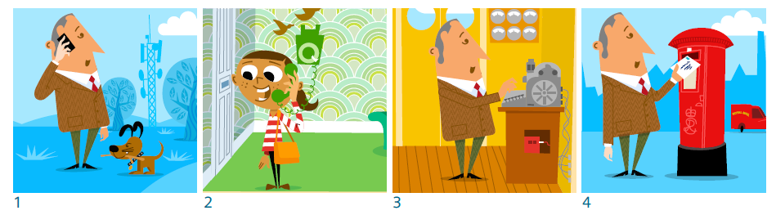

Personal communications
Leading questions:

Scene | Leading questions | Points to draw out
 |  | 7-11 yrs primary | 12-14 yrs secondary
Mobile phones | Why are mobile phones so popular?  What kinds of functions can be performed by a mobile phone?  Why does not having a cord to link the phone to the rest of the systems make such a difference?  Why has the miniaturisation of electronic components been so important in the development of mobile phones? | Phones can now perform a variety of functions such as texting and internet access as well as conversations.  As the phone travels with the person, so it is more likely that they can be reached.  As people work in different places, such as from home or whilst on  a train, a mobile phone is more practical.  Mobile internet access has increased as phones can display more data  and transmit responses quickly. | Freedom from the need for a cable connection has meant that mobile phone use is far more versatile.  Changing work patterns have meant that people are expected to work in more flexible ways, often from a range of locations, and to  be more accessible; mobile phones make this more possible.  As a mobile phone system can carry a large amount of digital data, it  can support services such as mobile internet.
Landline telephone | What is the advantage of a real time conversation compared with messages being sent back and forth?  What impact do you think the invention of the telephone had upon  organisations trying to sell things to people?  What difference did the telephone make to families with members living some distance away from each other? | Telephones enable a complete conversation to take place over a long distance within a few minutes.  They also make it easier to develop a relationship as people can hear how things are being said as well as what is being said.  It made it easier for customers to enquire about services or products and to place orders.  It also enabled sales organisations to telephone people to sell things.  Telephones improved access to emergency services. | Prior to the telephone, if people weren’t in the same room they couldn’t have a conversation in  real time, so exchanges took much longer.  Telephones enabled communications within and between organisations to be much quicker.  Telephones increased commerce as people can more easily find out about things they might want to buy. They can access services more rapidly.
Telegram | What was the huge advantage of a telegram over a letter?  Telegrams tended to be used for special occasions or emergencies – why was this?  Customers paid to send a telegram according to the number of words, rather than one charge for the whole document. Why do you think this was?  Telegrams were less private than letters – why? | Telegrams travelled much quicker than letters (apart from getting them to the Post Office at the start and delivered at the end) and so were useful in an emergency.  Because they were labour intensive, they were more expensive. People had to be employed to enter the information and to process it at the end.  At each stage the information was seen by telegram operators. | The information in telegrams was sent over cables. Once the cable system was in place information could be sent quickly.  It could also be sent by submarine cable to reach other continents.  Entering and receiving the information needed skilled people and specialist equipment connected to the cable network.

Personal communications
Leading questions (cont):

Scene | Leading questions | Points to draw out
 |  | 7-11 yrs primary | 12-14 yrs secondary
Mail | Why has the mail service  been around for much longer than the other ways of sending communications?  Even though it’s relatively slow, millions of letters still get sent every year. Why?  What kinds of things used to go by post, but now generally don’t? | A mail system can be relatively ‘low tech’ and work with little equipment apart from a means of transport.  The ‘high-tech’ equipment used is to speed up processes such as sorting mail, so that it becomes cheaper and quicker.  The mail system can be used for small items as well as letters.  Promotional material (sometimes referred to as ‘junk mail’) now represents a larger proportion of the mail sent.  Sometimes mail is used for legal documents or tickets, where the physical object needs to be transferred. | Physically carrying objects means they don’t need to be processed. They need to be in written form but this is taken care of by the sender rather than the system.  Small goods can also be sent in the same system.  Getting a postal address is sometimes easier than getting an email address or personal telephone number.  Some documents or tickets need to be physically transferred in order o be valid.

Thinking about the future

The coverage of 4G networks are expanding every month, allowing more information to be sent and received in less time and with greater reliability. The devices we use to communicate with each other are lighter and more efficient with longer battery lives. What will this greater connectivity offer?

Will the selfie image be replaced by the selfie video call? Call your friends and let them see you on Bondi Beach/in front of the Taj Mahal/at Stonehenge as the sun rises! Might the images be in 3D? And how about calling a group of friends at once – even if they’re all in different places? What do you think the next generation of phones will offer?

Life without STEM
Notes for Teachers
Page 12/19

Domestic Energy
Exploring the steps:

Step 1 to Step 2: this step-back involves going from a large colour TV to a small monochrome (i.e. black and white) TV, fewer ancillary devices such as clocks that are electrically powered and homes that are centrally heated to ones in which heating is localised.
Part of this of course, comes from increased prosperity. Some of these are related to household income and there are homes in the UK without large TVs and not

The four scenes relate to:

1. Modern home, entertainment and central heating.
2. Small monochrome TV, localised heating.

3. Radio, coal fire.

4. Open fire.
centrally heated. Nevertheless these things are more widespread now than a few years ago and it is technological developments that have helped to make this possible.

Domestic heating is now more efficient. This is partly because heating systems are better designed, wasting less energy and controlled more effectively. Houses are better insulated and lose less energy to the outside. A small but increasing number use energy sources such as solar energy and ground sources to partly replace the use of fuels.

TVs are better designed. The circuitry is largely based on integrated circuits as opposed to the valve
technology of the 1950s, which was heavy, unreliable and used a lot of electricity. Not only are there far more channels but the remote controls (unheard of in the days of the older TV) enables easy changing.

As well as the far wider number of channels, modern TVs often have access to online material, meaning that
the viewer can access programmes broadcast previously (or content never broadcast). On the one hand this has significantly increased the role of niche programmes but it has also changed the role of the TV. When live broadcasts on a few channels were the only content available, viewing figures could be huge (the record for the UK is over 30m in the 1980s) and such programmes would be the focus of conversations for days afterwards.

Small electrical appliances, such as clocks, have motors that are cheap, accurate and use very little electricity. Both these and the remote control will use small batteries lasting a year or more.

Step 2 to Step 3: this corresponds to moving from TV to radio. Whereas TV remains a largely ‘sit down and watch’ medium, radio has altered more regarding how it is used. Whereas now it is largely listened to by people whilst doing other things, when first available it was more likely (especially in the evenings) that people would sit and listen. Early radio broadcasts were non-commercial (i.e. no advertising) and there were fewer channels. Listening to the radio was often a social event.

Houses were more likely to be heated using a fuel such as coal or gas. Coal was widely used in the UK; it was easily stored, relatively cheap and in some cases was used to heat water and cook as well as keeping the house warm. However it is less controllable than gas or electricity and takes a lot more maintenance.

Step 3 to Step 4: this relates to using available fuel and available natural features for dwellings. People have long utilised local materials to build houses, including wood, slates and stone, and have used local materials

Domestic Energy
Exploring the steps (cont.):

to make building materials such as bricks and tiles. Stone buildings in the UK are a different colour and texture according to the area as transporting it is expensive. However previously people would have used whatever natural structures existed. Early settlements were sometimes short-lived if people followed wild animal herds rather than growing crops and tending animals so people had to be good at exploiting what they could find.
Similarly fuel would be gathered and prepared according to what was available. People would be skilled at lighting fires, knowing what material would be a good fuel and using it to cook, keep them warm and even fashion materials.

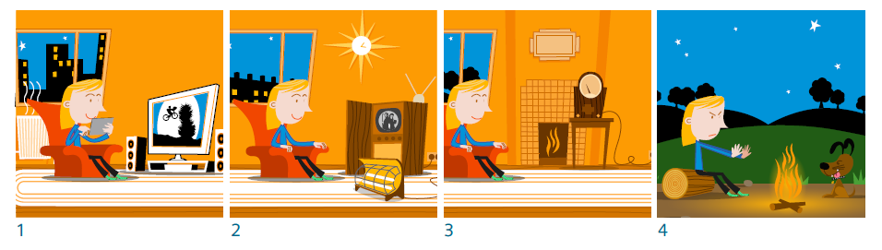

Life without STEM
Notes for Teachers
Page 14/19

Domestic Energy
Leading questions:

Scene Leading questions |  | Points to draw out
 |  | 7-11 yrs primary | 12-14 yrs secondary
Large TV, central heating small electrical devices such as clocks | Why is it pleasant to live in a centrally heated home?  What fuel might be used to keep a house warm?  How can homes be made less dependent upon the use of fuel?  Why do modern homes often use less fuel than older homes?  How have TVs improved in the last few years? | Centrally heated houses are warm throughout.  Various fuels can be used such as oil, coal or gas. Electricity is also used for heating. Some homes make use of energy from the sun, either to warm the building, heat water or generate electricity.  Modern homes have effective insulation and are designed to lose less energy through doors and windows.  Modern TVs have large screens, many channels, good sound systems and can display programmes from the internet as well as broadcast. | Centrally heated homes have a consistent temperature throughout.  Some homes use a fuel such as a fossil fuel. In other cases the fuel has been used at a power station to produce the electricity to heat the home.  Modern house design (and alterations to older houses) often make walls, ceilings and floors better insulators; window size is often reduced (apart from south facing to increase solar heating) and double or triple glazed.  Renewable energy sources can be used to heat the home, heat water and produce electricity.  Modern TVs can access data from a variety of sources and produce great sound and beautiful images.
Small monochrome TV, localised heating | What impact do you think the arrival of televisions made?  How easy do you think it would be for the family to watch programmes in  black and white on a screen about the size of a tablet PC screen?  Electrical heating is more controllable than using  a coal fire; what other advantages might it have? | Early televisions are a great novelty and prized but the picture quality and range of programmes was far less. There was no colour in the images and a few channels broadcasting for a few hours a day.  Small TV screens (and bulky cameras) meant that programmes were often more modest technically. However it meant that moving images could be regularly seen in the home.  Electricity is a versatile source of energy as it can be easily increased and decreased. Electric fires don’t need to be cleaned or refuelled. | Small black and white screens are not as effective as modern screens at showing sports action, stunning scenery or complex images.  Until 1964 there were only two channels and they both closed down at the end of each evening. However TV meant that events such as the Queens’s Coronation and the assassination of President Kennedy were seen by millions of people in their own homes.  Electricity is a versatile source of energy as it is controllable and can be transferred in a range of  Ways such as space heating, water heating, cooking and running a range of appliances.

Domestic Energy
Leading questions (cont.):

Scene Leading questions |  | Points to draw out
 |  | 7-11 yrs primary | 12-14 yrs secondary
Radio, coal fire | How would it feel to sit and listen to the radio instead of watching a TV programme?  What are the advantages and disadvantages of a coal fire?  How would you feel about water having to be specially heated instead of being continuously available? | Radio broadcasts were listened to by many families in their homes in the evenings as well as in factories or the home as people worked during the day.  Coal fires are more interesting to watch but need a lot of maintenance.  Some homes with coal fires  Had ‘back boilers’ to heat water as well but in others the water had to be specially heated for washing or a bath. | Most homes prior to TV had one radio and it was in the living room as a source of news and entertainment. It brought key news live to people, such as the declaration of war in 1939.  Coal is dirty and produces soot and ash as well as carbon dioxide. Coal fires are welcoming but need cleaning and the waster disposing. Homes at that time were much more labour intensive; maintaining basic services such as bathing and clothes washing took a lot of effort.
Open fire | How would it feel to live in a shelter or cave instead of a house or flat?  How easy do you think it would be to provide energy for heat and light? | Early human civilisations used shelters from natural materials or features in the landscape. People gathered fuel and learned how to make fire from flints or bows and sticks. | Natural shelters are few and  far between; as soon as people started to settle they used and adapted materials to make homes.  Gathering fuel and lighting fires is skilful and produces limited benefits. Supplying heat and light continuously is difficult.

Thinking about the future

What will the entertainment system of the future look like? Will the trend towards larger screens, curved and
3D and with cinema-style sound systems continue, or is it a move towards smaller and more personal? Will we end up isolated yet engrossed in our own personal choice of channel or game, shared with people all over the world who we’ve never met (and won’t need or want to) and fed through small screens and earphones? What will keep us entertained in the 2020s and which features are already with us?

And how will we keep warm in our homes, especially as energy is likely to rise in price? Might homes become more intelligent, sensing where there are people and controlling heating accordingly? It’s now possible to use a smartphone to control a heating system remotely, but might the systems of the future also draw the curtains in the evening to keep heat in and open them in the morning to let the light in?

Healthcare
Exploring the steps:
Note that unlike some of the other sequences, all four of the scenarios are in widespread current use. In this sequence the intention is more to show how more complex and sophisticated techniques are sometimes called into play if a situation demands it. The medical expert has a wider range of strategies to call upon.

The four scenes relate to:

1. MRI scanner

2. Endoscope.

3. Electrocardiogram.

4. Manual monitoring of tissue.

Step 1 to Step 2: this change involves moving from an MRI scanner to an endoscope. Magnetic Resonance Imaging involves forming detailed images of the inside of the body. The images are finely detailed and show a range of tissues with great clarity; they can be taken in any plane, enabling cross sectional views to be formed. The process involves using strong magnetic fields to make hydrogen nuclei in the body oscillate. It doesn’t involve the use of ionising radiation and is thus sometimes preferable to other procedures such as CT scans or X rays. Endoscopes enable a doctor to see inside the body by inserting a tube into an orifice. Optical fibres carry light into the body, where it illuminates the inside of the cavity being examined. The image is carried out of the body by a different set of fibres in the same tube so it can be viewed by the doctor.

Step 2 to Step 3: this corresponds to moving from diagnosing conditions based on imaging to one on data, in this case of heartrate. In some cases, of course, real time data on the functioning of the heart is sufficient to make an effective diagnosis. It may be that the heart is being affected by other factors and that data is sufficient. However the doctor (or whoever is making the prognosis) can’t watch how the organs are functioning. The data is immediate and its gathering is non-invasive but it may lead to the medical expert needing to actually see what is going on, either in that area or a different part of the body. The diagnosis may be better if images of the key area can be captured.

Step 3 to Step 4: prior to electronic data gathering, the monitoring of conditions was a manual process and therefore often subject to sampling at intervals rather than constant monitoring. A patient’s temperature, breathing or pulse might be measured manually and recorded on a chart. This presents an ongoing record, but data is only entered when someone with an appropriate level of skill records it. This is easier with temperature but listening to a heartbeat or breathing takes more skill.
Survival rates in many countries continue to improve and whereas this is partly due to improved procedures, medication and after care it’s also down to better and earlier diagnosis and providing high quality information upon which to base judgments.

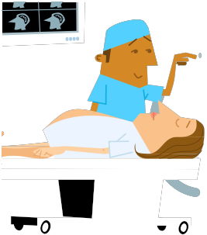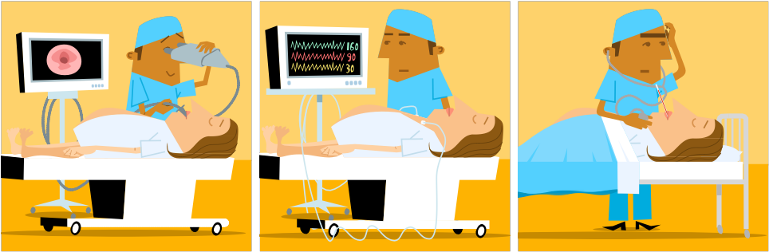1 2 3 4

Life without STEM
Notes for Teachers Healthcare
Page 17/19

Healthcare
Leading questions:

Scene Leading questions |  | Points to draw out
 |  | 7-11 yrs primary | 12-14 yrs secondary
MRI scanner | An MRI scanner is like a large tube that the patient is slid into. How do you think that might feel?  It’s also noisy: might this upset some patients?  It uses strong magnetic fields: what implications does this have for patients getting ready for a scan?  The images it produces are very detailed and can be of any part of the body. Why might this be useful in diagnosing a condition? | The patient has to lie still inside the scanner whilst the huge magnets are switched on and off very quickly. It’s noisy and claustrophobic but produces very clear images which enable doctors to see organs in great detail.  Patients can’t have anything magnetic on them or such objects will be ejected by the machine. | Changing magnetic fields produces noises that some find disconcerting. These strong fields mean that patients can’t have anything magnetic on them or it would be subject to huge forces.  The images can be produced in any plane and have fine detail so they show organs very clearly. Key features are highlighted so the functioning of the organs as well as the shape and size are easy to see.
Endoscope | An endoscope is a long flexible tube that is inserted into the body through an opening such as the mouth and enables the doctor  To see inside organs such as the stomach. How do you think it might feel to have an endoscope inserted? What do you think it’s like to be  able to explore the inside of an organ such as the stomach? Why does the endoscope need to be able to both guide light down there and guide it out again? | The inside of the body is dark so light has to be guided down there to illuminate the inside of organs. This is done with optical fibres.  Then the image is carried out again by fibres and used to make an image on a monitor.  This enables doctor to examine the inside of certain organs and see if they are damaged or affected. | Optical fibres use a process called total internal reflection. This means that no matter how the endoscope has to twist and bend, light can always be guided down to illuminate the inside of the organ and guided out again to form an image.  A skilled operator can explore organs to locate damage, growths and blockages.  Images appear in real time and can be used to guide procedures such as removing objects.

Healthcare
Leading questions (cont.):

Scene Leading questions |  | Points to draw out
 |  | 7-11 yrs primary | 12-14 yrs secondary
Electrocardiogram | For an ECG (electrocardiogram) a number of leads are attached to the patient, mainly around the chest but also on the limbs. They measure electrical activity in the working of the heart, showing how it is beating and displaying it as graphs on a screen. What do you think medical experts can see from an ECG trace?  Why might such a monitor be fitted to someone who has been involved in a serious accident or who  is recovering from an operation? | The heart is a muscle and responds to electricity. The ECG measures those signals and can show various things such as how often the heart is beating, how strongly and how evenly.  The measurements are shown on a series of graphs, so it is easy to see how these are changing.  The data is shown in real time, so any sudden change is immediately displayed. | The heart is a muscle and is made to work by electrical impulses. The ECG leads pick up the responses and the system compare the measurements from different points.  By comparing this it can work out not only the frequency of the heart beat but also the strength and how well the two sides of the heart are working. It also indicates whether the heart has been damaged at all and if it is responding to drugs which affect its operation.
Manual monitoring of tissue | An endoscope is a long flexible tube that is inserted into the body through an opening such as the mouth and enables the doctor to see inside organs such as the stomach. How do you think it might feel to have an endoscope inserted? What do you think it’s like to be able to explore the inside of an organ such as the stomach? Why does the endoscope need to be able to both guide light down there and guide it out again? | Patients who are not at high risk are often monitored using fairly basic equipment. This might include using thermometers or fever strips to measure temperature, counting heart beats by feeling the pulse or using a stethoscope, and using the stethoscope to listen to breathing.  This may be plotted on a graph to show changes over time. | There are a number of basic measurements which can provide some information to support a diagnosis of a condition or to indicate whether a patient’s condition is improving or deteriorating.  Temperature can be measured by thermometer or fever strip. The body has a complex system to maintain a constant internal temperature so an increase is cause for concern.  Heart rate can be calculated by counting beats over a set period of time. There are arteries near the surface in the wrist and the side of the neck where the pulse can be felt, or it can be heard through a stethoscope.  A stethoscope can also be used to listen to air travelling in and out of the lungs, showing whether breathing is effective.  Recording data on a graph shows trends in indicators.

Life without STEM
Notes for Teachers
Page 19/19

Thinking about the future

Are nanobots the doctors of the future? Cell sized robots will not only be able to power their way round the inside of the body but sense objects and manipulate cell organelles. Could they be used to dispose of pathogens (substances that cause diseases) and even learn how to treat viruses that mutate, recognising them even as they change their forms?

Is this the way forward for health diagnosis in the next few years? Would you feel happy with having such a tiny machine exploring your innards?

