General

This document is an example for a safety acceptance test

Usage of the document

This document can be used as a template

Remarks for the usage of the document:

- Set up a team with all functions during the development of the machine, for example:
  - Mechanic design
  - Electric design
  - Software
  - Documentation
  - Machine-tester
  - Commissioning
  - ...

- Define standard terms fort the whole document
  - Comprehensible terms for all team members
  - Easy to review ( official verification)

- Fill the tables of the document

Acceptance test for safety functions – Cutting machine with automatic feeder

Moderator

Name | Role | Comment
Mr. Creator | Creator

Participants

Name | Role | Date, Signature
Mr Tester 1 | Tester 1
Mrs Tester 2 | Tester 2

Document – History

Version | Date | Changes | Name | Role
0.1 | 01.01.2018 | First version | Mr. Creator | Creator

Table of content

1 Project data 4
1.1 Machine description 5
1.2 Machine part 1 7
1.3 Other documents ( references) 10

Project data

Rev. | Modification contents
 | New construction of cutting machine
Contract No | 125345-2018
Project | Cutting machine with automatic feeder
Plant
Area
Equipment
DocType | Acceptance test |  | Referenced document/
Doc Title | Example_template_acceptancetest_V1_0.docx |  | Substitute for /
 |  |  | Replaced by
Language(s) | EN
Customer specific:

 |  | Name |  | Date | Signature
Made by |  | Mr. Cretaor
Checked by |  | Mrs. MachineCheck
Approved by |  | Mr. Approver

Machine description

Type: | „Machine“  in the sense of MD 2006/42/EC Article 2 / Pt. a
Name: | Cutting machine with automatic feeder
Machine-Typ: | Cutting machine
Year of construction: | 2018
Customer: | METCON
Location: | Nuremberg
Projectcode: | 123-3949

Cutting machine with automatic feeder

Use
    - Machine for cutting solid wood or similar
material up to 150 mm x 150 mm
    - Maximum diameter of cutting disk 600 mm
Application boundaries
    - Connection: 400 V 3~ 50 Hz
    - Indoor use (IP54)
    - Temperature range: -15° C to +50° C
User groups
    - Only specialist personnel, no laypersons
    - Trainees only under supervision by specialists
Time boundaries 150,000 operating hours
Physical boundaries
    - The machine does not include loading aids
    - Space required by persons handling the machine

.

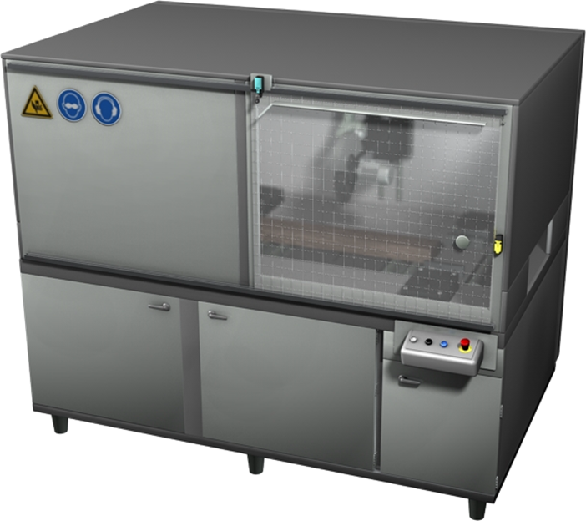

Machine part 1
Place of potential hazard: | Whole machine | Operation mode: | All

 | E-Stop | 1.2.3
 | If the E-Stop is activated, all drives will stop. | SIL1 | 1 | Activate E-Stop | Drive 1 "Saw blade rotation" stops immediately  Drive 2 "Saw blade lift" stops immediately  Drive 3 "Feeder" stops immediately  Drive 4 "Conveyer" stops immediately  Drive 5 "Clamp 1" stops delayed after 0.5s  Drive 6 "Clamp 2" stops delayed after 2s  Drive 7 "Centering" stops delayed after 2s | OK  OK  OK  OK  OK  OK  OK  OK

Gefahrenstelle: | Door 1 | Betriebsart: | Alle

 | Door monitoring | 2.3.4
 | If the door will be openend the drives 1, 2, 3 and 4 will stop. | SIL3 | 1 | Open the door | Drive 1 "Saw blade rotation" stops immediately  Drive 2 "Saw blade lift" stops immediately  Drive 3 "Feeder" stops immediately  Drive 4 "Conveyor" stops immediately | OK  OK  OK  OK
 |  |  | 2 | Fault simulation discrepancy (only one position switch is open) | Drive 1 "Saw blade rotation" stops immediately  Drive 2 "Saw blade lift" stops immediately  Drive 3 "Feeder" stops immediately  Drive 4 "Conveyor" stops immediately  Fault is detected. Restart is not possible until the defect is corrected. | OK  OK  OK  OK  OK
 |  |  | 3 | Fault simulation Cross fault (Cross fault between both contacts of the position switches) | Drive 1 "Saw blade rotation" stops immediately  Drive 2 "Saw blade lift" stops immediately  Drive 3 "Feeder" stops immediately  Drive 4 "Conveyor" stops immediately  Fault is detected. Restart is not possible until the defect is corrected. | OK  OK  OK  OK  OK

 | Door locking | 2.3.4
 | During operation of the blade (blade is rotating) the door is locked. In case of standstill of the blade the door is unlocked. (Detection with standstill monitoring) | SIL2 | 1 | Door is closed, Machine is running, Saw blade is rotating. | Door is locked,can not be opened | OK
 |  |  | 2 | Door is closed, Machine is stopped, Saw blade is in standstill. | Door is unlocked, can be openend | OK
 |  |  | 3 | Door is open, Machine Start is requested. | Door is not able to lock  Machine will not start | OK  OK
 |  |  | 4 | …

Gefahrenstelle: | Handzuführung | Betriebsart: | Alle

 | Admission control witch light grid /light curtain | 2.3.5
 | If the light grid is activated the drives 5,6 and 7 will stop. | SIL3 | 1 | Activate Ligthgrid with test-finger | Drive 5 "Clamp 1" stops immediately  Drive 6 "Clamp 2" stops immediately  Drive 7 "Centering" stops delayed after 2s | OK  OK  OK
 |  |  | 2 | Fault simulation Cross fault (Cross fault between both OSSD outputs) | Drive 5 "Clamp 1" stops immediately  Drive 6 "Clamp 2" stops immediately  Drive 7 "Centering" stops delayed after 2s  Fault is detected. Restart is not possible until the defect is corrected. | OK  OK  OK  OK

Other documents ( references)
e.g.:
specifications
Safety Evaluationen Report
Operating manual
Maintenance manual
...

