Overall learning objectives

• Developing a sense of scale and proportion with regard to measurement of frequency and loudness and how these can be represented graphically.
• Understanding the process of hearing and the use of loudness and frequencies to compare sounds.
• Identifying the key factors in a design brief and using a block diagram to represent a system.
Overall learning outcomes

• To explain how the human ear works and responds to sounds of different intensities and frequencies.
• To describe how hearing loss might occur and the effects it might have.
• To develop a design for a hearing aid, showing how it allows for a range of design requirements.

Curriculum learning objectives
Students should be able to: Maths
• Identify the mathematical aspects of a situation or problem.
• Select mathematical information, methods and tools to use.

Science
• Explore how the creative application of scientific ideas can bring about technological developments and consequent changes in the way people think and behave.
• Use appropriate methods, including ICT, to communicate scientific information and contribute to presentations and discussions about scientific issues.
• Use real-life examples as a basis for finding out about science.

Technology
• Understand that products and systems have an impact on quality of life.
• Explore how products contribute to lifestyle and consumer choices.
• Make links between principles of good design, existing solutions and technological knowledge to develop innovative products and processes.

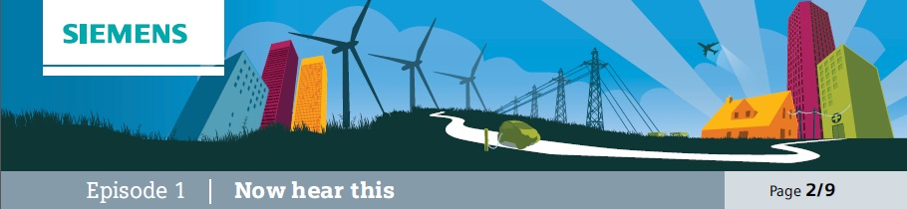

Introduction
This episode is intended to provide students with an understanding of how the ear works and how sounds are converted into nervous impulses.

Learning objectives
• To understand how the ear works.
• To understand how vibrations are converted to nervous impulses.
• To understand how hearing can be affected.

Learning activities

1. Start off by showing pictures of ears of various mammals and asking for ideas about what their form and function is. Draw out that in each case the purpose is to gather sound waves and guide them into the next part of the ear. Explain that sound waves are vibrations travelling (in this case) through the air; energy is being transferred. Draw attention to the directional nature of sound and that some animals, such as cats, can direct their ears to pick up sounds from different directions. Ask why some ears are small compared to the size of the animal whereas other animals have (relatively) large ears. Explain that large ears may confer a survival advantage (being able to detect predators or locate prey) but are vulnerable to attack and may be damaged. Point out the hairs and ask for ideas about the importance of preventing small objects from entering.

2. Then show a diagram of the workings of the human ear and explain how:
a) The outer ear gathers sound waves and funnels them into the middle ear, thus concentrating the energy. They reach the ear drum and cause it to vibrate. Louder notes cause greater vibrations; higher notes cause more rapid ones.
b) The middle ear transfers those vibrations through three tiny bones (the smallest in the body).
Their delicate structure means that they have to be protected by being within the skull; blows to the head or loud noises can damage them.
c) The inner ear includes the cochlea into which the vibrations enter; this has nerve endings around the spiral structure. Higher frequency notes travel further around the cochlea and are detected
by nerves nearer the centre. The nerves convey impulses to the brain which indicate loudness and frequency.
d) The inner ear also contains the semi-circular canals which control balance.

3. Check understanding by asking questions such as how hearing would be affected by:
a) Having a larger outer ear (more sensitive hearing).
b) Having an outer ear that could be directed (more directional hearing). c) Having an ear drum that was perforated (hearing loss).
d) Having one of the bones in the middle ear knocked out of alignment (hearing loss). e) Having an infection in the ear (hearing loss).

Outcomes
• To explain the function of different parts of the ear.
• To describe how sound is converted to nervous impulses.
• To suggest the effect of changes to the ear.

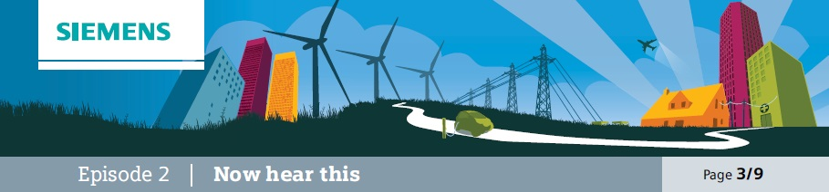
Explore
This episode explores loudness and hearing loss and is designed to introduce the concept of loudness and
the unit of the decibel; it also provides an opportunity for students to develop a sense of how big a unit the
decibel is.

Learning objectives
• To understand the term loudness and the decibel as a unit to measure this.
• To become familiar with the use of decibels to measure loudness.

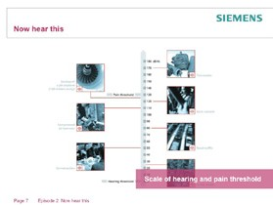
Learning activities

1. Explain that loudness is a term used by scientists to measure how loud a noise is perceived to be and is measured using the decibel. Say that, for example, normal conversation is at around 50-60dB and that no sound is 0dB. Add that pain through loudness starts at around 130dB.

2. Use Student Support Sheet 10A to present to students a scale of loudness with, for example, conversation and pain threshold marked in and ask them to place other examples on the scale.

3. Use demonstration from How we hear to check responses.

Outcomes
• To explain what loudness is and the units it is measured in.
• To be able to relate various typical sounds to measures of loudness.

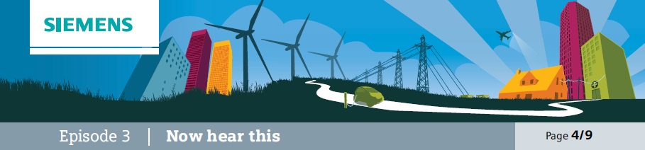
Compare
This episode provides a comparison of loudness to frequency and explanation of what frequency is. It introduces the term frequency and relates it to loudness and to sounds.

Learning objectives
• To understand frequency and the units it is measured in.
• To relate this to different sounds.
• To understand how sounds can be represented as waves.

Additional resources required
• Guitar / Guitar string
• Signal generator
• Loudspeaker
• Microphone
• Cathode-ray oscilloscope

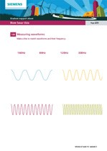
Learning activities

1. Make a sound using something that produces a continuous note, such as a guitar string. Ask students to suggest how it could be varied and draw out that it could be made louder or quieter and higher or lower. Show how this is done.

2. Then demonstrate, using a signal generator and loudspeaker, sounds of varying frequency and loudness. Introduce the term frequency and explain that it is measured in hertz (Hz). Demonstrate a range of frequencies.

3. Explain that sound travels in vibrations and that we can think of these as waves. Like waves they have a regular form. Use a microphone and Cathode-ray oscilloscope to show that a sound such as a bang or clap produces the shape of a pulse on the screen. Then show that a continuous sound has a regular waveform by using the signal generator, loudspeaker and CRO. Vary the frequency of the sound and show that this changes the length of each wave. Explain that the frequency (or pitch) of the note is determined by the number of waves arriving at the ear every second. Middle C for example has a frequency of 256Hz – 256 waves arrive every second. More than that and it would sound higher, fewer and it would sound lower.

4. Use student sheet 10B to show a number of waveforms and ask them to place them in order of frequency. Then ask them to match them up with the frequencies and finally ask them to explain why the notes will all be as loud as each other. Take feedback.

Outcomes
• To explain why sound can be understood as a wave.
• To relate the waveform of a sound to its frequency and loudness.
• To use the Hertz as a measurement of frequency.

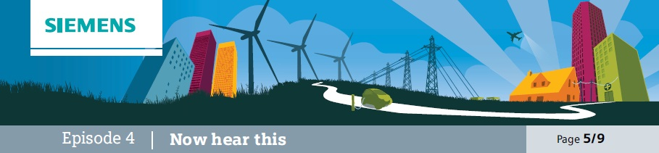
Research
This episode consists of students conducting secondary research and presenting ideas about causes, effects and preventative strategies related to hearing loss.

Learning objectives
• To understand what might cause hearing loss and how it can be prevented.
• To research material and identify key points.
• To present ideas clearly and succinctly.

Additional resources required
• Research tools
• Flip chart paper

Learning activities

1. Ask students to suggest various causes of hearing loss. Gather ideas and display them. Then allocate causes to small groups of students and ask them to conduct research. Say that they will have to summarise their findings in terms of:
a) Exactly how that situation may cause hearing loss. b) The nature of the effect on the person.
c) How this effect can be eliminated.

2. Enable students to access various sources of information and gather ideas. Ask students to either summarise their ideas on a poster or on a slide in a presentation.

3. Share ideas. Emphasise that the importance of this task is not only to identify causes and preventative measures but also for them to work efficiently and effectively to access information and present it in a clear and succinct form.

4. Ask students to provide feedback with regard to the clarity of presentation and how well it covers the three aspects required.

Outcomes
• To have researched a cause of hearing loss and identified how it could be prevented.
• To have identified and recorded key points.
• To have presented them clearly and succinctly.

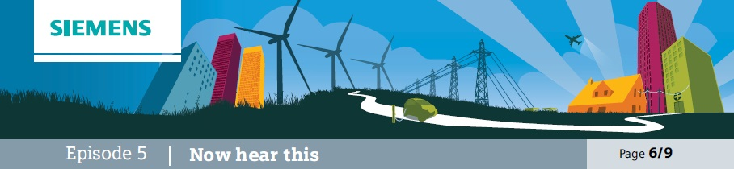
Explain
This episode is designed to get students thinking and talking about how hearing is tested.

Learning objectives
• To consider the kinds of situations in which hearing loss may first be apparent.
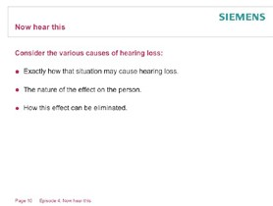• To consider how hearing could be tested in such a way as to replicate more challenging situations.

Learning activities

1. Ask students if they have any experiences they feel comfortable to share about family or friends who are getting older and suffering hearing loss. Ask them to describe the kinds of situations in which they find it more difficult to hear what is going on. Say that the kind of situation in which people often first become aware that their hearing is not as good as it used to be is when there is a fair amount of background noise and they are trying to separate out the sound that they want to hear from other noises.

2. Explain that you are going to run a hearing test. Say that the purpose of this is to show how hearing tests are set up, not to actually test their hearing. Explain that in order to do this they would have to be tested individually and use headphones so that each ear could be tested separately. Say that they will hear certain sounds and they will need to try to identify those from a list. Run the test, ‘Test your Hearing’ and ask for responses.

3. Discuss how this is designed and why some sounds are harder to hear than others.

Outcomes
• To explain why a particular test has been constructed in a particular way to produce valid data.

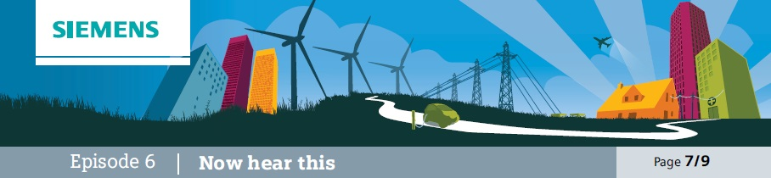
Application
This is episode is designed to encourage students to revisit the concept of frequency, introduce the idea of intensity and apply them to the concept of hearing loss.

Learning objectives
• To apply terms such as frequency and intensity to compare different spoken sounds.
• To use graphical representation to relate frequency and intensity to various sounds.
• To explain the implications of gradually deteriorating hearing loss.

Learning activities

1. Ask students to reflect on the hearing test in the previous episode (5) and suggest which sounds they found harder to hear and whether they thought that they were lower or higher frequency sounds.

2. Now distribute student support sheet 10B. Explain that the graph on this shows how sounds compare in terms of intensity and frequency. Draw attention to the examples included, such as the bus and the aeroplane. Ask students to consider the groups of consonants and vowels provided and consider whether they are lower or higher frequency.

3. Now show students the results from experimental evidence. Draw attention to the impact of different degrees of hearing loss and ask them to suggest the kind of words that would be the first to be difficult to hear if someone’s hearing loss deteriorates from mild to moderate.

Outcomes
• To explain how different sounds compare in terms of intensity and frequency.
• To suggest the implications of different degrees of hearing loss.

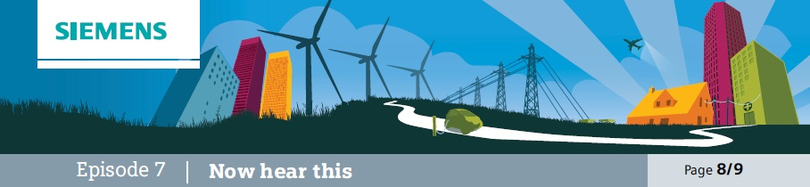
The challenge
This episode challenges students to think about the common characteristics of information processing systems and how they can be usefully thought of in terms of input , process and output.

Learning objectives
• To understand that many information systems can be thought of in terms of input, process and output.
• To apply this to a variety of everyday contexts.
• To design the outline of a hearing aid system using these ideas.
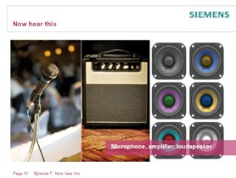

Learning activities

1. Show students a picture of a PA system and ask them to identify the key components and suggest their purposes. Draw out that the microphone is to pick up sound, the amplifier to increase the size of the signal and the loudspeaker to transmit a louder sound.

2. Explain that a way of representing this is to use a block diagram showing input, process and output and that this relates to the information, or signal.
Explain that the purpose of this system is to show what happens to the information, not the power. Say that this applies to many other systems as well and provide some examples, such as the following.

Example Input Output
TV | Signal from aerial, satellite or fibre optic cable. | Screen and loudspeaker
Computer | Signal from internet, memory or CD-ROM. | Screen, loudspeaker, printer or memory device.
Radio | Signal from aerial. | Loudspeaker or headphones.
MP3 Player | Signal from memory card. | Loudspeaker or headphones.

3. Explain that the focus at this stage is to identify the input and output rather than to understand the detail of the processor functions. Emphasise that the input refers to information and not to energy. The power supply is not a signal input (even though it is essential).

4. Point out that a hearing aid can be thought of in the same way as a large scale PA system
(same process, different scale). Designers still need to consider input, process and output.

5. Ask students to think about how, in a design for a hearing aid, they might allow for the input, process and output. Working in small groups, they should start to develop some ideas about where these might be located.

6. They should then reflect upon other considerations as well, including power supply and vanity.
Ideas should be summarised in a labeled diagram.

Outcomes
• To have applied concept of input-process-output to various devices.
• To have produced an outline of a design for a hearing aid.

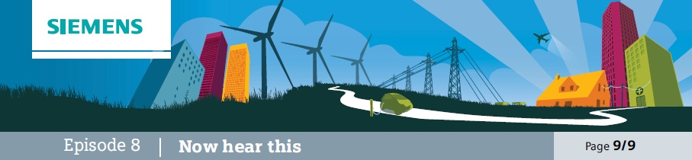
Reflection
In this episode students develop their ideas for a hearing aid and explore how various features can be allowed for.

Learning objectives

Additional resources required
• Model car
• Example hearing aids

• To understand the various factors affecting the design of a hearing aid.
• To develop a design for a hearing aid that meets design considerations.
• To reflect upon various solutions from other designers.

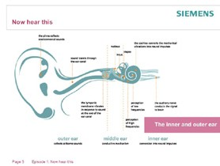
Learning activities

1. Show students a model ear and explain that their task is to design a mock-up of a hearing aid that allows for various factors, including:
a) Appropriate positioning of input device
(microphone).
b) Space for processor.
c) Appropriate positioning of output device
(small loudspeaker, as in earphone). d) Power supply.
e) The need for the device not to be obtrusive.

2. Show students various commercial solutions and explain that one of the reasons for variation is that some people need more amplification than others and that this also influences the design. Ask students to consider how these devices have allowed for the factors listed above.

3. Then ask students to come up with a more detailed design. They could either produce a 3D mock-up of a device using a suitable medium or a 2D representation. In either case they should explain how they have allowed for each of the design factors.

4. The various designs should then be presented and shared, either by display or by presentation to the rest of the group.

Outcomes
• To identify how various design solutions have been developed.
• To produce and present a design solution that meets various design factors.

