The formula for calculating speed is
$$average speed =\frac{distance travelled (metres)}{time taken (s)}$$

YOU MUST SHOW YOUR WORK. You can use a calculator but you must show all of the steps involved in doing the problem.

Speed
In 2009 Usain Bolt set the 100M world record covering the distance in 9.58 seconds.  What was his average speed over the 100m? | 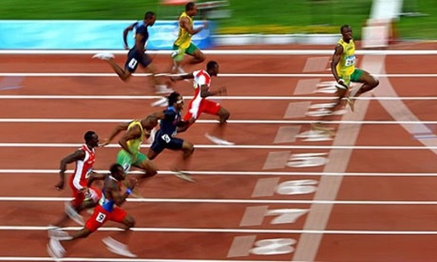
 | https://www.youtube.com/watch?v=3nbjhpcZ9_g
Answer:

In 1998 Florence Griffith-Joyner set the Women’s 100m world record covering the distance in 10.49 seconds.

What was her average speed over the 100m?
 | https://www.youtube.com/watch?v=Mrt9yZL8dbI
Answer:

Time
How long would it take a Greenpower car travelling at 50kph to travel around the Rockingham Speedway in the UK (the oval circuit)?  The answer should be given in metres per second (m/s), kilometres per hour (km/h), and miles per hour (mph). |  | 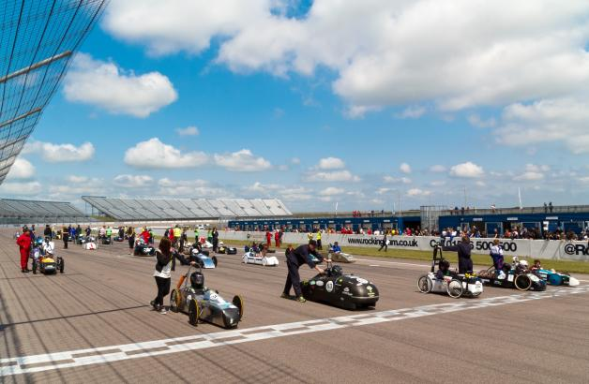
You will need to visit the following link to get the distance around the oval circuit. https://en.wikipedia.org/wiki/Rockingham_Motor_Speedway
Answer:

Bloodhound SSC aims to break the 1,000mph barrier. The world record attempt will measure the average speed over a “measured mile”.

What is 1,000mph in km/h?
What is a mile in km?

www.bloodhoundssc.com
https://en.wikipedia.org/wiki/Land_speed_record
How long will it take Bloodhound to travel the measured mile if it’s travelling at 1,000mph?
Convert into m/s and metres and then calculate the answer.
Answers:

Time
How long would it take you to cycle from your house to your school if you travelled at an average speed of 15km/h?

Use Google Maps to find the distance from your house to school. Use the Get Directions option.

Answers:

The distance from my house to school is ______metres

Cycling at an average speed of 15km/h it will take me ____minutes and ____ seconds to travel from home to school.

Distance
Calculate the distance from the Earth to the Moon.  Watch the YouTube clip from the Big Bang Theory.  https://www.youtube.com/watch?v=-e5CtbbZL-k | 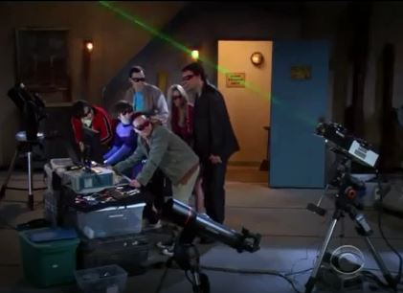
The speed of light in a vacuum is 299,792,458 m/s
In the YouTube clip how long did it take the light from the laser to travel from the Earth to the Moon and back to Earth?

Answer: __________ seconds

Using this information calculate the distance from the Earth to the Moon in km.

Answer:

