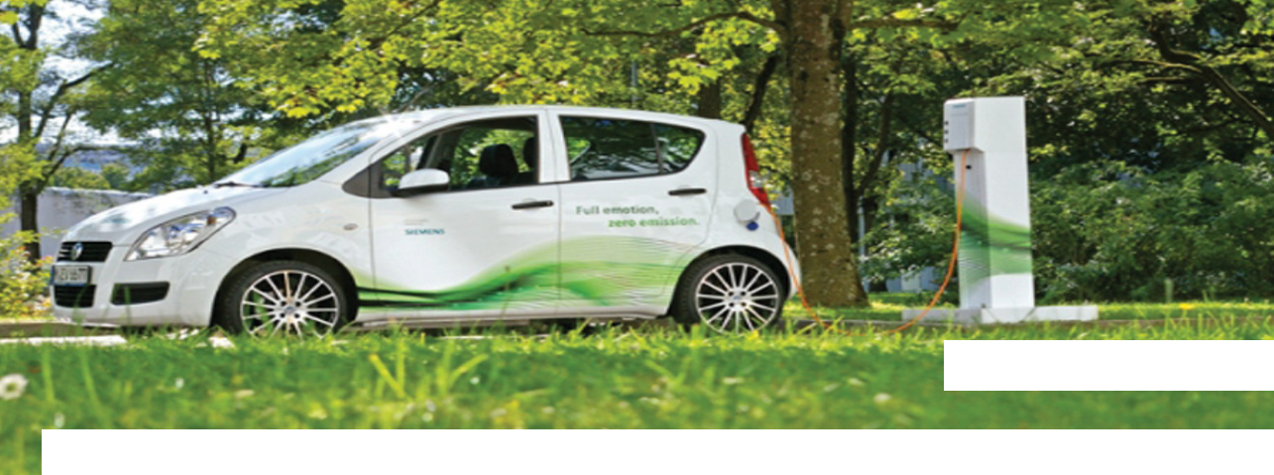1A Battery

Battery powered car

No polluting gases

There’s nothing new about electric vehicles. For a long time it has been possible to build a vehicle with a large battery inside it, that makes it go.

The battery isn’t the same sort that you would put in a torch, although it does the same job. The battery needs charging up by plugging it into the mains.
Then, as the vehicle is driven, the battery runs down.
Battery powered vehicles have a number of advantages over petrol or diesel powered vehicles; they are much quieter and don’t release polluting gases (although of course the power stations
that provide electricity to charge them up may have). They do however have a limited range; and can only go so far before they need charging again. This means that they are often used in cities,
where the lack of noise and pollution is particularly important. The lower speeds and limited range may well be less of an issue, as distances travelled may be less and speed limits are lower.

The cost of electricity to run an electric vehicle is much less than the cost of the fuel for a similarly sized petrol or diesel vehicle. However, the batteries are very expensive and can only
be recharged a certain number of times.

1B Fuel cell powered vehicles

A fuel cell powered vehicle has an electric motor but it isn’t powered by a battery. Instead the electricity comes from a fuel cell.

Typical fuel cell batteries

Electricity

Hydrogen

_
_
_
_

O O
_ + O O
+ O
_

Oxygen

+ O

How a fuel cell works
_
+ O
O

Heat & Water

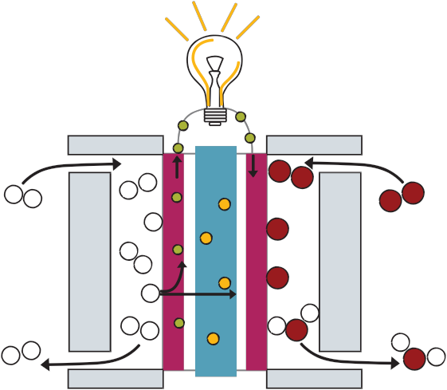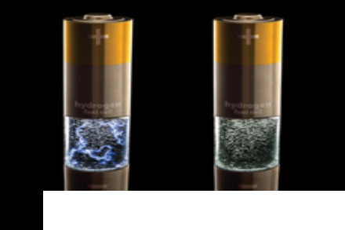You may know that water is a compound of hydrogen and oxygen (H O) and you may have seen or read about an experiment in which electricity is passed through water, splitting it up into these two gases. A fuel cell works the other way around, instead of using electricity and releasing the gases, it uses the gases and releases electricity. It uses hydrogen from a storage tank and oxygen from the atmosphere.
2

Fuel cells are a more expensive way of powering motors than using batteries but the vehicles can have a greater range.
How a fuel cell works
• A fuel cell takes energy from chemicals, usually hydrogen and oxygen, and releases it as electricity. The oxygen supply is easy
to arrange as it can be taken from the atmosphere but the hydrogen needs to be stored in a tank. Hydrogen is highly flammable so it has to be used carefully.

• At the centre of the cell is a membrane which is often coated with platinum; this acts as a catalyst and speeds up the reaction.

• Fuel cells have been extensively used in space craft, such as the Apollo moon missions.
Their costs are still high but are coming down.

1C Diesel

Diesel engine vehicles

Diesel-electric railway locomotive

Diesel engines have long been used in large road vehicles and increasingly in cars. Around half of all new cars sold in Europe are now diesel powered.

How a diesel engine works

Diesel engines are a type of internal combustion engine, meaning that the burning of the fuel takes place inside the engine. Diesel fuel (unlike petrol) doesn’t need a spark to ignite it; a mixture of diesel fuel vapour and air will ignite simply
by being compressed.

Diesel engines are reliable and long lived. However

diesel fuel enters air enters
here
air in cylinder

crankshaft

exhaust gases leave here

cylinder

piston connecting
rod
they release a range of polluting gases. They release less carbon dioxide than a petrol engine doing the same work, but the exhaust gases are carcinogenic (they cause cancer).

Certain vehicles such as some railway locomotives and some buses which have diesel engines are actually `diesel-electric’. Instead of the diesel engine directly driving the wheels, as in a car, the engine drives a generator which produces electricity. The electricity then drives electric motors, which turn
the wheels.

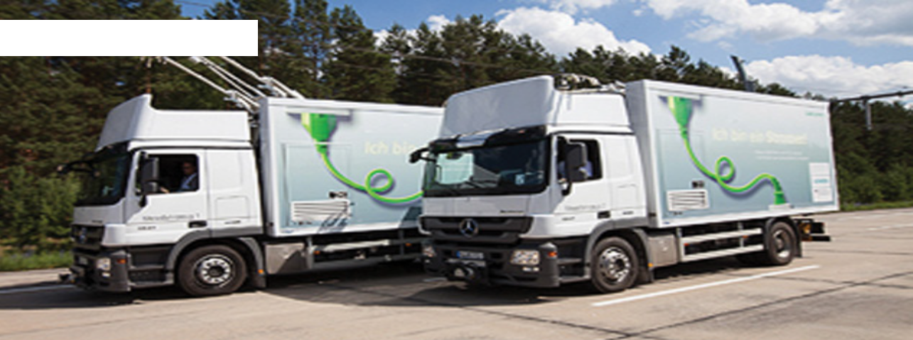In the engine, fuel is drawn in, mixed
and compressed. It ignites, forcing the piston down the cylinder, making the connecting rod turn the crankshaft. There will be several cylinders driving the same crankshaft.

Scheme of work 1 - episode 3

