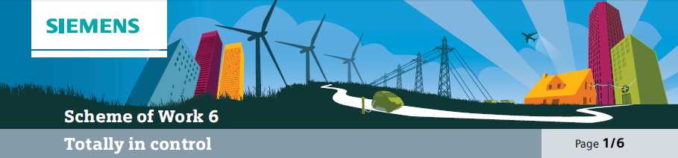

Overall learning objectives

• Identify how sequences of commands can be used to run equipment and how logic operation can respond to inputs and control outputs.
• Apply ideas about circuits and energy transducers to using inputs in systems and about forces to simple and complex situations.
• Understand features of a system in terms of input, process and output, how the design of a system responds to a detailed brief and how a system can be modified to improve
its performance.
Overall learning outcomes

• Understood the concept of input-control-output systems and applied them to various situations.
• Constructed and evaluated sequences of commands.
• Evaluated the advantages of an automatic control system for a particular context.

Curriculum learning objectives
Students should be able to: Maths
• Work logically towards results and solutions, recognising the impact of constraints and assumptions.
• Use accurate notation, including correct syntax when using ICT.
• Engage with someone else’s mathematical reasoning in the context of a problem or particular situation.

Science
• Share developments and common understanding across disciplines and boundaries.
• Plan and carry out practical and investigative activities, both individually and in groups.

Technology
• Explain the practical application of systems and control in design proposals.
• Describe electrical, electronic, mechanical, microprocessor and computer control systems and how to use them effectively.
• Use systems and control to assemble subsystems into more complex systems.
• Feedback how a variety of inputs can give rise to a variety of outputs.

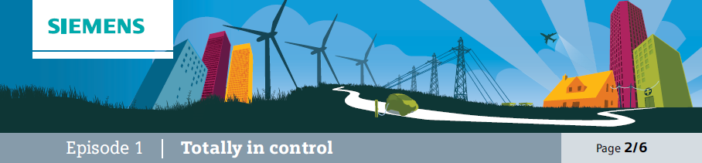
Introduction
This episode is designed to set the scene and to put the activity in a more familiar context. The subtext is that control systems aren’t only used in industrial settings that might be harder to identify with, but also in more familiar situations, where they make things both safe and enjoyable.

Learning objectives
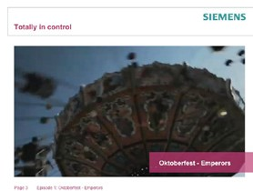• Understand some of the needs for an automatic control system.

Learning activities

1. Show the video “Oktoberfest Emperors” and ask students to share personal experiences of such rides.

2. Ask students to identify key features of the ride that make it fun and draw out points about the chairs swinging out further as the ride goes faster. Some students may notice that the axis of rotation isn’t vertical when the ride is at full speed; this gives a ‘swooping sensation’.

3. Ask students to suggest why the balance of the
ride may change from one group of passengers to another and draw out points about some passengers being heavier than others, passengers not being evenly distributed and some chairs being empty.

4. Ask for reasons why there is an automatic control system as well as the manual controls and draw out reasons for this being installed.

Outcomes
• To be able to suggest some advantages with having an automatic control system in this context.

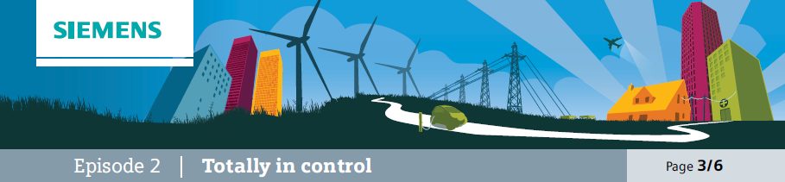

The context
This episode further develops ideas about the fairground ride as a system that needs control, what might go wrong and thinking about inputs and outputs.

Additional resources required
• Calculators

Learning objectives
• To analyse a system in terms of why automatic control is important.
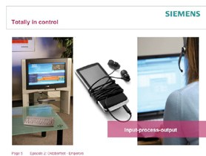• To analyse a system in terms of inputs and outputs.

Learning activities

1. Explain to students that many systems have inputs, a processor and outputs. Use a calculator as an example of this and show how the keypad
is the input, the processor is in the circuitry inside and the output is the display. Ask students to apply this idea to:
a) A TV.
b) A personal stereo. c) A computer.

2. Show student support sheet 6A which is a news
story on a fairground ride accident and ask them to think about the safety aspects of such a ride and how the ride might become unstable and dangerous. As well as the risk to onlookers, focus the discussion on the ride itself.

3. Ask students to work in groups and to gather ideas under these headings:
a) The features that make it an exciting ride.
b) Potential hazards and how they can be avoided. c) Inputs and outputs.

4. Take feedback. As well as drawing out points about the passengers moving quickly at some height and the ride needing to be balanced, focus on the information inputs to the control system including:
a) The weight of the passengers. b) The distribution of that weight. c) The height of the chairs.
d) The speed of the chairs.

5. The outputs may include: a) The height of the chairs. b) The speed of the chair.

Outcomes
• To have identified various inputs and outputs.
• To have explained why the system needs to monitor and respond to the inputs.

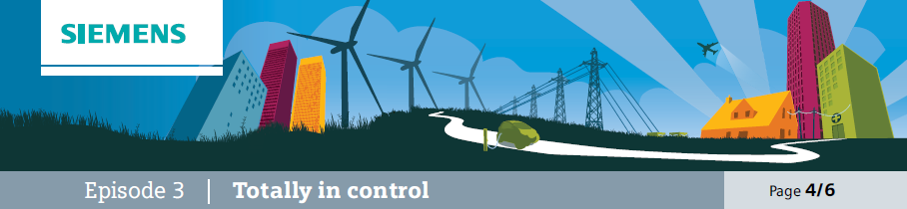
Apply
This episode is to support students to apply their concept of an input-process-output system to another context.

Learning objectives
• To apply concept of input-process-output to a practical context.
• To sequence steps logically.
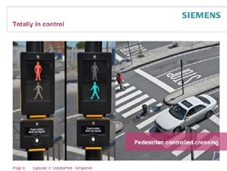• To search a sequence for mistakes.

Learning activities

1. Show students an illustration of a pedestrian- controlled crossing and emphasise that this system responds to an input with an output. Ask students to identify these and establish that the input is the button and the output is the changed sequence of traffic lights.

2. Give students student support sheet 6B (preferably cut into cards) and ask them to sequence them in the correct order.

3. Ask one group to read out their sequence and
alert other groups that you will be asking them if they think it is correct, students should establish the correct the correct sequence:
a) Traffic lights green and pedestrian light red. b) Button pressed.
c) Traffic lights amber. d) Traffic lights red.
e) Pedestrian light green and bleeper turned on. f) Bleeper turned off.
g) Pedestrian light red.
h) Traffic lights red and amber. i) Traffic lights green.

4. Then say that it is not only the sequencing that is important but also the timing. Ask students to put suitable timings in between each of these stages.

Outcomes
• To have correctly analysed the input and outputs in the crossing system.
• To have correctly sequenced instructions to control the crossing.

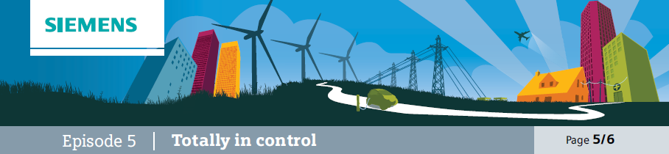
Evaluate
Students consider the flying chairs as a system to be controlled; students will need to identify the inputs and outputs and consider the control sequence. At this stage it can be assumed that the control is being done manually; the focus is upon the correct sequence.

Learning objectives
• To consider how a fairground ride could be controlled manually.
• To identify inputs, outputs and sequencing.

Learning activities

1. Explain to students that the purpose of this part is to apply their understanding of inputs and outputs and also the correct sequencing of instructions to control the ride.

2. Say to students that once the controller is satisfied that it is safe to start, the hub (from which the chairs are suspended) starts to rotate. Then the hub rises vertically upwards. Near the top of its travel, the hub tilts slightly to one side.

3. Check students understanding of the context by asking them questions such as:
a) Suggest what the controller does to satisfy themselves that it is safe to start the ride. b) What will happen to the chairs as the hub turns more quickly?
c) What will happen to the chairs as the hub rises?
d) What will happen to the chairs as the hub tilts at the top?

4. Ask the students to suggest a series of instructions for the controller. Assume no automatic control.

5. Now ask the students to consider what would happen if the ride was significantly unbalanced, such as if there were a lot of heavy people sitting on one side and none on the other.

6. Ask the students to consider what should happen in this case and how they could modify their control sequence. If necessary suggest that sensors in the hub might be part of the solution.

7. Ask the students to consider how a strong wind might make a difference to the ride and how this could be responded to by the control system.

Outcomes
• To have identified a range of inputs and outputs.
• To have constructed a control sequence.

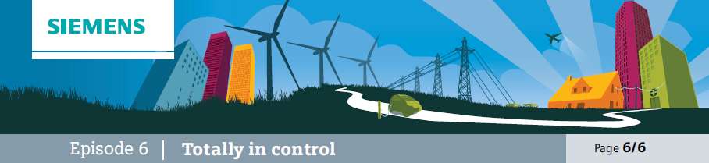
Evaluate
This episode challenges students to consider the advantages of an automated control system.

Learning objectives
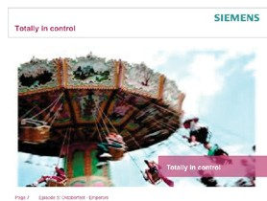• Consider the advantages of automatic control.

Learning activities

1. Say to students that it is now being proposed that an automatic control system be installed on the flying chairs ride. This will run parts of the control sequence automatically.

2. Ask them to work in groups to consider answers to these questions:
a) What would the advantages be of automatic control, thinking about:
– Adverse weather?
– Unbalanced loads?
– Controller fatigue?
b) Which aspects would you still want to be manually controlled, and why?

3. Students should be prepared to share ideas and suggest a combined and refined set of responses.

Outcomes
• To have presented a case for automatic control, identifying its features and advantages.

