Exploring the body

Exploring protection

Some parts of the skeleton, such as the skull, rib cage and pelvis provide protection and the spinal cord also protects some important nerves.

You are going to investigate how a delicate object can be protected. Your task is to protect a chocolate teacake from damage. You will need to be working in teams; your team will be provided with the resources shown above. Each team will have the same quantity.

Resources required:
paper
card
drinking straws sellotape
chocolate covered teacake

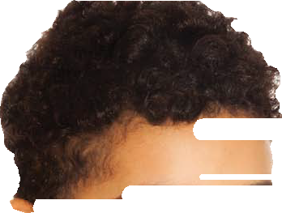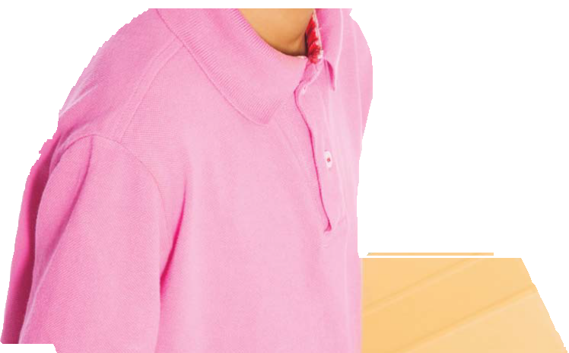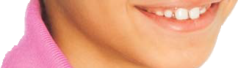

1. Design and construct something that will protect the chocolate covering on a chocolate teacake from cracking if it dropped. The teacake cannot be attached to the structure; the structure will be dropped from increasing heights to see how successful it is.
2. Think about how you can use the materials most effectively. For example, is it better to have them fit the teacake snugly or loosely? Would a spherical (i.e. ball shape) structure be the best?

3. Test and compare devices. Look at the more successful ones and identify key features of effective designs.
• Were they good at protecting the teacake (as far as possible) from all angles?
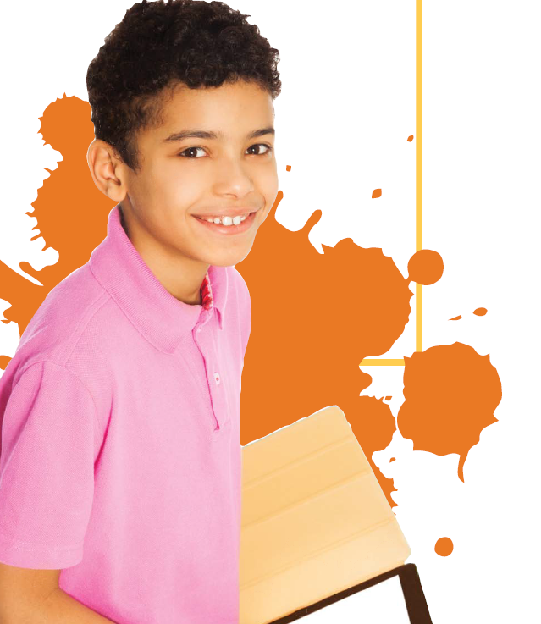
• Is it true that effective designs aren’t necessarily rigid?

4. Now look at a picture of the skeleton and look at the protective structures. See if there are features in common with your designs, possibly including:
• All round protection (e.g. skull)

• Flexibility (e.g. ribcage and backbone)

• Lightweight structure (e.g. rib cage)

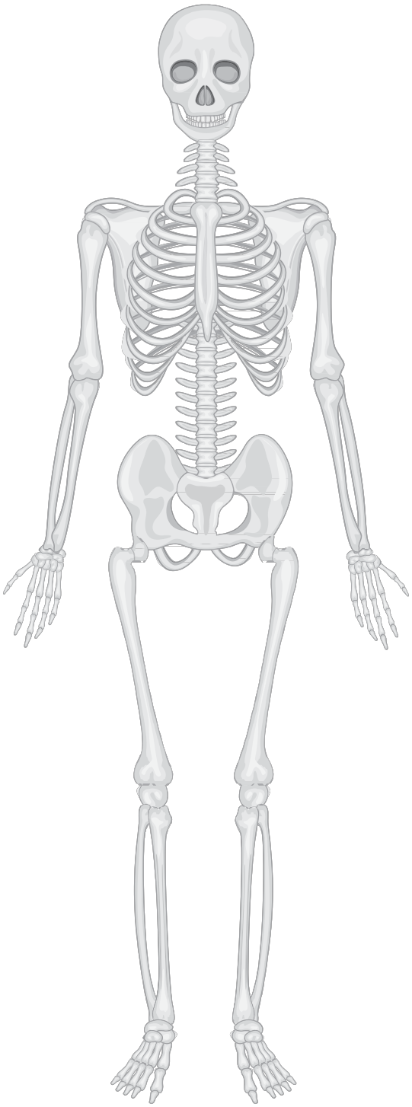The human skeleton

? Extension:
A beetle has a strong outer casing, called an exoskeleton, which provides protection. How successful a feature is this compared with, say, the skull and rib cage? Would humans be better with an exoskeleton than an endoskeleton?

