Pillar: Healthcare

Overall learning objectives | Overall learning outcomes
• Explain how MRI scanners produce images  • Apply their understanding of waves and particles to this application  • Describe typical uses of MRI images | • Write and discuss how images are produced by  MRI scanners  • Look at typical images and explain how they were produced  • Suggest ways in which these images are useful to medical practitioners

Curriculum learning objectives
Students should be able to:
Physics:
• Develop knowledge and understanding of the relationship between the properties of electromagnetic waves and their uses.
• Use scientific theories, models and evidence to develop hypotheses, arguments and explanations.
• Develop and use models to explain systems, processes and abstract ideas.

Introduction
The teacher presents students with a situation in which a doctor is making a medical diagnosis and needs
information about what is happening inside the patient’s body. In short, they need a picture. The teacher
asks for suggestions and may well elicit ideas such as exploratory surgery, X-rays and ultrasound; they then
show an example of an MRI scan and explain that for some applications, this is a powerful technology.
Students compare the images and consider, simply on the basis of these, what MRI has to offer.

Learning objectives
• Identify the importance of medical imaging in diagnosis.
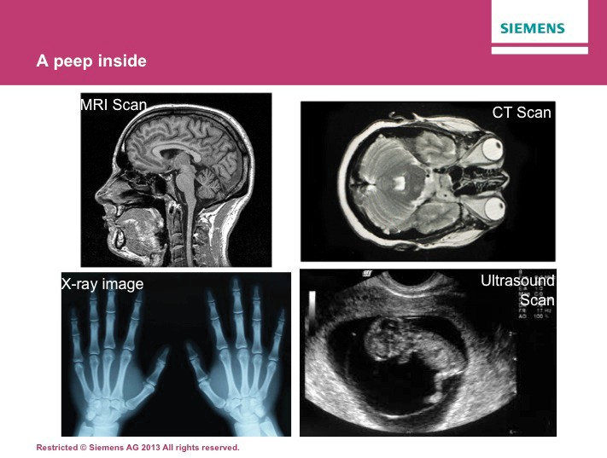• Recognise the advantages offered by MRI scans

Learning activities

1. Show an image of a doctor making a diagnosis and suggest that in some instance, images of the relevant organ will be useful. Ask for suggestions of examples and discuss.

2. Show an example of an MRI scan and ask for suggestions about what it shows.

3. Show some images from other technologies and ask for comparisons. Draw out that the images are clear, well defined and show fine detail. The three main alternatives are X-rays, CT scanning and ultrasound.
a) X-rays are good at delineating hard materials, such as bones and they can produce a clear image relatively quickly. However the ionising radiation produced is hazardous and its application has to be carefully controlled.
b) CT scans are similar to MRI scans but only work in one plane.
c) Ultrasound scans are quick and easy to produce and are safe. However the resolution is lower so fine detail may be lost.

Outcomes
• Explain the value of MRI images to doctors.

Developing a quality explanation

Introduction
This session starts with an explanation of how MRI scanners work. Depending on what the group have studied previously, the amount of detail should be modified and the recapping of concepts adjusted.

Learning objectives:
• Explain the operation of an MRI scanner
• Apply their understanding of wave and particle physics to this context

Learning activities

1. Display a simple diagram showing the structure of an atom in terms of protons, neutrons and electrons and remind students of the relative charge and mass of these. Now show the corre- sponding diagram of a hydrogen atom and ask, should it shed its electron, what would remain. Draw out that both ‘a proton’ and ‘hydrogen nucleus’ are correct answers and that therefore these terms are synonymous. Explain that in water (and therefore in any aqueous solution) and also in fat there will be hydrogen nuclei available.

2. Ask students to suggest what happens to magnetic objects in a magnetic field and draw out that they experience a force which will result in movement. Then ask what will happen if the magnetic field is one that changes.

3. Now display an image of an MRI scanner and say that it produces a changing magnetic field around the person. Point out that a large proportion of the human body consists of water and that this changing field will cause magnetic resonance. In particular, explain that:
a) The permanent magnets cause the hydrogen nuclei to align with the field. Around half align one way and half the other but there are a few unmatched ones.
b) The RF coils produce radio waves which cause the unmatched nuclei to spin the other way.
Another set of magnets can alter the plane from which the image is produced.
c) When the RF coils are switched off, the unmatched nuclei revert to their previous orientation but in doing so release energy. It is this energy that is detected by the coils and used to produce an image. Different materials in the body produce different responses and this shows up as different shades on the image.
d) Say that the resulting motion of atomic particles can be captured to form images.

Outcomes
• Produce both oral and written explanations of the operation of an MRI scanner
• Explain how the imaging is made possible by the application of wave and particle behaviour

Using images

Introduction
Explain that this session is about the interpretation and application of images produced by MRI scanners. The purpose of this is to prompt ideas about ways in which these may be of use.

Learning objectives:
• Understand how MRI images are interpreted
• Suggest the value of these in various applications

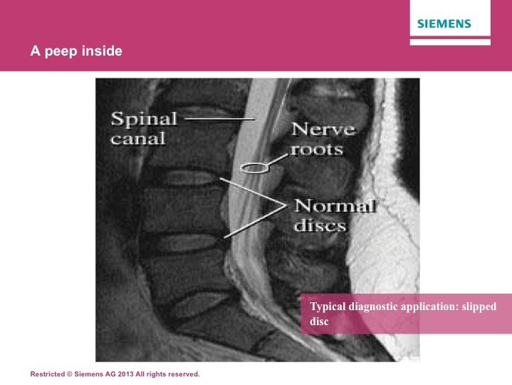
Learning activities

Refer to Supporting Lesson Plan PPT for images

1. Show a typical MRI scan (such as the one of the lower vertebrae on Slide 16). Draw attention to the key features, and ensure that students understand what they are looking at. The use of a model skeleton or large poster may be of assistance. Draw attention to the way in which the MRI scan delineates between various features.

2. Then show a corresponding scan with a medical condition (such as the one of the slipped disc on Slide 17). Draw attention to the way in which the
nature of the condition can be identified from this. Ask students to suggest why this is useful and draw out points such as identifying which disc, the extent of the prolapse and
the proximity to other tissues.

3. Another example is shown in Slide 18. This shows one of the advantages of MRI scanning
– that of images from any plane being possible. This is the cross section through a wrist; the captions indicate the key features a doctor would look for in the case of a suspected sprain.

Outcomes
• Identify benefits offered by MRI scans.

Consolidating understanding

Introduction
This session is to provide students with the opportunity to express their understanding in ways that might be
required by an examiner.

Learning objectives:
• To identify key points around the imaging process
• To express those in the form of an exam question response.

Learning activities

1. Start by asking students to summarise key points about the way that MRI scanners work.
They may use bullet points or diagrams if this helps; the purpose is to recall and identify key features.

2. Then present students with the sample assessment task (Slide 19). If they are unused to these, spend a few minutes discussing what is being expected and how they might structure an answer.

3. Ask students to attempt the task.

4. Provide mark sheet and ask them to peer assess their work.

Outcomes
• Students will have consolidated their understanding of MRI imaging by identifying key points and processes.
• Students will have produced quality responses to asessment tasks.

Expected answers | Additional guidance
[Level 3]  Answer correctly describes the processes of stimulating hydrogen nuclei and causing the energy to be released so that images can be formed. All information in answer is elevant, clear, organized and presented in a structured and coherent format. Specialist terms are used appropriately. Few, if any, errors in grammar, punctuation and spelling. (5-6 marks)  [Level 2]  Answer may name some processes rather than describing them, and/or may not make the correct order clear. For the most part the information is relevant and presented in a structured and coherent format. Specialist terms are used for the most part appropriately. There are occasional errors in grammar, punctuation and spelling. (3-4 marks)  [Level 1]  An incomplete answer, naming some processes without describing them and omitting other processes. Answer may be simplistic. There may be limited use of specialist terms. Errors  of grammar, punctuation and spelling prevent communication of the science. (1-2 marks)  [Level 0]  Insufficient or irrelevant science. Answer not worthy of credit. (0 marks) | Answers may make use of some or all of the following points:  • Hydrogen is present in the body in a number of substances including water and fats.  • MRI scanners have powerful magnets.  • In a magnetic field hydrogen nuclei are strongly aligned, north or south.  • Most nuclei are balanced by one orientated the opposite way but a few are unmatched.  • RF coils produce radio waves which make unmatched nuclei spin in the opposite direction.  • When the RF coils are switched off, these nuclei revert to their previous position, emitting energy.  • This energy is detected and used to form an image.

