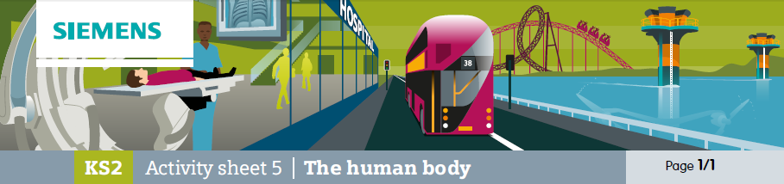

Arteries, Veins and capillaries

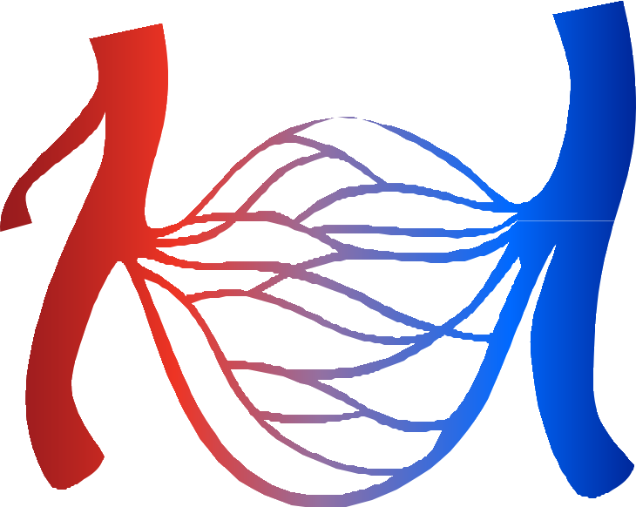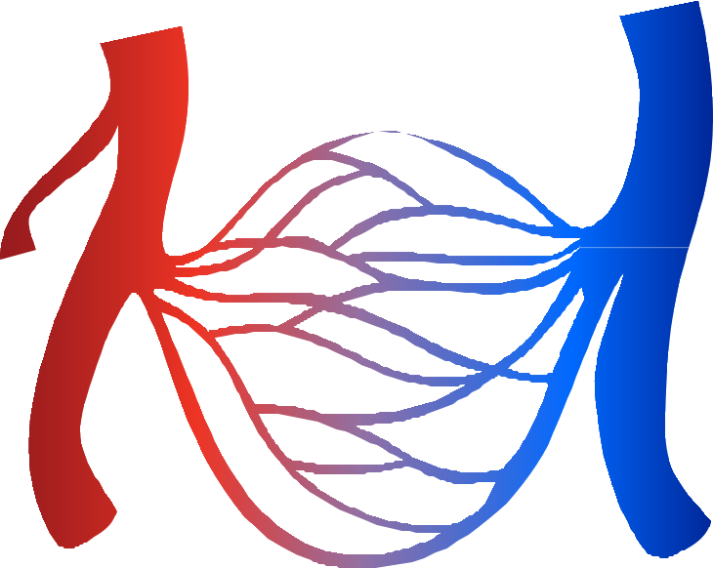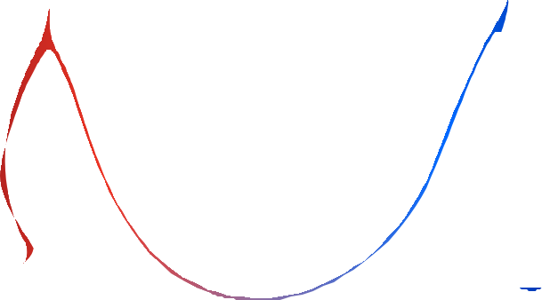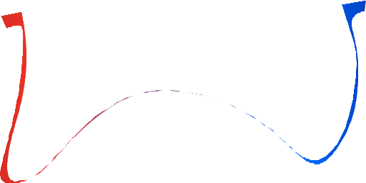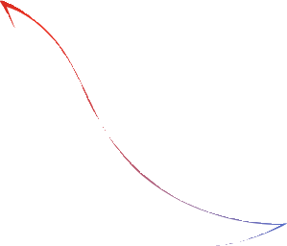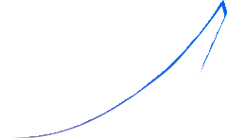In this activity you’re going to be looking at some of the ideas you’ve met already about arteries, veins and capillaries. This diagram shows these different types of vessels. On the left is a list of the types of blood vessels and on the right some statements. See if you can match these up with the diagram.

arteries veins capillaries
• Return blood back to the heart

• Narrow vessels that allow chemicals to leave and enter the blood

• Carry blood out from the heart

• You could feel a pulse in this vessel

• These vessels have valves to make sure the blood flows in the right direction

• These vessels have thick muscular walls

