11A Analysing the forces on a car

This car is standing still on a firm level surface. There are two forces acting upon it, weight and a reaction force from the ground (the ground being capable of supporting the weight of the car).

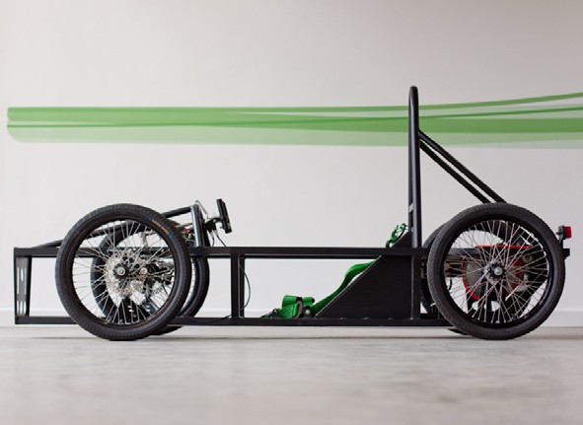1) Draw in those two forces, showing the directions they are acting in.

2) The car isn’t moving: compare the forces in terms of size and direction.

11A Analysing the forces on a car

This car is travelling forwards along a level road at a steady speed and in a straight line. Various forces are acting upon it.

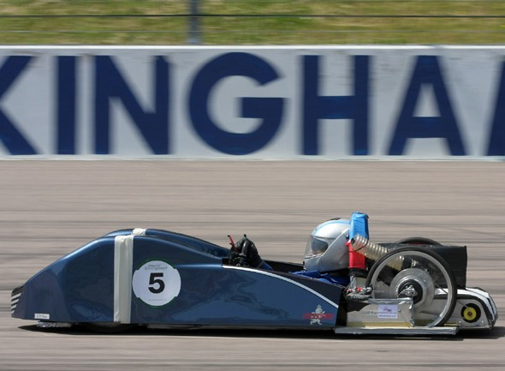1) Draw and label arrows on the picture to show the direction of:
a. The force due to the motor b. Weight
c. Air resistance
d. Friction in the moving parts
e. Reaction force from the ground (the ground being strong enough to support it).
2) Think about the size and direction of the forces.

a. Compare the weight and the reaction force. b. Compare the force due to the motor,
driving it forwards, with the forces due to air resistance and friction (remember the car is travelling at a steady speed).
c. Think about the forces in Part B. If you wanted the car to travel faster what could you do to the size of those forces?

11A Analysing the forces on a car

This car is accelerating – it is speeding up.

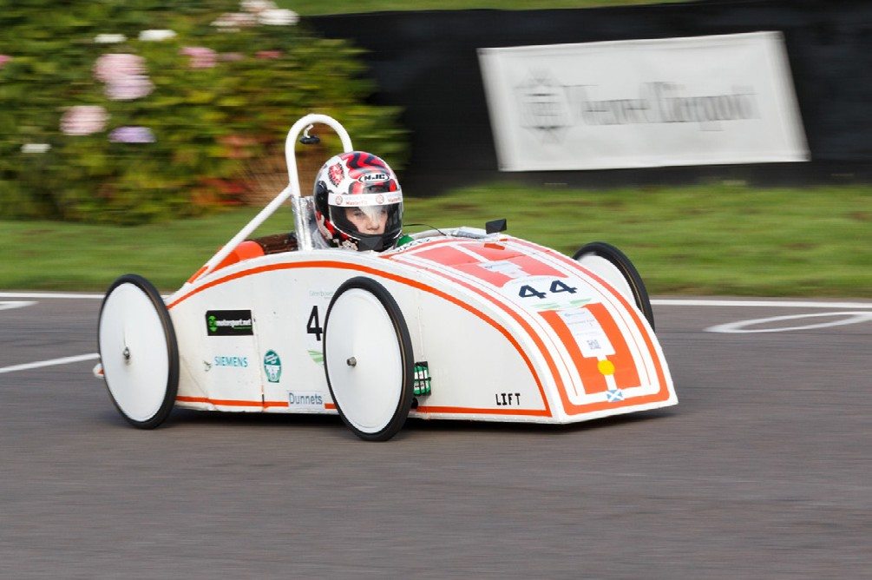1) What can you say about the size of the force from the engine compared with the size of the forces from friction and air resistance if its speed is increasing?

2) What might the designers have done to enable it to travel at a higher speed (remember that all Greenpower Challenge cars have the same size motors)?

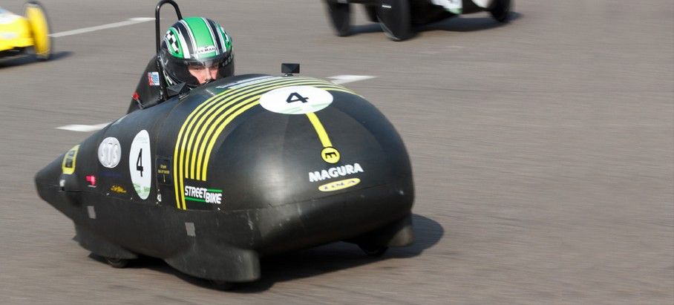

Energy can be transferred from one place to another.
11B
Thinking about energy
Engineers and scientists have to understand how to manage those transfers in order to make best use of it.

Greenpower Challenge cars have energy transferred to them by the batteries being charged up. As the car moves, so the batteries run down. Some of the energy used as

Designing for energy efficiency
the car moves is put to good use; some of it is wasted.

Look at this list of ways in which energy is transferred from the battery:
• Sound from moving parts
• Heat in the motor and wiring
• Moving the car along the racetrack
• Pushing air in front of the car out of the way
• Heat in moving parts, such as axles

1) Divide these into two lists, useful and wasteful.

2) For each of the wasteful ones, suggest ways in which they could be reduced.

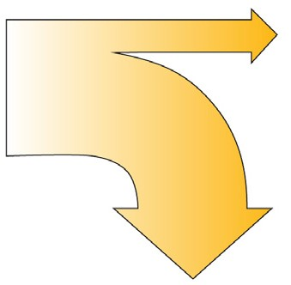
Sankey diagram
A useful way of showing energy transfers in a system (such as a car) is to use a diagram called ‘Sankey’ diagram.

The input on the left is the total energy supplied (in this case the energy in the fully charged batteries). The useful output is shown horizontally, top right. The wasted output is shown vertically, lower right. Either of the outputs can be split into separate arrows if there is more than one. (If we knew the amount of energy we could show this by the width of the arrows but we don’t in this case).

3) Draw a ‘Sankey’ diagram to show the energy being supplied by the batteries, the useful output(s) and the wasted output(s). Use your answers from Q2 to guide you.

Total energy in

Useful energy out

4) Remember that the width of the arrows indicates the amount of energy. What does the ‘Sankey’ diagram look like for a less wasteful system?

5) Look at the Greenpower car in the illustration. What steps have the designers taken to make their car more efficient?

Wasted energy out

