Clean silent trains

• Think about these four ways of improving rail services in Britain
• Put the four ideas in order of importance, with the one you think is the best idea at the top
and the others in order after it.
• Think about why you’ve put these in the order that you have – you should be able to explain
why you think that some of the ideas are better than others.

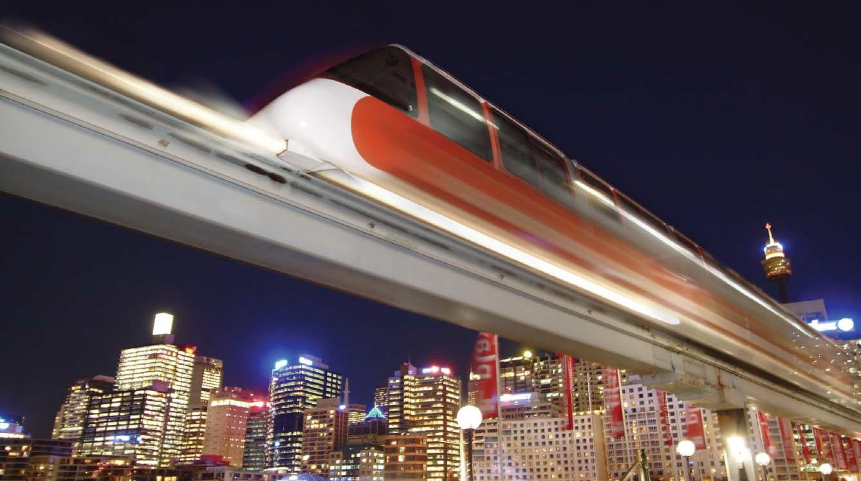Idea 1: MagLev

Explain that MagLev, or magnetic levitation, trains use magnetic fields for support.

If possible use a pair of magnets with ‘like poles’ facing, so that they repel (a particularly effective demonstration is if you can get donut shaped magnets on a pole with like poles facing so the upper one is ‘hovering’).

Explain that this means there is no friction, so the ride is very smooth and it takes little force to move the train along. MagLev trains have been tested in several different countries and one system ran at Birmingham Airport for eleven years. Explain that the advantages of Maglev trains include a smooth ride, low fuel requirements and the potential of high speed services. However they need a special track, and any existing routes need to be converted before MagLev trains can run on.

Clean silent trains

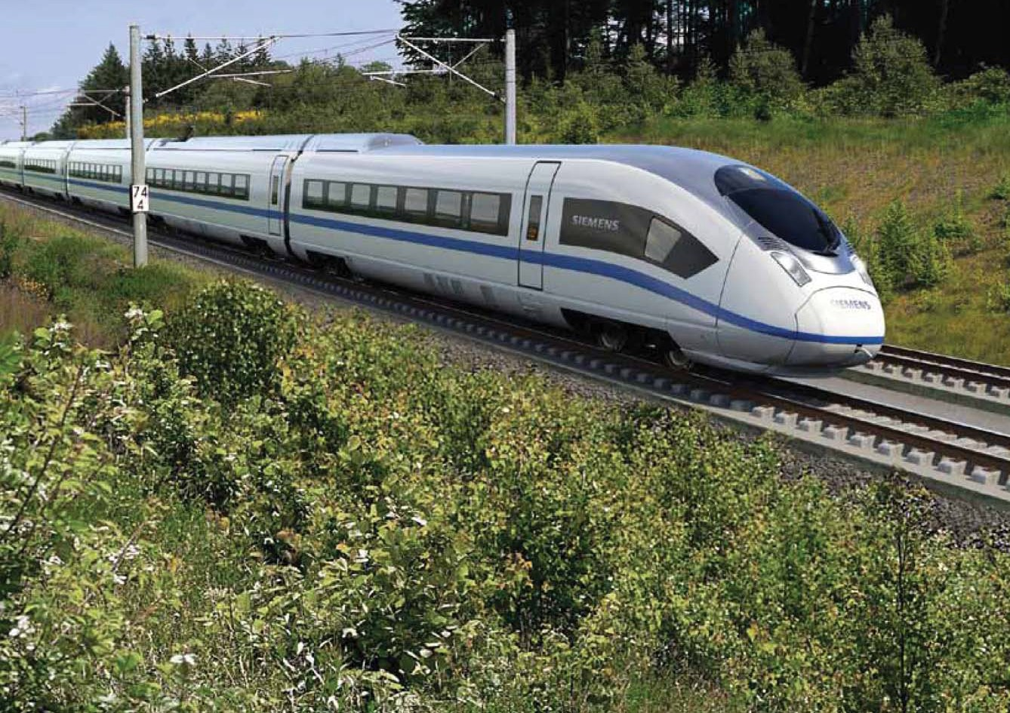Idea 2: High Speed Trains

The 125mph trains running in Britain are slow compared with the services in some other countries.

The French TGV trains (now running into other European countries) and the Japanese shinkansen (Bullet trains) regularly reach 200mph, now being matched by Chinese services.

The HS2 (High Speed 2) project is intended to link
London with first Birmingham and then cities in the
North of England, including Leeds and Manchester,
with trains running at 200mph. The intention is for
over half of the line to be in tunnels or cuttings to
avoid affecting existing buildings and spoiling views.
The line would provide a fast and reliable link between major cities and release pressure on crowded lines. However it will be tremendously expensive to build; it has been argued that cutting 20 to 30 minutes from existing journeys isn’t good value.

Clean silent trains

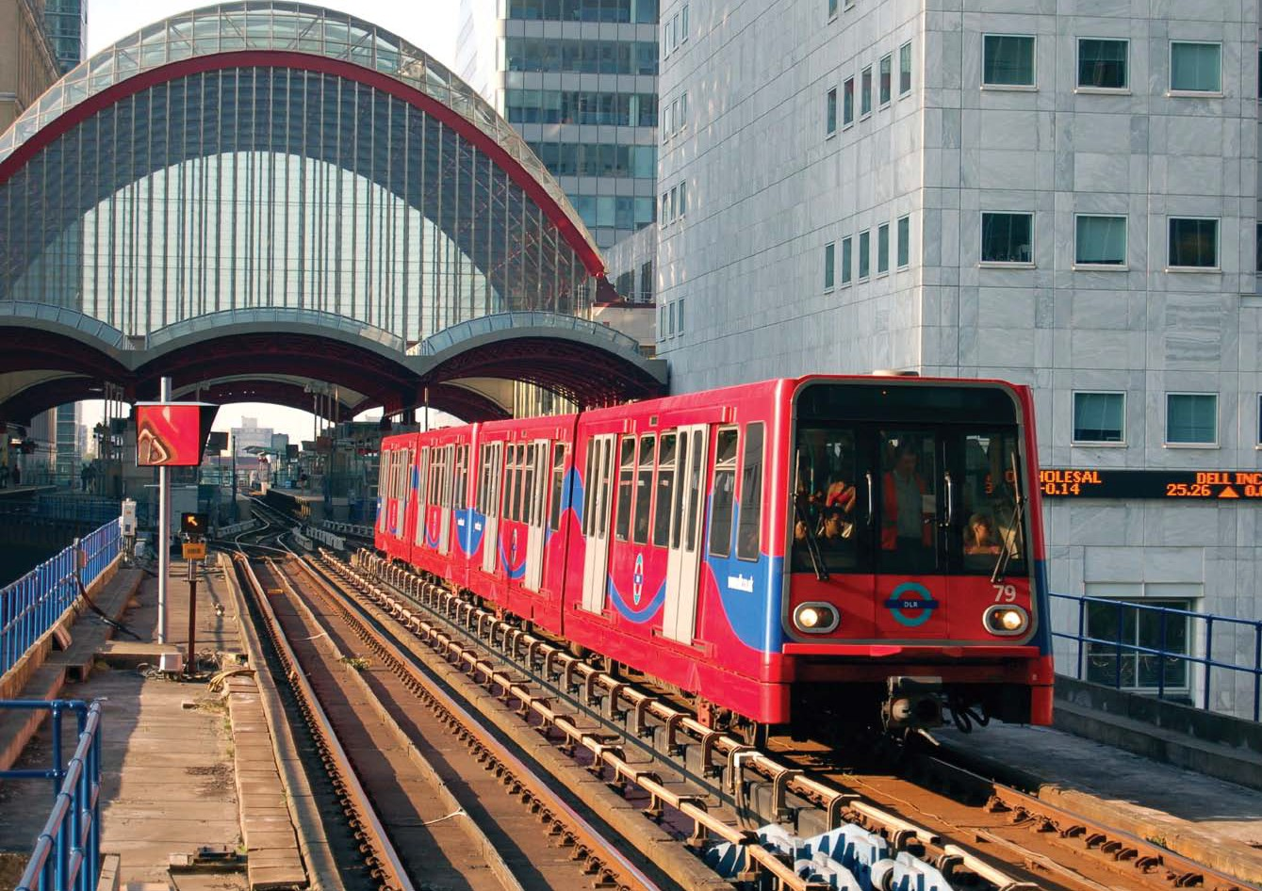Idea 3: Driverless trains

Explain that Britain already has trains that don’t need drivers.

Driverless trains (or Automatic Train Operation) are used in urban areas where there are trains arriving every few minutes and the speeds are relatively low. The trains are controlled by a centralized computer system, which makes sure that the system is safe runs as quickly as possible and at a low cost.

Driverless trains are a good way of making sure that a complicated system with lots of trains runs quickly and smoothly. However some driverless systems still use train crews to control doors and ensure safety. They may not be as suitable for long distance high speed services yet.

Clean silent trains

Idea 4: Street trams

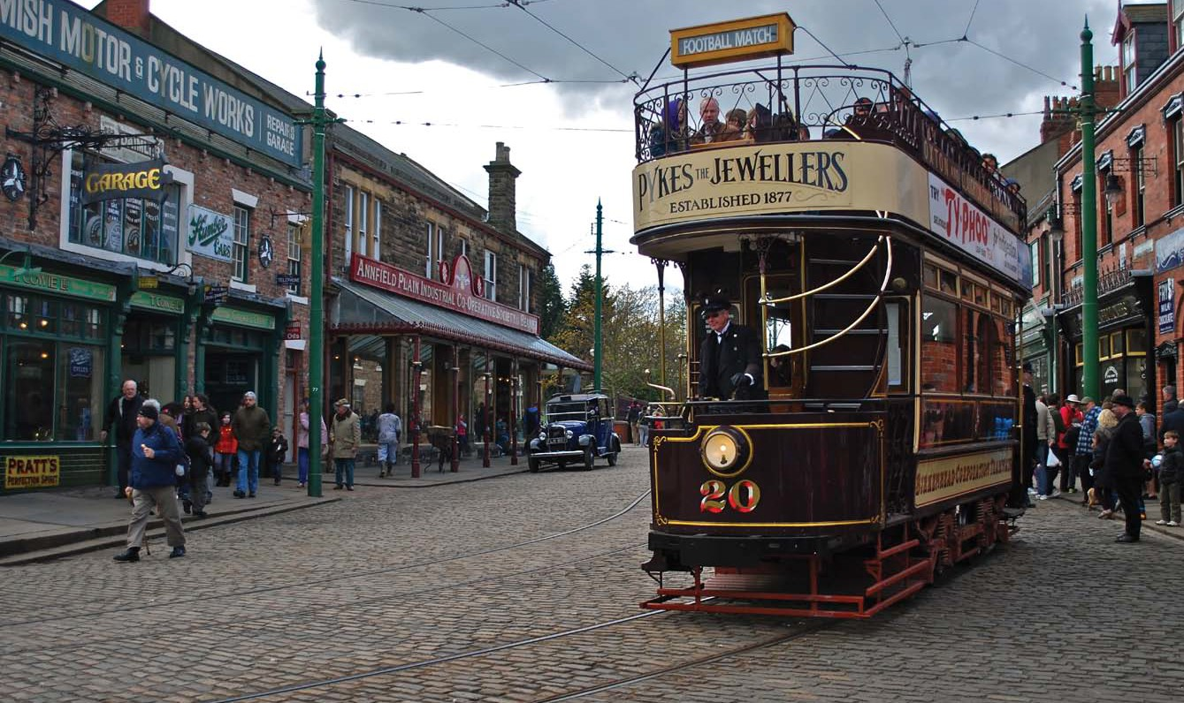A hundred years ago, most cities had tram systems

These were gradually replaced with buses and trains until only one was left (in Blackpool). However they have been returning in a modern form to places such as Manchester, Sheffield, Newcastle and South London.

Trams provide a convenient service
through the streets with stops in
convenient places. They can connect
suburbs with places in the city centre,
enabling people to travel into places
of work or leisure without having to
change from one form of transport
to another.

Trams provide a good way of linking
parts of a city to each other and to
the suburbs. However the routes are
more expensive to build than bus
services are to provide and they
can’t completely avoid congestion
in city centres.

