Exploring the body

Exploring Support

One of the functions of the skeleton is to provide support. In this activity you’re going to be finding out how a structure can support a load effectively.

Resources required:
a tennis ball (or similar)
ten sheets of A4 paper (recycled is ﬁne)
a metre of sellotape

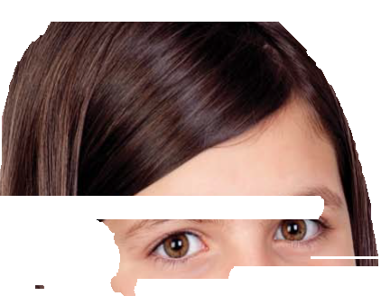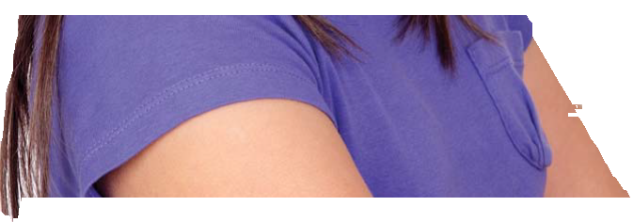You will need to work in a small team. Your team will be provided with the resources listed above. These can be varied but should be the same for all teams.

1. Your task is to design and construct a structure that will support the ball as high above the table top as possible. The structure should be stable and may not be fixed to the table.
• What kind of structure do you think will work well?
• How can you use the materials to produce something strong?

• How can you make it stable?

2. When you’ve made a structure, the class can then test and compare them.
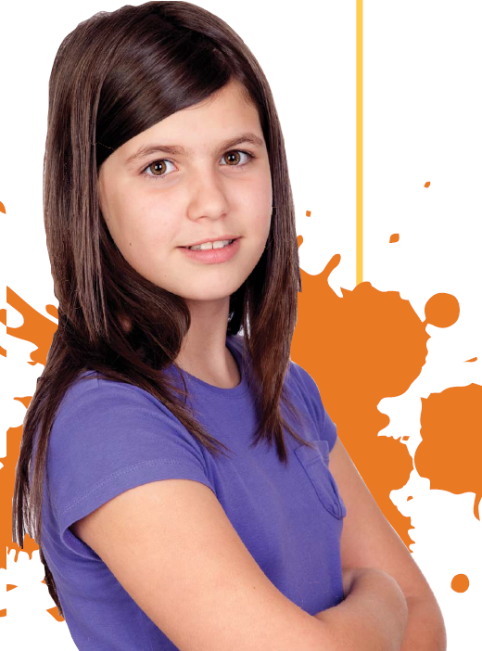
• Look at the structures that were more successful - what seemed to be true about them? What features did they have that worked well?

• Did they use tubes?

• Was the structure broader at the top where it supports the ball?

• How was it made stable?

3. Now look at pictures of a skeleton and identify what makes bones such as legs, pelvis and backbone effective at support. Think about these features:
• Tubular structure (such as the backbone) being light and strong

• Broader structure (such as pelvis and feet) providing stability

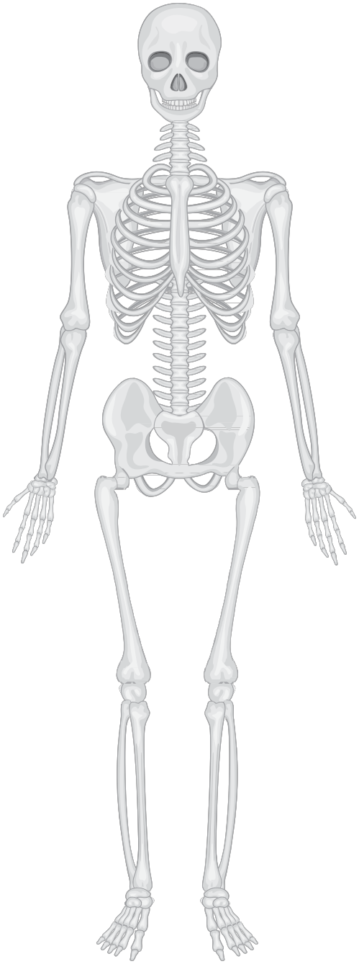The human skeleton

? Extension:
Is building a structure like this a good way of seeing how a skeleton provides support?

• In which ways was your structure trying to do the same thing as a skeleton does in supporting a weight?

• In which ways was your structure not working as a skeleton does?

