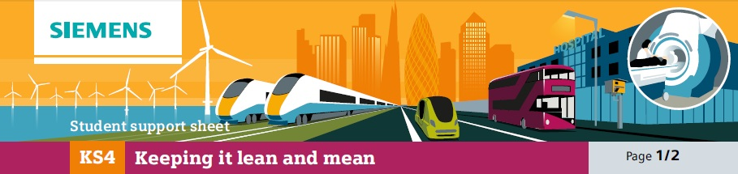

16A Kitchen design

What is good and what is less effective about this plan?

Option A
 | Cooker | Fridge | Dishwasher | Storage for knives  & cooking utensils | Cupboard for ingredients
Floor plan of kitchen |  |  |  |  | Sink & draining board
 |  |  |  |  | Work surface with chopping board
Crockery
Storage

What is good and what is less effective about this plan?

Option B
 | Cooker | Cupboard for ingredience | Dishwasher | Crockery  Storage | Storage for knives  & cooking utensils
Floor plan of kitchen |  |  |  |  | Sink & draining board
 |  |  |  |  | Work surface with chopping board
 |  |  |  |  | Fridge

What is good and what is less effective about this plan?

Option C
 | Sink & draining board | Fridge | Dishwasher | Cooker | Cupboard for ingredients
Floor plan of kitchen |  |  |  |  | Sink & draining board
 |  |  |  |  | Work surface with chopping board
Crockery
Storage

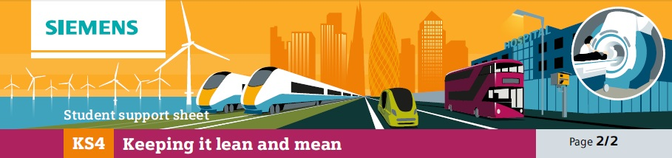
KS4

16B Planning the torch assembly

Processes in the assembly line sequence.

Inserting bulb

Putting adhesive label on the side
Inserting batteries Screwing battery cover on Screwing bulb cover on
✁

Now devise:
• Three assembly sequences that would work
• Three assembly sequences that wouldn’t work

• From the three that would work, why one might be slightly better than the others

