The railway timetable

Volk’s Electric Railway

Part 1: single track

When Volk’s electric railway first opened the track plan was like this:

Aquarium Station Half Way Station Black Rock Station

The railway line is only single track, so trains can’t get past each other. This diagram shows the track plan.

Remember it takes 12 minutes (in dry weather) for the train to get from one end to the other. However, you also need to allow 3 minutes for passengers to get off and more to get on. The train can’t come in and go straight out again.

The manager wants you to write a timetable for the line, showing when the trains are departing from each station. It’s a busy day so they want as many departures as possible.

Train departs Aquarium Station at: | 10.00
Train departs Black Rock Station at:

The railway timetable

Volk’s Electric railway

Part 2: sidings

Aquarium Station Half Way Station Black Rock Station

The railway has now been developed by having three trains and putting in a siding at each of the terminus stations. This means that one train can arrive on one side of the platform to unload passengers, whilst another train, loaded up, can leave from the other side.

As soon as one train arrives, another one goes. How does the timetable look now?

Train departs Aquarium Station at: | 10.00
Train departs Black Rock Station at:

The railway timetable

Part 3: Passing loop

The railway has now been modified, to have a ‘passing loop’ in the centre. This means that two trains, travelling in opposite directions, can pass each other. Remember they take 12 minutes to travel the length of the line and 3 to unload and reload.

The track plan of the railway is like this:

Aquarium Station Half Way Station Black Rock Station

The manager wants you to write a new timetable, showing when the trains are departing from each station. It’s another busy day so they want as many departures as possible.

Train departs Aquarium Station at: | 10.00
Train departs Black Rock Station at:

Is this a better arrangement? What difference has it made to:

• How often trains depart from each station?

• The number of people the railway can carry?

The railway timetable
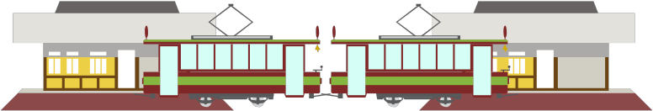

Part 4: Single track and two coaches

Problems with the timetable.

The manager is pleased that more passengers are being carried but finds that more staff are having to be employed. The line now has two drivers instead of one and a signal operator to control the passing loop. On the other hand having two trains means more passengers, which is good.

The manager decides to experiment with a different arrangement. The railway is going to go back to a single line but use two trains coupled together (so they only need one driver):

Aquarium Station Half Way Station Black Rock Station

What difference will this make to:

• The number of staff needed?

• The number of passengers carried?

• How often trains leave each station? (Draw out a timetable and compare it with one for the line with the passing loop)

Train departs Aquarium Station at: | 10.00
Train departs Black Rock Station at:

Is this a better arrangement or not as good?

