Scheme of Work 4

**I can see clearly now**

Page 1/7

**Overall learning objectives**

• To gather and use data to construct Sankey diagrams to illustrate efficiencies and support conclusions.

• To explain how light bulbs can transfer energy and the concepts behind different light bulb technologies, and to use ideas about reflection to design a flood light reflector.

• To evaluate the impact of different technologies on society and different technological approaches to a challenge.

• To conduct cost benefit analysis and evaluate different solutions using set criteria

**Overall learning outcomes**

• Students will have analysed two different sorts of bulb in terms of how they work and how energy efficient they are.

• Students will have used ideas about reflectors to design and test one of their own to meet a particular brief.

• Students will have decided how to apply multiple success criteria.

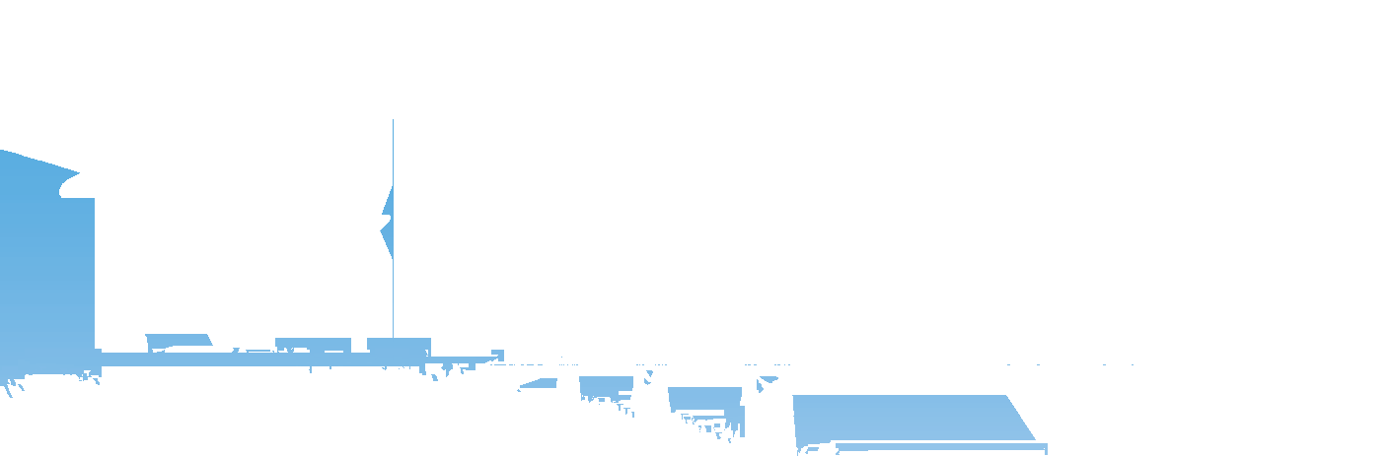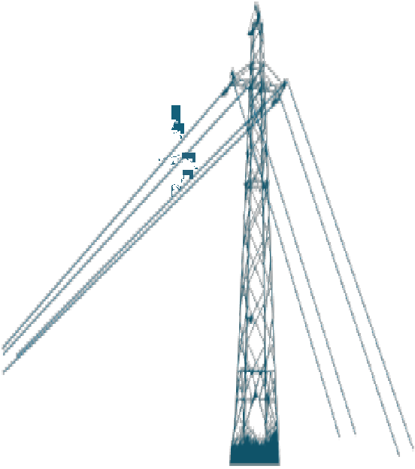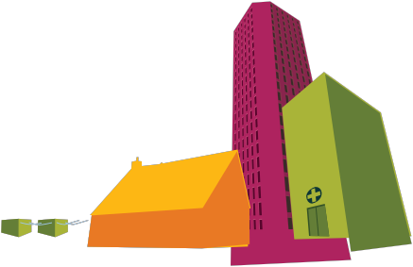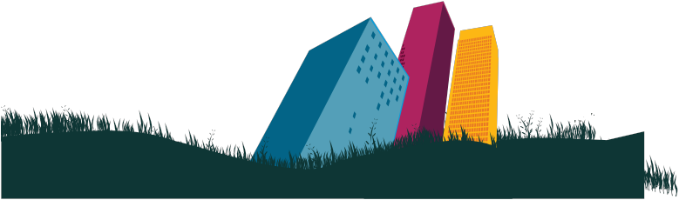

**Curriculum learning objectives**

**Students should be able to: Maths**

• Apply suitable mathematics accurately within the classroom and beyond, and use existing mathematical knowledge to create solutions to unfamiliar problems.

• Understand that mathematics is used as a tool in a wide range of contexts, identify the mathematical aspects of a situation or problem and select mathematical information, methods and tools to use.

• Work logically towards results and solutions, recognising the impact of constraints and assumptions.

• Make accurate mathematically diagrams, graphs and constructions on paper and on screen, and communicate findings effectively.

**Science**

• Assess risk and work safely in the laboratory, field and workplace, plan and carry out practical and investigative activities, both individually and in groups.

• Obtain, record and analyse data from a wide range of primary and secondary sources, including ICT sources, and use their findings to provide evidence for scientific explanations.

**Technology**

• Apply knowledge of materials and production processes to design products and produce practical solutions that are relevant and fit for purpose.

• Understand that products and systems have an impact on quality of life.

• Make links between principles of good design, existing solutions and technological knowledge to develop innovative products and processes.

• Analyse existing products and solutions to inform design and process.

• Respond creatively to briefs, developing their own proposals and producing specifications for products to solve technical problems.

Episode 1 **I can see clearly now**

Page 2/7



**Introduction**

This episode is designed to set the scene and place the topic in a social as well as technical context.

This topic is about the effective use of low energy light bulbs and how they have enabled the waterfront

at Durban in South Africa to be transformed. The first episode sets the scene by showing how lighting is not

only a technical process but has a social impact too. It then presents students with the challenge of finding the best way of producing cheap and even illumination over an area.

**Learning objectives**

• Students will understand how technical developments such as lighting can have a significant social impact.

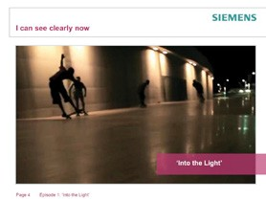

**Learning activities**

**1. Explain that this topic is about lighting and how cost-effective lighting can be used to change areas and how people use them.**

**2. Show the video “Into the Light” and ask students to consider these questions:**

a) Why did the installation of lighting transform the area?

b) Why did low energy lighting make it more cost effective?

c) What is special about low energy lights?

**3. Ask students to talk about whether they use low energy light bulbs at home, and what the advantages and disadvantages are.**

**4. Explain that their challenge in this topic is to plan and produce a reflector and supporting information for the design of cheap and even illumination.**

Outcomes

• Students will be able to describe the importance and impact of low energy lighting.

Episode 2 **I can see clearly now**

Page 3/7

**Introduction**

The purpose of this episode is to familiarize students with the technology behind filament and low energy light bulbs.

**Learning objectives**

**Additional resources required**

• Filament light bulb

• Low energy light bulb

• Students will be able to explain how both filament and low energy light bulbs work.

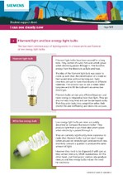

**Learning activities**

**1. Explain to students that the two most common ways of lighting rooms in a house are to use either filament or low energy light bulbs. Say that both of these transfer energy from a flow of current to heat and light. However the amount of current used, the amount of heat released and the life expectancy are quite different for the same amount of usage.**

**2. Show the students a filament light bulb. Ideally use a clear bulb**

**so that the filament is clearly visible. Explain that as current flows through the fine wire it glows. Use student support sheet 4, to provide reinforcing information.**

**3. Then show students a low energy light bulb. Ideally this should emit a**

**similar amount of light to the filament bulb. Support the explanation with the use of student support sheet 4 and a simple demonstration.**

**4. Explain that low energy bulbs have been introduced because although they were initially more expensive and the early ones didn’t get to full brightness immediately, they produce less heat for the same amount of time being used and last longer.**

Outcomes

• Students can explain the difference in operation between filament and low energy bulbs and why there has been a switch to the latter.

Episode 3 **I can see clearly now**

Page 4/7

**Investigate**

In this episode you will demonstrate comparison, using a power meter to compare energy consumption and a light meter to compare effect.

The purpose of this episode is to make it clear how the energy transfers between the two types of bulbs differ in their proportions and how the transfers can be represented graphically by using Sankey diagrams.

**Additional resources required**

• A power meter

• A light meter

• Selected appliances

• Filament light bulb

• Low energy lightbulb



**Learning objectives**

• Students will be able to compare the relative proportions of light and heat released by different types of bulbs.

• Students will be able to represent energy transfers quantitatively using Sankey diagrams.

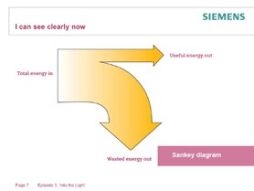

**Learning activities**

**1. Explain that the purpose of this activity is to compare how efficiently each type of bulb transfers energy from electricity to light. Say that you will also be showing how this can be usefully communicated using a special kind of diagram called a ‘Sankey’ diagram.**

**2. Show how you can use a power meter to display the amount of power any mains appliance uses (you may want to have some other appliances for the sake of comparison) and that you are going to use it with two bulbs (one filament and one low energy).**

**Explain that you chose the bulbs to be similar in terms of light intensity; you could demonstrate this by dimming other lights in the room and using a light meter to measure the light output from a set distance. If it is difficult to match the bulbs in terms of light intensity, select a low energy bulb that has a slightly higher light output (it will still have a much lower input). Using the light meter is a useful introduction to that piece of equipment for later in the topic.**

**3. Measure and display the power used by each of the bulbs in watts. Ask students to comment on the difference. Explain that 1 watt of power indicates that 1 joule of energy is being transferred every second.**

**4. Explain how we can show the amounts of energy being supplied to a device and released from it by using a Sankey diagram. Explain that:**

a) The width of the arrows is related to the amounts of energy. b) Total energy input equals total energy output.

c) The input is shown on the left and the output(s) on the right.

d) The useful output is shown by a horizontal arrow and the wasted output by an arrow on the right curving downwards.

**5. Explain that a typical filament bulb is around 10% efficient, so 10% of the output is light and shown horizontal; 90% is wasted as heat. Say that a typical low energy bulb is 75% efficient so 75% of the output is light and shown horizontal; 25% is wasted as heat.**

Episode 3 **I can see clearly now**

Page 5/7



**Learning activities cont’d.**

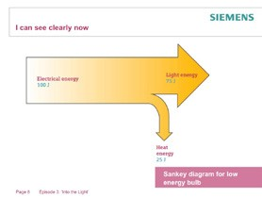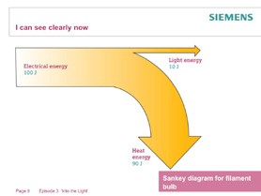

**6. Now ask students to work in groups to draw the Sankey diagrams for a filament bulb and a low energy bulb, each releasing 10J of light per second (using the efficiencies given above).**

**7. Take feedback. Draw out responses and show that the filament bulb will be releasing 90J of heat per second and using 100J/s. Explain that the low energy bulb will be releasing 3.3J of heat per second and using 13.3J/s. If these are drawn to the same scale they will indicate quite clearly the difference in energy usage.**

**8. Point out that bulbs also use energy in their manufacture and cost money to buy so the life expectancy of the bulbs is important. Low energy bulbs last, on average, around eight times longer than filament bulbs.**

**9. However, it is also important to say that the term ‘wasted energy’ is a value judgement. Ask students to consider whether this is true. Take feedback and draw out that the bulbs are sometimes specifically used as a heat source (such as keeping newly hatched chicks warm) and sometimes generally add to heating, such as in a house on a cold evening. It could be argued that they are then more efficient as more of the output is useful.**

Outcomes

• Students understand how the efficiency of the bulbs compare.

• Students know how to display the energy transfers quantitatively using a Sankey diagram.

Episode 4 **I can see clearly now**

Page 6/7



**Solutions**

Students work in groups, generating ideas and using materials to devise a practical solution to design a reflector for a bulb that will produce most even illumination over a stipulated area with the bulb at a stipulated height.

**Learning objectives**

• Students will apply ideas about reflection to design a reflector.

• Students will be able to explain the ideas behind their design and how it is intended to succeed.

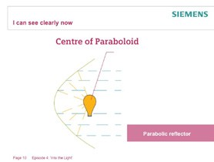

**Learning activities**

**1. Explain to students that the purpose of this activity is for them to design a reflector for a low energy bulb to produce as strong and even as an illumination as possible. They will be able to research their ideas, construct them and test them.**

**2. Explain that the brief is to reflect light from a low energy bulb down onto an area, in the way that a floodlight works. The bulb will be suspended 1m above the bench and the illumination has to be**

**as even as possible over a circle, 1m in diameter.**

**3. Encourage students to research designs for reflectors. They might look at designs for car headlamps, satellite dishes, torches, etc.**

**4. Students should then make their design. There will need to be clear guidelines about how it is**

**to be attached to the bulb holder, the materials and the proximity to the lamp; this is, of course, part of the design process.**

Outcomes

• Students will have used ideas from the topic and their own research to design and construct a reflector.

Episode 5 **I can see clearly now**

Page 7/7



**Evaluate**

Designs to be tested and peer assessed.

The purpose of this episode is not only to test designs but also to explore the use of success criteria. The brief was to produce illumination that is not only large in size but also even.

**Learning objectives**

• Students will explore the use of success criteria to judge the effectiveness of a design.

• Students will test a design to determine the extent to which it meets the criteria.

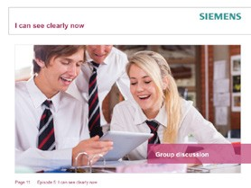

**Learning activities**

**1. Explore with students the idea that with the success criteria calling for strong and even illumination, that both of these need to be**

**taken into account to identify the most effective design. Ask students to consider what might happen if one or the other was effectively ignored. Students may suggest solutions; one would be to take light meter readings at various points in the circle and average them to get an overall score.**

**2. The various designs should be tested and judged.**

**3. Students should be asked to critically appraise their designs, to identify the strengths and the areas for development. There is an opportunity for peer assessment here as well.**

Outcomes

• Students will have decided how to apply multiple success criteria to judge a successful outcome.

• They will have evaluated their own design.