Levers and Gears homework sheet

Levers
What class of lever is an oar on a rowboat? | 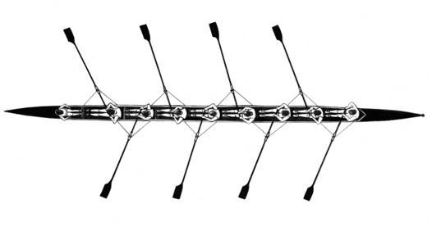
What class of lever is a bicycle hand brake? | 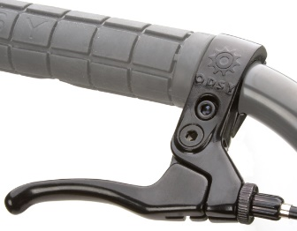
What class of lever is a human arm? | 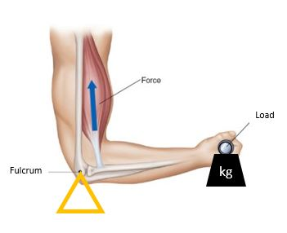
What class of lever is a bottle opener? | 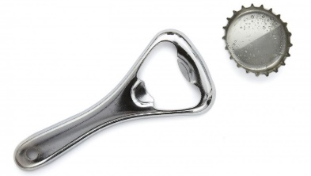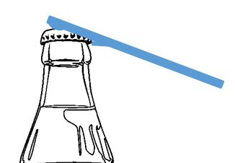
What class of lever is a stapler remover? | 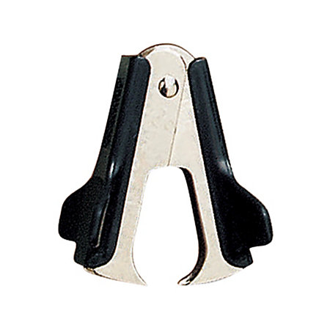

Gears
Gear A is rotating clockwise. In which direction with Gears B and C rotate? | 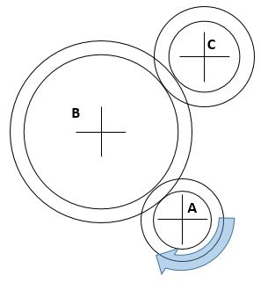
Gear A is rotating clockwise. In which directions will the other gears rotate? | 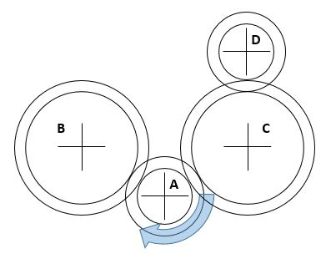
What’s the gear ratio between Gear A and Gear B?  What’s the gear ratio between Gear C and Gear D?  How many times does Gear A have to turn to result in Gear D competing one revolution  If the Driver gear (A) is rotating anti-clockwise which direction is gear D rotating | 