Student support sheet

Water, water, everywhere

Page 1/1

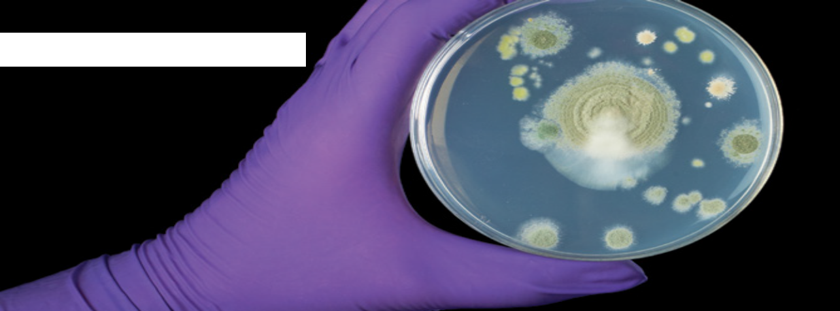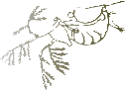3 Finding and growing microbes

Microorganisms live in water

Microbes, often too small to be seen by the naked eye, are found everywhere.
Millions can be found in just one litre of pond water!
Growing bacteria from pond water
Procedure:
1. Take one agar plate. Choose a suitable place to leave it open to the air.
• Label the base with your name, the date and the place.
• Take the lid off the dish and keep it open until the end of the lesson.
• Replace the lid at the end of the lesson.

2. Label another agar plate with your name, the date and ‘pond water’.
• Shake your bottle of pond water to mix the contents.
• Remove the top, flame the neck in the Bunsen burner and draw up a small amount of water with a dropping pipette.
• Flame the neck again and replace the top.
• Lift the lid of the dish and dispense 2 or 3 drops on to the surface of the agar.
• Discard pipette and spreader into the beaker of disinfectant.

Adapted from “Microbes all around us” (Nuffield Foundation and Society of Biology)
and ‘Finding and growing microbes’ (Society for General Microbiology) as published
at www.nuffieldfoundation.org/practical-biology/microbes-all-around-us Scheme of work –episode 3

