10A Measurement of loudness

Think of a sound and then suggest where this will fit on the graph. Draw lines to show where these should be.

Conversation
 | 180
 | 170
 | 160
 | 150
 | 140
Pain threshold | 130
 | 120
 | 110
 | 100
 | 90
 | 80
 | 70
 | 60
 | 50
 | 40
 | 30
 | 20
 | 10
Hearing threshold | 0

Rock concert

Startup of a jet airplane
(100 meters away)
dB HL

In the woods

Compressed air hammer

Firecracker

Road traffic

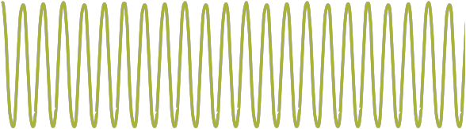

10B Measuring waveforms

Make a line to match waveforms and their frequency.

160Hz 84Hz 120Hz 300Hz

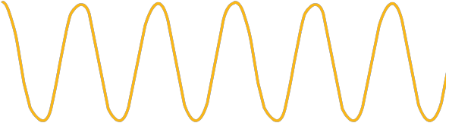

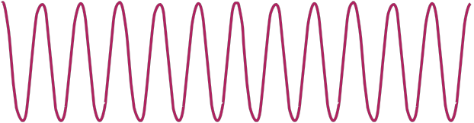

10C Activity sheet on loudness and frequency

This graph shows how sounds compare in terms of intensity and frequency. Consider the groups of vowels and consonants and decide whether they are lower or higher frequency.

Soft
Right ear

Degree of hearing loss

0

20
m d b n
l

i p g
k

f s h t

Mild

Intensity
40

60

80

100
u a e r

Vowels

sch
Consonants

Moderate
Intensity

Severe

Profound

Loud
125

125

Low

250 500 1K 2K 4K 8K Hz

High
Frequency

