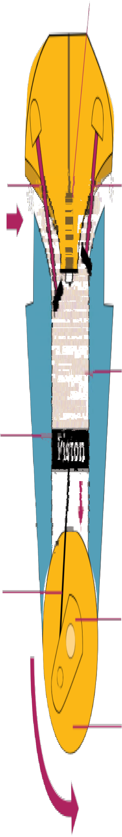2A Finding out about petrol generators

How a petrol engine works

Spark plug

Intake valve
Exhaust valve

Cylinder
Petrol vapour and air mixture
t
P
n
o
is

Piston rod

Crank shaft

Wheel

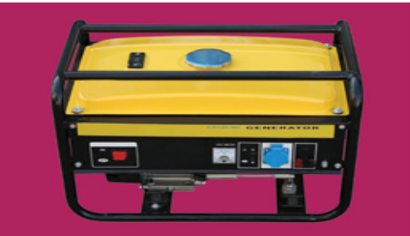Petrol generators come in a wide range of sizes, depending upon the amount of electricity to be generated.

Portable petrol generator
Small petrol generators are highly portable and all of them are reliable. They can be started up and shut down quickly so they can respond rapidly to needs. However they produce a range of pollutants such as carbon dioxide, sulphur dioxide and nitrous oxides.

Portable petrol generators consist of two main components.
• There is a petrol engine; this is a type of internal combustion engine in which petrol vapour is mixed with air and ignited inside a cylinder. The rapid combustion forces the piston down the cylinder, turning the crankshaft. The energy has been transferred from the fuel to the crankshaft which
is now spinning.

• There is a generator; This is driven by the crankshaft and consists of magnets and coils of wire. When turned it produces electricity.

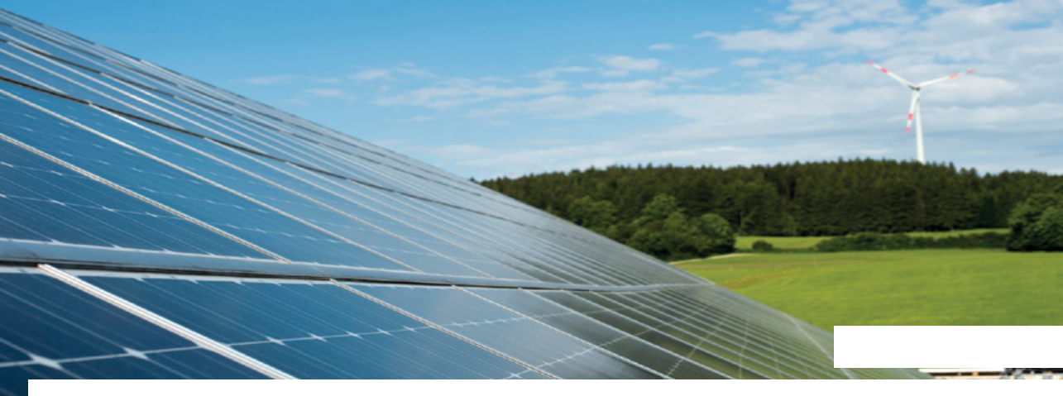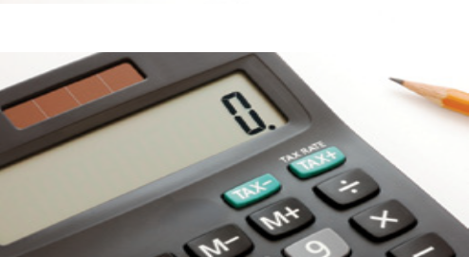2B Finding out about solar Cells

Solar cells, photovoltaics, transfer energy from sunlight directly to electricity. They are not to be confused with solar panels, which transfer energy from sunlight to water, raising its temperature.

Photovoltaics

Solar powered calculator

Solar cells have the obvious advantage that they eliminate the need for fuel to be purchased. They have long been used where low weight
and portability are important, such as in pocket calculators or in isolated locations.

However, more recently, price reductions mean that they can compete in larger scale applications. In some parts of the world, such as Hawaii, it is already cheaper to use photovoltaics to produce electricity than competing technologies, such as petrol generators.

They do, however, need a large area to produce significant amounts of electricity and are
obviously dependent upon the amount of sunlight.

