Student support sheet

I can see clearly now

Page 1/1

4 Filament light and low energy light bulbs

The two most common was of lighting rooms in a house are to use filament or low energy light bulbs.

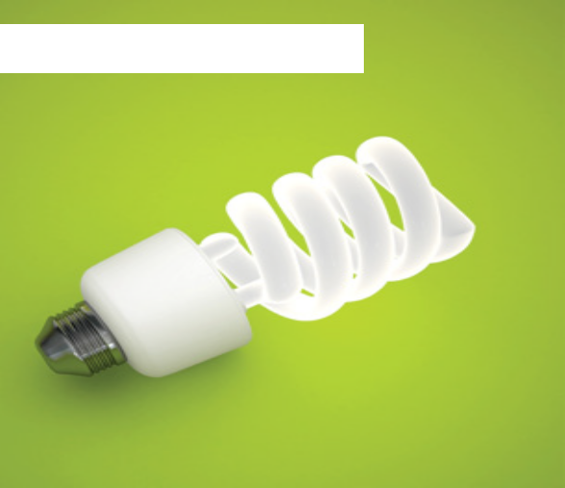Filament light bulb

White low energy bulb

Filament light bulbs have been around for a long time. They consist of a very fine wire which glows when electricity passes through it. This transfers energy from the electricity as light and heat.

The idea of the filament light bulb was easier to come up with than the identification of a material that would glow without burning out. Early inventors are said to have tried dozens of different materials. The solution was to use a metal called tungsten and to fill the bulb with an unreactive (inert) gas.

Filament bulbs are not very efficient however, and more energy is released as heat than light. They are also not very long lived and can be damaged easily. Their low price looks less competitive when their shorter life and inefficiency are taken into account.

Low energy light bulbs are more accurately described as ‘compact fluorescent bulbs’. They produce light from a gas filled tube which glows when electricity is passed through it.

They are currently significantly more expensive to make than filament bulbs, but last much longer (often around ten times longer) and use much less electricity (around a quarter) to produce the same amount of light.

However they need to be disposed of with care as they contain mercury, which is poisonous. On the other hand, coal fired power stations also produce mercury and low energy bulbs reduce the need
for electricity.

Scheme of work 4 – episode 2

