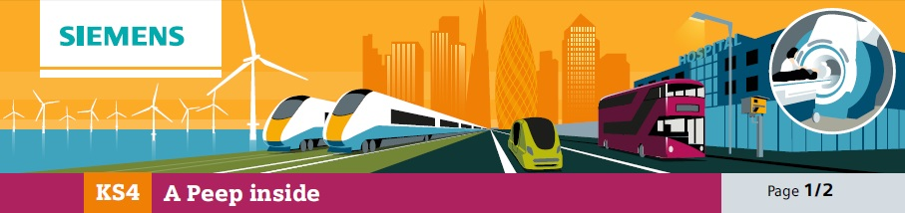

15A Sample assessment task

This diagram shows a simplified cutaway view of an MRI scanner.

Explain how it produces images for clinical diagnosis.

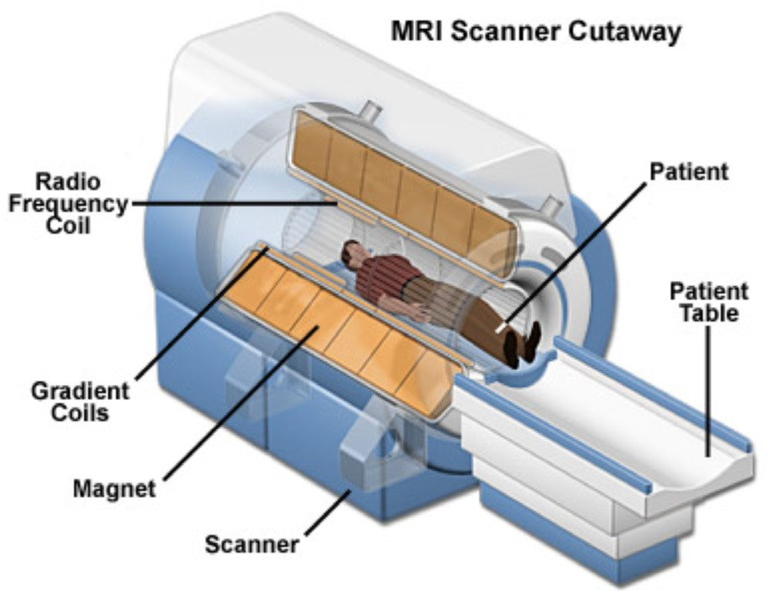

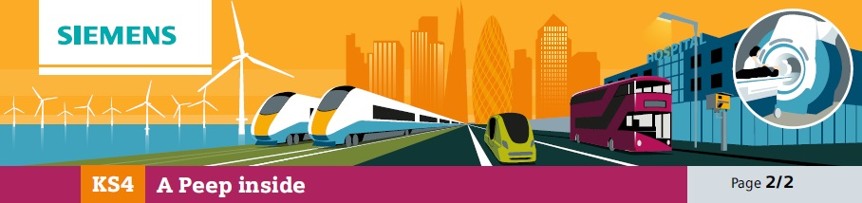

15B Sample assessment mark sheet

Expected answers | Additional guidance
[Level 3]  Answer correctly describes the processes of stimulating hydrogen nuclei and causing the energy to be released so that images can be formed. All information in answer is relevant, clear, organised and presented in a structured and coherent format. Specialist terms are used appropriately. Few, if any, errors in grammar, punctuation and spelling. (5-6 marks)  [Level 2]  Answer may name some processes rather than describing them, and/or may not make the correct order clear. For the most part the information is relevant and presented in a structured and coherent format. Specialist terms are used for the most part appropriately. There are occasional errors in grammar, punctuation and spelling. (3-4 marks)  [Level 1]  An incomplete answer, naming some processes without describing them and omitting other processes. Answer may be simplistic. There may be limited use of specialist terms. Errors of grammar, punctuation and spelling prevent  communication of the science. (1-2 marks)  [Level 0]  Insufficient or irrelevant science. Answer not worthy of credit. (0 marks) | Answers may make use of some or all of  the following points:  • Hydrogen is present in the body in a number of substances including water and fats.  • MRI scanners have powerful magnets.  • In a magnetic field hydrogen nuclei are strongly aligned, north or south.  • Most nuclei are balanced by one orientated the opposite way but a few are unmatched.  • RF coils produce radio waves which make unmatched nuclei spin in the opposite direction.  • When the RF coils are switched off, these nuclei revert to their previous position, emitting energy.  • This energy is detected and used to form an image.

