Gamification

The buzzy term simply refers to the practice of applying game mechanics
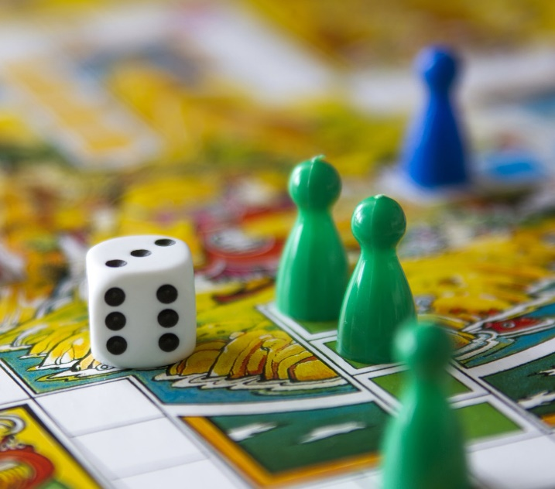
- like leveling, rewards and competition - to any experience.

Brands and companies have realized that friendly competition and metered rewards are a great way to get people interested and engaged in a product. Green initiatives are getting wise as well. Games such as Trash Tycoon challenge players to recycle their way to victory whereas sites such as myenergy, recyclebank or DailyFeats encourage users to reduce their energy consumption or improve their green actions by offering light competition and relevant rewards for eco-behaviour.

Organic Food Production

Organic foods are foods that are produced using methods of organic farming
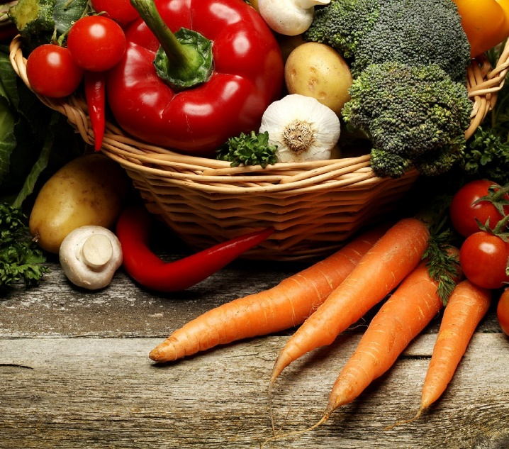
- that do not involve modern synthetic inputs such as synthetic pesticides and chemical fertilisers.

Organic foods are also not processed using irradiation, industrial solvents, or chemical food additives. Demand for organic foods is primarily driven by concerns for personal
health and for the environment. Global sales for organic foods climbed by more than 170 percent since 2002 reaching more than $63 billion in 2011, while certified organic farm- land remained relatively small at less than 2 percent of total farmland under production.

Africa is almost entirely organic now - leading to low yields, hunger, and deforestation. Africa needs to boost its yields, and that means enabling farmers to use modern crops, fertilizers, and pesticides. Producing less with more effort might appeal to well-fed First worlders, but it is literally starving the poor.

The Plastic Bag Company

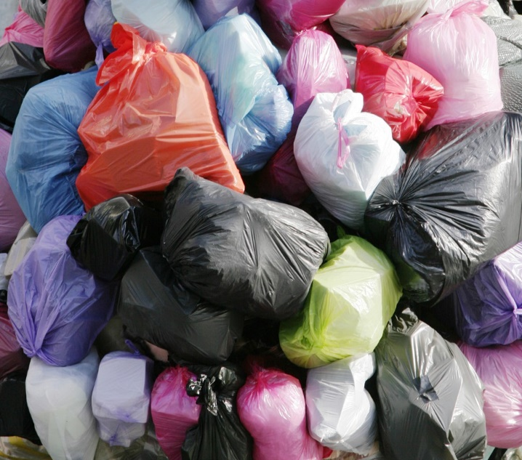
The Plastic Bag Company has over 40 years of experience in plastic bag manufacture and is a trusted and reliable supplier of quality UK manufactured, printed plastic bags and flexible packaging.

They supply a wide range of products for use in many applications, from the textile industry to the food industry, with a customer base reaching from the U.K and Europe to the Middle East.

Plastic bags are not biodegradable. They clog waterways, spoil the landscape, and end up in landfills where they may take 1,00o years or more to break down into ever smaller particles that continue to pollute the soil and water. Producing plastic bags requires millions of gallons of petroleum that could be used for transportation or heating. Biodegradable bags are currently produced but are not sold at the plastic bag company due to having expensive production costs for an often less reliable product.

Bugatti Veyron

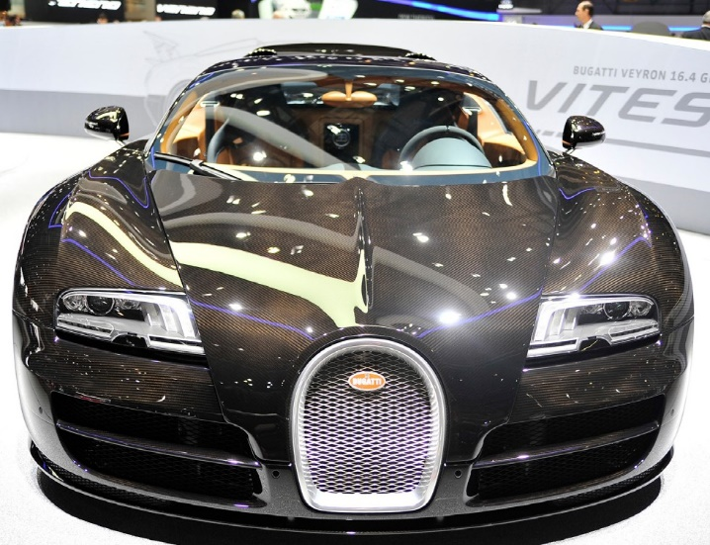
Bugatti apparently costs parent company VW £3,887,051 every time one is sold, and will end up costing almost £1.75 billion once all 450 units sell out. In their defence, the Veyron represents a technical showcase for VW who knew it would lose money.

With its 16-cylinder four-wheel drive, the Bugatti Veyron may well be the most sophisticated production vehicle of all time. Boasting a maximum speed of more than
400 km per hour, the Veyron is unmatched in the super sports category. It offers a total of 736 kW (1,001 HP).

