Using a circuit

People were communicating over long distances long before electrical circuits were invented. However circuits soon changed the way that communication took place – and how quickly. You are going to set up a circuit with a
switch and a bulb. You’ll need quite a lot of wire and you’ll need to be careful not to trip anyone up.
Resources required:
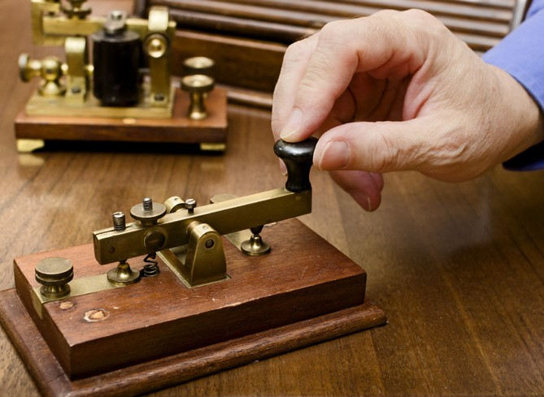Battery Bulb Switch

You need to set up a circuit with a battery, a bulb and a switch. However the wires need to be long enough to reach the other side of the room (it might be a good idea to run the wires along a wall rather than across the middle of the room).

What you’re going to be doing is using the circuit to send a message across the room. The circuit needs to be set up so that the battery and switch are at one side of the room and the bulb is on the other. When you push the switch on one side of the room – the bulb lights up on the other side.

You’ll need to use a code to turn the letters into the bulb being on and off. One of the most common codes to use with light is Morse code. This represents the whole alphabet using dots (short flashes) and dashes (longer flashes).

Write out the word you are going to send and convert it into Morse code.

Word:

Morse code:

Then send it and see if your classmates can decode it. Then get them to send a word back.

- What works well with this way of communicating?

• What are the things that you need to get used to?

• What are the more serious problems?

• How could you make it work with a buzzer instead of a bulb?

• Would this be better or not?

Morse code

