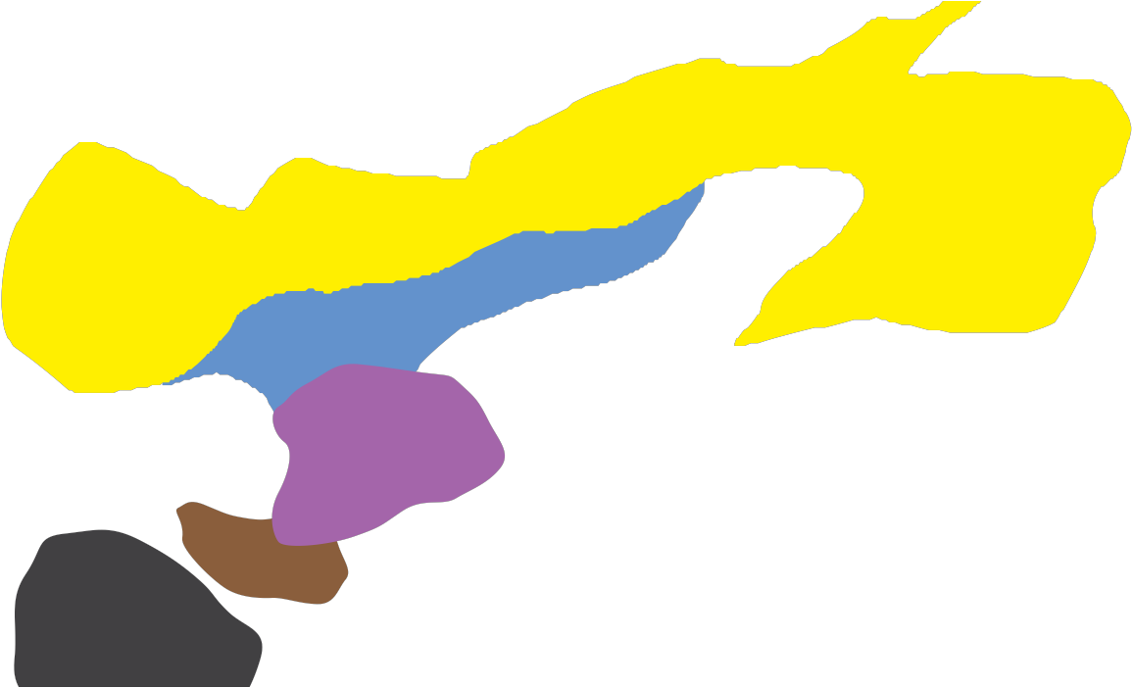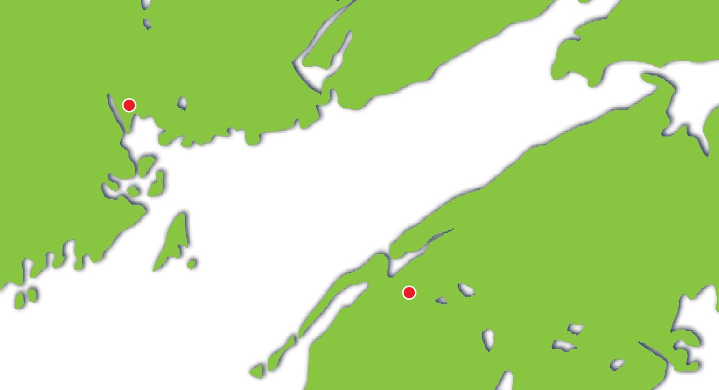Planning a cable route

N E W B R U N S W I C K

Submarine cables have to be placed with
care as there are many hazards. Breaks in
the circuit are difficult to repair and cause a
break in communications.

Town B

NOV A SCOTIA

Town A

Look at the map on page 2 of this sheet, it shows the sea between these two islands. Your job is to decide which route to use to provide a good link between the two towns. Look at the information, plan a route and explain why you’ve taken that route.

Planning a cable route - Map

N E W B R U N S W I C K

Town B

Town A

NOV A SCOTIA

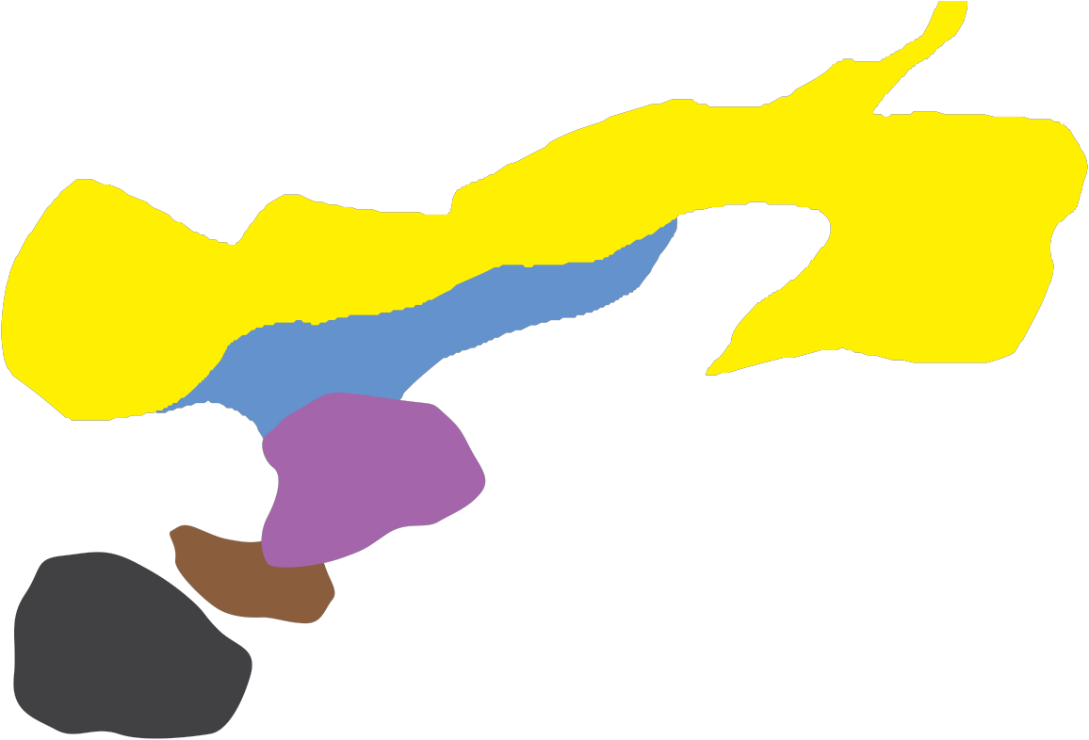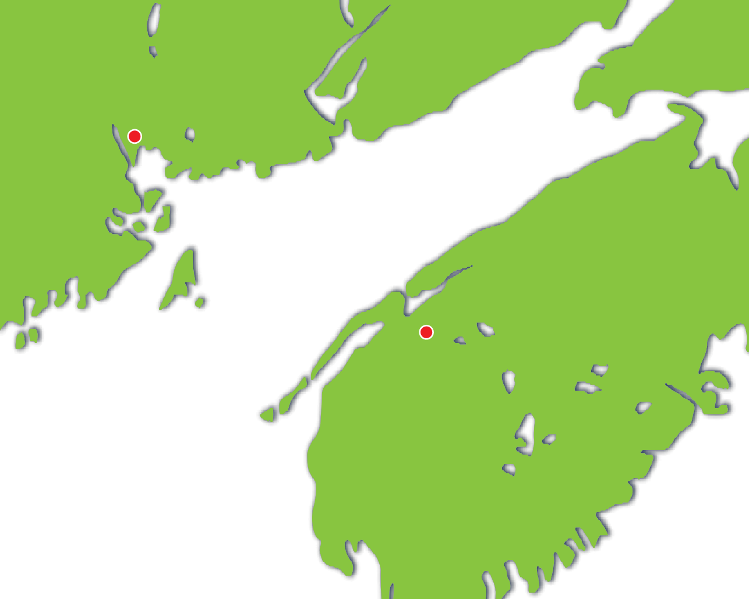MAP KEY

Soft sand, which tends to leave the cable exposed and prone to damage from weather and thieves

Fishing area – trawl nets may catch the cable and damage it

Mooring area in which large vessels anchor whilst waiting to enter port

Sharp rocks submerged

Area proposed for drilling for oil

