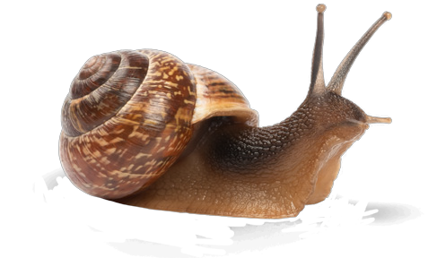

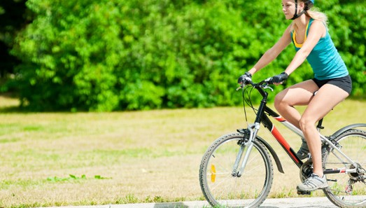The speed of a train

In order to know how fast something is going, we need to know two things – how far it has travelled and how long it took to travel that distance.

For example, Jemima is riding her bike along the road. She travels 10 metres along and does that in 2 seconds.

We know that distance = 10m

We know that time = 2s

We can work out the speed she was travelling at by dividing the distance by the time.

10m/2s = 5 metres per second

She was travelling at a speed of 5m/s. Every second she travelled another 5 metres. In 2 seconds she would have travelled 10 metres.

For example, Horace the class snail travels 16 millimetres in 4 seconds.

We know that distance = 16mm

We know that time = 4s

16mm/4s = 4mm/s

He’s travelling at 4mm every second.

Now let’s think about the trains on Volk’s Electric Railway. The manager wants to know how fast they are going (and they don’t have speedometers).

• What do we need to know to work out the speed?

• What measurements should be taken?

• What equipment might be useful?

The manager gets the measurements and finds out that:

• From one end of the line to the other is 1620m

• A train takes 12 minutes to get from one end to the other

See if you can work out the speed:

• In metres per minute*

• In metres per second** (think about how many seconds in a minute)

• In the wet the trains slow down – they take 15 minutes to get from one end to the other

• What will their speed be now?

* You might want to use a calculator

** This one’s a bit trickier

