**Levers as Force Magnifiers**

Key idea to explore: Torque = Force applied x distance from pivot

Note that **Torque** is also called a **Turning Force**, or **Moment**

1. Set up a hanging balance beam and explore different ways to make the beam balance.



Try to make it balance with different weights on the two sides



Can you work out a mathematical link?

Can you predict which pairs of weights will support each other at certain distances? **Explain how you can use a small force to balance a large force**

**Advanced**



Does your mathematical method work for multiple weights?

Applying mathematics

The table shows the results of another student’s trials. Fill in the missing spaces.

Can you calculate which combinations are balanced?

|  |  |  |  |  |  |  |
| --- | --- | --- | --- | --- | --- | --- |
| Left side (anticlockwise turning force) | | | Right side (clockwise turning force) | | | Balanced? |
| Force (N) | Distance (cm) | Torque (Nm) | Force (N) | Distance (cm) | Torque (Nm) |  |
| 50 | 10 |  | 5 | 100 |  |  |
| 30 | 15 |  | 9 | 40 |  |  |
|  | 25 |  | 10 | 10 |  | Yes |
| 5  and  5 | 20  and  40 |  | 20 | 30 |  |  |

Challenge

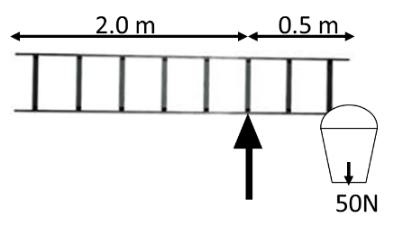A window cleaner tries to balance his ladder and bucket perfectly on top of a railing. The weight of the ladder is 100N. Show why this will not work. What weight of water will he need to add to his bucket to be successful?

**Levers as Distance Magnifiers**

Key idea to explore: Torque = Force applied x distance from pivot

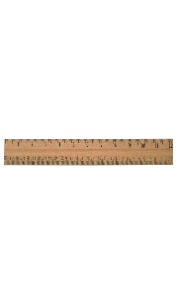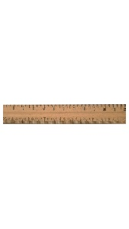

* How does changing the position of the pivot affect the height of the raised end?
* Can you work out the mathematical link?
* Can you predict the height the end will be for a new pivot position?
* **Explain how you can use a small movement to create a much larger movement**

**Advanced**

* **How does the use of a distance multiplier affect the force required to make it work?**

Applying mathematics

|  |  |  |  |
| --- | --- | --- | --- |
|  | Distance from pivot | Distance from pivot | Distance moved |
| Fishing Rod | 20 cm away, and moves 15cm | Tip is 3 metres away |  |
| Fore arm | Muscle is attached 5cm from elbow joint, and can move by 8cm | Fingertips are 40cm from elbow |  |

Challenge

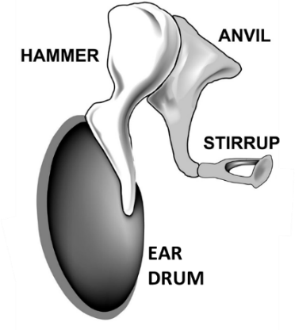

Biomechanics: Inside your ear there are a 3 bones which act as levers. They take the small vibrations of your eardrum easier to detect.

This is quite a simplification, but using the figures below, what would the final movement of the stirrup be?

|  |  |  |  |  |
| --- | --- | --- | --- | --- |
|  | Input movement (mm) | Input length  (mm) | Output length (mm) | Output movement (mm) |
| Hammer | 0.01 | 1 | 3 |  |
| The output of the hammer moves the anvil | | | | |
| Anvil |  | 0.005 | 4 |  |
| The output of the anvil moves the stirrup | | | | |
| Stirrup |  | 1 | 1.5 |  |

**Gears as Distance Multipliers**

Key idea to explore: Torque = Force applied x distance from pivot

* Choose a pair of gear wheels and set them up so the teeth mesh together. Use the larger wheel to turn the smaller one.
* Count the number of times the small wheel turns for one rotation of the large wheel
* Count the number of teeth on each wheel
* Can you work out a mathematical relationship between the numbers of teeth and the number of rotations of each wheel?
* Choose a different gear wheel and count the teeth. Can you correctly predict the number of turns the smaller wheel will make?

Applying Mathematics

|  |  |
| --- | --- |
| Number of teeth on the left wheel |  |
| Number of teeth on the centre wheel |  |
| If the left wheel turns 20 times, how many times will the centre wheel turn? |  |
| How many teeth on the right wheel? |  |
| For each turn of the centre wheel, how many turns does the right wheel make? |  |
| If the left wheel goes clockwise, which way do each of the other wheels go? |  |

Challenge

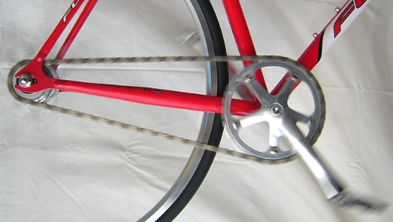The driving gear wheel on this bicycle has 48 teeth, the driven (rear) gear wheel has 16 teeth.

The rear wheel has a radius of 40cm.

If the pedals have a speed of 75 revolutions per minute, what distance will the bicycle cover in 1 minute

Can you convert this into kilometres per hour?

**Gears as force multipliers**

Key idea to explore: Torque = Force applied x distance from pivot

* Choose a pair of gear wheels and set them up so the teeth mesh together. Use the smaller wheel to turn the smaller one.
* Count the number of times the small wheel turns for one rotation of the large wheel. When the small wheel is being driven, is it easier or harder to stop the large wheel turning?
* Count the number of teeth on each wheel
* Is there a relationship between the **radius** and the number of teeth?
* Can you work out a mathematical relationship between the **radius** and the number of rotations of each wheel? Is there also a relationship between the turning forces (the torque?)
* Choose a different gear wheel and measure the **radius**. Can you correctly predict the number of turns the smaller wheel will make? How about the relative turning forces (Torques)?

Applying Mathematics

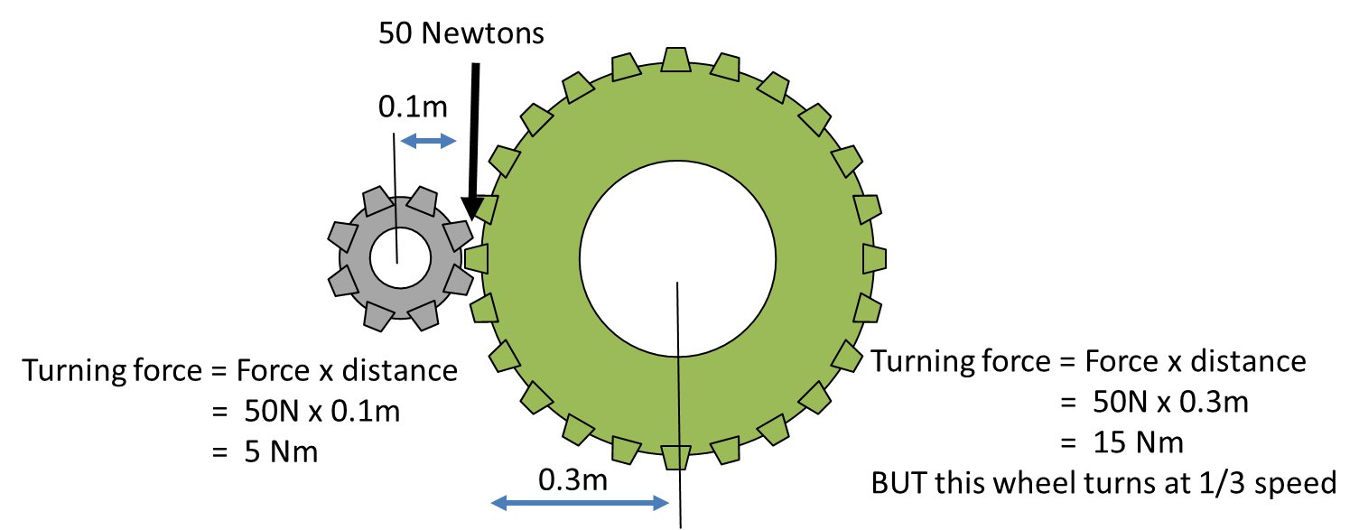

|  |  |  |  |  |  |
| --- | --- | --- | --- | --- | --- |
| Driving wheel | | | Driven wheel | | |
| Teeth count | Radius  (mm) | Turning force (Nm) | Teeth count | Radius  (mm) | Turning force (Nm) |
| 15 | 100 | 1.5 | 30 |  |  |
| 24 |  | 6 |  | 150 | 18 |
|  | 30 |  | 60 | 300 | 100 |
| 18 | 60 | 100 | 72 |  |  |