Overall learning objectives | Overall learning outcomes
• Explain where the timing of wheel bearing replacement is critical.  • Understand the features of the RailBAM process.  • Communicate key points and ideas to a target audience. | • Identify critical features.  • Produce an effective summary.

Curriculum learning objectives
Students should have the opportunity to:
Science
• Critically analyse and evaluate evidence from observations and experiments.
• Explore how the creative application of scientific ideas can bring about technological developments and consequent changes in the way people think and behave.

Technology
• Generate, develop, model and communicate ideas in a range of ways, using appropriate strategies.
• Solve technical problems.

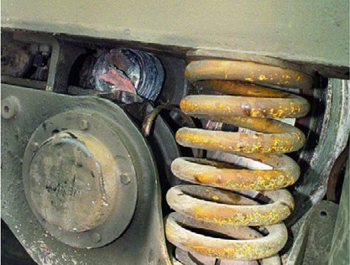Introduction

The purpose of this episode is to introduce the context to the students and present them with the problem to be addressed. The key point is for them to realise what the function of a bearing is and the importance of finding out whether replacement is needed. They should realise the cost implications of replacing bearings before it is necessary and the cost and safety implications of not replacing them in time.

Learning objectives
• Understand the function and importance of wheel bearings.
• Understand the importance of detecting the need for bearing replacement.

Learning activities

1. Present students with images of:
a) Derailed train.
b) Passenger bulletin board warning of disruption to services. c) News headline on rising ticket prices.

2. Ask students discuss why these might happen and draw out that mechanical failure might be a cause of the first two, but that increasing maintenance will cause the third.

3. Present students with labelled diagram of outline structure of rail bogie, with frame, wheels, axle and bearing and challenge them to explain how it works and how it might wear out over time.

4. Students explore and present ideas in response to three questions:
a) What happens if a bearing failure is not caught in time?
b) What happens if bearings are replaced too often?
c) How might you tell if a bearing was starting to wear out?

5. Draw out the points that:
a) Bearing failure is critical; it causes train failure which is expensive, disruptive and dangerous.
b) Bearing replacement is expensive; it is important to manage costs by avoiding taking trains out of service and spending unnecessariy on maintenance.
c) The noise made by a bearing changes as it wears out.

Outcomes
• Explain what the function of a wheel bearing is.
• Identify the factors that influence when they should be replaced.

Development

The purpose of this session is to explain the students how the RailBAM system works and how scientific ideas are put to practical use by this to identify the optimum point of time for the replacement of wheel bearings.

Learning objectives
• Interpret technical literature to understand how a system works.
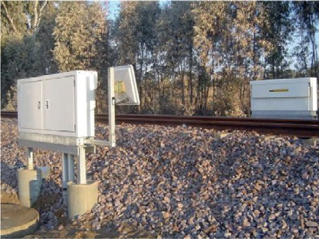• Extract key points to summarise them and identify the principles being used.

Learning activities

1. Teacher recaps from previous episode that the optimum situation is to replace a bearing when (but only when) it’s starting to wear out and that a worn bearing sounds different and is inclined
to run hot.

2. Explain that the traditional technique used on railways to identify worn wheels was to tap the wheel; the note would reveal any defects. A worn bearing would be detected by touch, as it would
‘run hot’. A worn bearing or cracked wheel sound different when moving.
a) Use a small metal tool to tap an object such as a glass beaker or metal bowl. It should have a clear resonant sound, unless it is flawed.
b) Show first two minutes of “Oh Mr Porter”, a 1937 film in which Will Hay (initially) plays the part of a wheeltapper: (http://archive.org/details/Oh_Mr.Porter_1937)
c) Explain that bearings sound different when the vehicle is in motion. Play a video clip such as: (http://www.youtube.com/watch?v=7r2hjYH2hqA) to show how worn bearings on wagons sound.

3. Present students with resource sheet and ask them to work out how the RailBAM system works. Ask them to identify key points and summarise on a flipchart sheet (alternatively, if iPads are available, use an app such as EduCreation or ExplainEverything to capture ideas for sharing).

4. Take feedback and draw out points including:
a) Bearings functioning properly make a certain sound when running. b) If the bearings are worn, the sound is different.
c) The RailBam system records the sound made by passing trains and compares it with the sound of a train with bearings in good working order. If there is a difference the system notes this and issues a warning.
d) The train can then be withdrawn from service for maintenance.

Outcomes
• Explain clearly and logically, how the RailBAM system works.

Summary

The purpose of this episode is for students to summarise and express key features of the system, identifying key points and explaining how it works.

Learning objectives
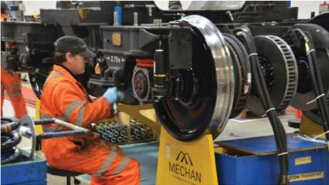• Summarise key points and communicate in an effective way.

Learning activities
In plenary teacher draws out and summarises (or gets students to summarise) key points, including:

1. System records sound of running train.

2. Compares sound with that of a train with bearings in good condition.

3. Identifies trains in need of maintenance.

4. Worn bearings replaced as necessary:
i. Avoiding breakdown.
ii. Avoiding unnecessary replacement.

Students then select one of the following products:
a) Explanatory A4 leaflet b) Poster
c) Diagram to explain to younger students (say, Year 7)
d) Podcast of no more than two minutes.
They work in small groups to develop these. They then share their work and peer assess, using the following criteria:

Criteria | Mark
Clarity of explanation
Accuracy of explanation
Effectiveness for target audience

Outcomes
• Present key points in an accurate and clear way, suited to the target audience.

