Overall learning objectives

• Developing a sense of scale and proportion with regard to measurement of frequency.
• Understanding of concepts of sound and ultrasound with use of wave model.
• Use of frequencies to compare waves.
• Assessing the advantages of a particular technology.
Overall learning outcomes

• To explain what ultrasound is and how it can be used to form images.
• To explain how these images can be applied to medical diagnostic situations.
• To use images and other evidence to form ideas and conclusions.

Curriculum learning objectives
Students should be able to: Science
• Critically analyse and evaluate evidence from observations and experiments.
• Explore how the creative application of scientific ideas can bring about technological developments and consequent changes in the way people think and behave.
• Obtain, record and analyse data from a wide range of primary and secondary sources, including ICT sources, and use their findings to provide evidence for scientific explanations.

Science
• Use real-life examples as a basis for finding out about science.

Technology
• Understand that products and systems have an impact on quality of life.

Introduction
This episode is designed t set the scene and to encourage students to think about medical diagnosis and how information can assist the doctor in being effective and accurate.

Additional resources required
• Flip chart

Learning objectives
• To consider how a range of evidence is useful in making effective medical diagnoses.
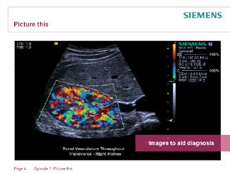• To suggest how imaging may play a role in this.

Learning activities

1. Ask students if they have been nearby when someone is complaining of symptoms which need a skilled diagnosis or if they have been in a similar situation. Ask students to think of some possible causes for such a complaint. At this point don’t rule out ideas unless they are completely ludicrous.

2. Ask students to work in groups and answer these questions:
a) What questions might it be useful for the doctor to ask the patient?
b) What other evidence might the doctor want to gather?
c) How might imaging have a role to play in this?

3. Draw together ideas about the medical imaging and what a useful image should show if it is to aid diagnosis. Record this and display for future reference.

Outcomes
• To suggest ideas about the characteristics of a useful image to support a medical diagnosis.

Investigate
This episodes visits (or revisits) some ideas about the properties of sound and how sound is made. It develops and reinforces ideas about sound travelling as a wave. The detail and extent of this will depend upon the extent to which the topic has previously been covered in science.

Learning objectives
• To understand what sound is and how it is made.

Additional resources required
• Variety of objects that make a noise for example musical instrument, tuning fork, or a conical flask half full of water.
• CRO (cathode ray oscilloscope)
• Microphone

• To be able to explain the significance of amplitude, frequency and pitch.
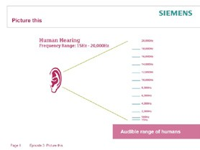• To describe how these can be displayed and what they show about a sound wave.

Learning activities

1. The nature and detail of this episode may need to be judged by careful questioning and recognition of prior learning. A good starting point is to ask students to suggest how sound
is made. It is useful to have a variety of objects that make a noise, but do so in different ways. Some of them may be musical instruments, but they shouldn’t all be. You might include, for example, a guitar, a penny whistle, a drum, a tuning fork, a box (to be hit) and a conical flask half full of water (which can be tapped and also blown across the top of). Ask for suggestions
about how each of them makes a noise and then ask for generic characteristics. Draw out that a noise is made when a pressure wave travels through air. Something that makes a continuous sound produces a series of such waves.

2. Ask for ideas about how sound can be displayed. It may be useful to show the effect that a vibrating tuning fork has on the surface of a beaker of water or that a loudspeaker cone facing upwards has on small polystyrene beads. This emphasises that vibrations are taking place. However, it is important to move students’ thinking on to ways of displaying a sound wave. There are various good ways of doing this; the more traditional one is by using a microphone and CRO (cathode ray oscilloscope) but a newer one is to use an iPad app such as oScope. In both cases it is important to explain that the waveform is a representation rather than a picture of a sound wave (it could usefully be included that sound is a compression wave and these images are of transverse waves; nevertheless they are useful because of the information they show).

Learning activities cont’d.

3. Explain that by using a waveform like this, measurements can be made that are useful. It is useful if this part is carried out with the equipment from the previous part to hand. Explain that the height of the waveform indicates how loud the sound is and that this is called the amplitude. Then explain that the horizontal distance between one peak and the next is called the wavelength and that this indicates the pitch of the note. This is easier to see with a continuous note, but one that can be varied in pitch. Emphasise that a shorter wavelength indicates a higher pitch.

4. Say that sound can be explained by thinking of it as a series of vibrations. The more energy is put into each vibration the louder it will sound. The more frequently the vibrations arrive (the more waves per second) the higher the note sounds. The waveform therefore displays more useful information.

Outcomes
• To explain how sound travels.
• To explain why a waveform is a useful way of conveying information about sound.
• To relate the amplitude of a waveform to the loudness of the note and the frequency to the pitch.

Understand
This episode explores the idea that humans can hear sound within a certain range of frequencies and that other sounds (ultrasound) exist at higher frequencies. Although they cannot be heard by humans they have uses.

Learning objectives

Additional resources required
• Signal generator
• CRO (cathode ray oscilloscope)
or an oScope
• Dog whistle, microphone

• To recall that humans have an upper limit to sounds they can hear and that sounds above this frequency are referred to as ultrasound.
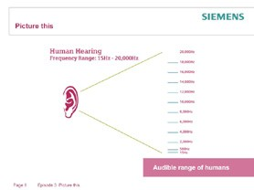

Learning activities

1. Remind students about ideas from the previous episode about frequency. Explain that this is measured in Hertz (Hz) and that a frequency of
1Hz is one wave per second. Say that ‘Middle C’ has a frequency of 256Hz; 256 waves arrive every second. More than that and it is a higher note, fewer and it is lower. Illustrate this using equipment such as a signal generator and CRO. Add that 1,000 Hz is 1 kilohertz (1kHz).

2. Then explain that there is an upper limit to the frequency we can hear and that it is around 20kHz.
This can be demonstrated by using the signal generator and CRO (cathode ray oscilloscope) and further illustrated using a dog whistle, microphone and CRO. The whistle can’t be heard, though it will be clearly displayed. Emphasise that although our audible range is around 50Hz – 20kHz other animals have different ranges.

Outcomes
• To be able to explain what is meant by ultrasound and how it differs from sounds that we can hear.

Research
This episode provides students with the opportunity to research how bats use high frequency sounds.

Learning objectives
• To explain how bats use ultrasound to locate prey.
• To research and present scientific ideas.

Additional resources required
• Access to research tools
• Flip chart paper

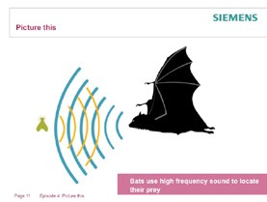• To be able to provide constructive feedback on the work of peers.

Learning activities

1. Explain that bats use high frequency sounds to locate their prey in pitch darkness. The sounds are usually above frequencies that humans can hear. Say that students are going to find out and present ideas about how this works.

2. Set students these questions:
a) Which frequencies do bats use?
b) How does this help them to find their prey?
c) Why does this give the bats an advantage over other predators?

3. Ask students to work in groups; each group is to prepare a poster to answer the questions.
Allow access to books and the internet.

4. Students should prepare and display their posters; they should also have the opportunity to peer assess them. This might be done by, for example, students commenting on three other posters using, “I thought ……….was really effective; it would have been even better if …….” with the teacher ensuring even coverage.

5. In the plenary draw out key points about the frequencies going up to 100kHz and beyond, the bats detecting their prey by comparing the strength of the returning signal with that of the outgoing signal and the bats thus being able to hunt in conditions in which most other predators would not be able to compete.

Outcomes
• To produce an effective visual summary of ideas about echo location in bats.
• To provide effective peer assessment.

Application
This episode applies ideas about ultrasound to the process of medical imaging and shows how the concept can be used to produce useful images.

Learning objectives
• To explain how ultrasound waves are affected by substances of differing densities.
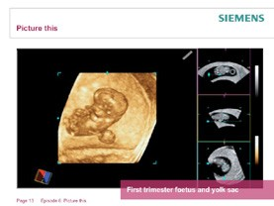• To describe how these are used to form images.

Learning activities

1. Remind students about bats finding moths by releasing high frequency sounds and listening for the echoes. Explain that the reflection took place when there was a change in density; the moth is more dense than the air so the sound bounces off it. Explain that the same principle is used in ultrasound imaging.

2. Show students an image of an ultrasound being used to produce images and point out that different parts of the body have different densities. Explain that when the ultrasound
reaches a part with a different density some of the waves are reflected. The amount of the waves that are reflected and the direction from which they are reflected are used to produce the image.

3. Student support sheet 9 presents a summary of the key points. This can be used to consolidate the key learning points and includes questions.

Outcomes
• To use and apply information to explain how ultrasound images are formed of the inside of the body.

Application
This episode shows some of the applications of ultrasound imaging.

Learning objectives
• To understand how ultrasound images can be applied to medical diagnosis.
• To explain the advantages thy offer.

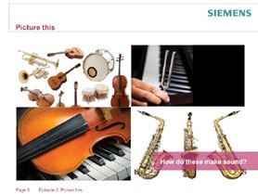
Learning activities

1. Show students ultrasound images: explain that pregnancies are divided in time into three equal parts, called trimesters. Ultrasound causes no ill effects to the mother or the foetus and can be used to monitor growth rates, identify some
types of medical issues and help with the bonding between parent and child. Explain that the ultrasound scanner takes a cross sectional view; in other words, turning the scanner produces an image in a different plane. The individual images are shown on the right but can then be combined to form the ‘3D’ view in the main part of the picture.
Then show the image of the uterine polyp and explain that this is a growth in the uterus. They may cause abnormal bleeding and occasionally become cancerous. The images clearly show the position and size of the polyp; they have been taken in two different planes and provide a doctor with a wealth of information to draw upon to make a diagnosis.

2. Ask students to identify the key points.

3. Following this ask students to work in small groups to identify key points about the use of ultrasound in medical imaging. Suggest that they group their ideas under these sub-headings:
a) What ultrasound is.
b) How it can be used to form images?
c) Why this is useful in medical diagnoses?

4. Take feedback and produce an agreed list of key points from the class.

Outcomes
• To have collaborated to produce key points about the nature and properties of ultrasound.
• To be able to explain how an image is formed and why it is useful.

