7 Resource sheet - E-zero island

Weigh up the factors below and decide on the best way to provide energy for the island.

City with industrial and commercial facilities
Open hillsides

Farmland and grazing
Lake, with river
draining to sea

Rocky windswept area
Coastal area with fishing villages and
tourist facilities

Weather forecast for the next 24 hours: Most areas of the island will be dry and rather cloudy during the day, but brighter in places.
Patchy rain is likely over hills but brighter on
the coast. Light winds in coastal areas.

Tonight it will be mainly dry with broken cloud. Mist and fog will form widely with temperatures falling towards, but unlikely to reach, freezing. Light variable winds.

High tide is at 13.05 this afternoon and 01.25 tomorrow morning.

Briefing note from power network manager: Taking into account the weather forecast and the time of year, the likely energy consumption for
the island for the next 24 hours is 15,000 units.
However if the temperature drops earlier in the evening and stays low this could rise to as much as 18,000 units.
Stocks of biomass are high but unlikely to be added to for the next 3-4 months and coal stocks are slightly lower than average for the time of year.

More complaints have been received from property developers on the east coast saying that sales of properties are being hampered by aspects of the landscape being spoiled by generating equipment.

The mayor has called, asking for reassurances that this winter won’t see a repeat of last year’s problems with power shortages.

Scheme of work 7 – episode 3

7 Energy cards for the island

Onshore wind turbine

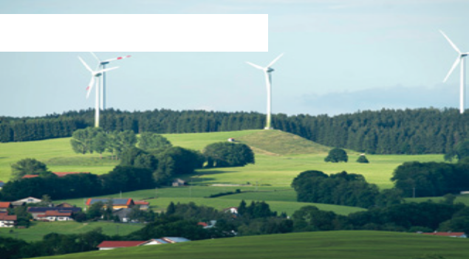Biomass energy plant

Photovoltaics

• 1,000 units of electrical energy produced by onshore wind.

• Cost: £100

This energy source requires no fuel and only occasional maintenance. However the output is highly variable as it depends on the wind blowing. Furthermore some people object to the appearance of wind farms, especially if they are placed in undeveloped areas.

• 1,000 units of electrical energy produced by biomass.

• Cost: £90

This energy source can use biodegradable waste material so the only fuel costs are the transporting of this material, although there are limits to the amount of energy that can be produced this way. However the costs (and environmental impact)
increase if plants are grown specially for this purpose.

• 1,000 units of electrical energy produced by a solar farm.

• Cost: £150

This energy source requires no fuel and only occasional maintenance. However the output
is somewhat variable as it depends on sunlight, though even on a hazy day there is good output. Some people object to the appearance of solar farms, especially if they are placed in undeveloped areas.

7 Energy cards for the island

Tidal power

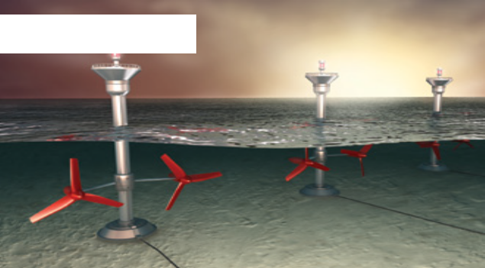Natural gas turbines with CO2 capture

• 1,000 units of electrical energy produced by
Tidal power.

• Cost £250

This energy source requires no fuel and only occasional maintenance. However the energy output depends upon the tides. Some people object to the appearance in what may well be an attractive area. Tidal power may have some impact on local wildlife.

• 1,000 units of electrical energy produced by

natural gas turbines with CO
2
capture.

• Cost £100

These are reliable and can be sited away from attractive areas. However they release pollutants such as nitrous oxides and the actual power station is not very attractive.

Natural gas turbines with
no CO capture
2

• 1,000 units of electrical energy produced by

natural gas turbines with no CO
2

• Cost £80
capture.

These are reliable and can be sited away from attractive areas. However, they release pollutants such as carbon dioxide and nitrous oxides, and
the actual power station is not very attractive.

7 Energy cards for the island

Coal powered energy plant

• 1,000 units of electrical energy produced by coal

with CO
2
capture.

• Cost £120

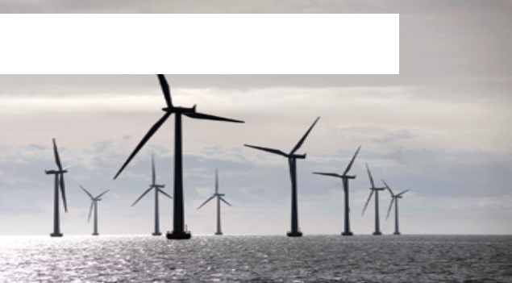These are reliable and can be sited away from attractive areas. However, they release pollutants such ass sulphur dioxide and nitrous oxides, and the actual power station is not very attractive.

Offshore wind turbines in Copenhagen

• 1000 units of electrical energy produced by offshore wind.

• Cost: £180.

This energy source requires no fuel and only occasional maintenance. However the output is variable as it depends on the wind blowing, though this varies less than if on land. Some
people object to the appearance of wind farms, especially if they are placed I tourist areas.

