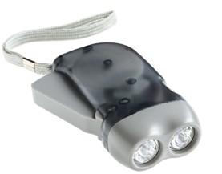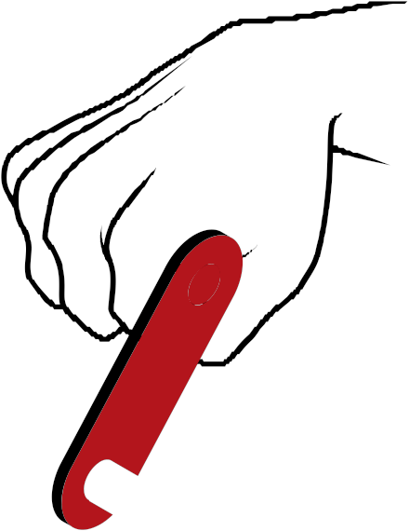

Hand crank technology

There are lots of devices that use batteries to power them. Working with someone else, see if you can make a list of battery powered items:

1.
2.
3.
4.
5.
6.

This is a picture of hand crank torches:

When you squeeze or turn the handle round it charges up a little battery, which then runs the torch for a few minutes. The more you crank, the more charged up the battery becomes and the longer the bulb lights for.

Choose four of your ideas that would work using a hand crank to charge up a little battery. Draw and label them in the boxes here:

What are the advantages and disadvantages of hand crank technology?

Advantages | Disadvantages

