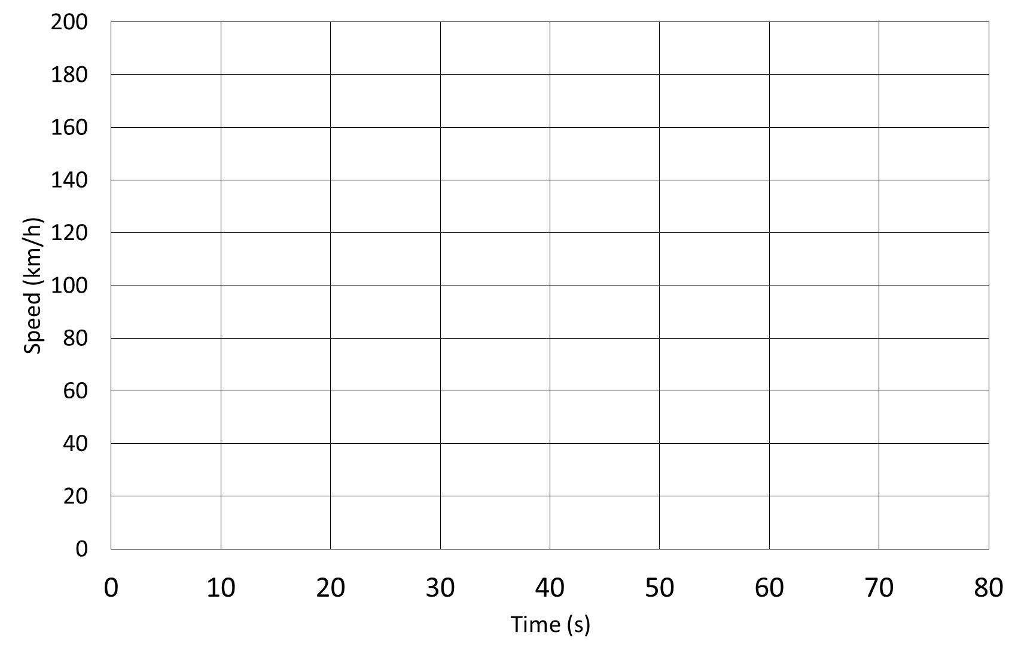
Miami Formula E Grand Prix Lap Profile

