

Answer Sheet

**Formula for Thrills**

**1/16**

**Interactive**

**Level 1**

The key point to be understood here is that it’s the difference in height between the start and end which determines the final speed. In other words there isn’t a single solution – any combination of start and end heights that gives the right difference will result in a journey which reaches the end at a safe speed.

If there is an intermediate ‘rise’ (such as a ‘hump’ or a loop) it will not affect the speed at the end, as long as it isn’t high enough to cause the train to stall before the intermediate rise is surmounted.

**Level 2**

The key point here is that the longer the track, the greater the amount of energy lost. This means that the height difference has to be balanced with the length. A greater height difference on a longer track can be adjusted to give a safe and complete journey; if the height difference is reduced then the length will need to be reduced as well. There are, once again, multiple combinations that will work.

**Level 3**

The calculations will change according to the heights selected and there are, therefore, a large number of possible calculations and a much larger number of combinations – well over a thousand for a ride with three different heights. One example set is given for each track, using the height shown on the screenshot in the Formulae Tasksheets.

In association with



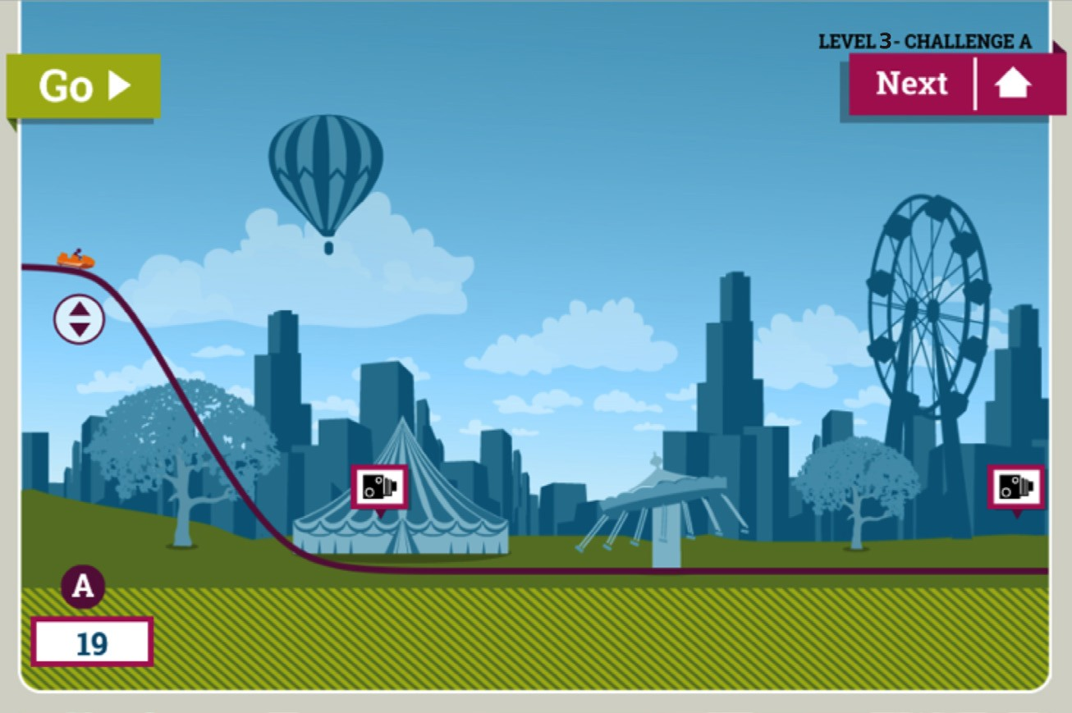

Answer Sheet

**Formula for Thrills**

**2/16**

**Demon Drop**

**a.** If h = 19m

Then GPE = mgh = 5000 x 10 x 19 = 950,000J

KE (for a stationary vehicle) = 0J

Total energy = 950,000J

**b.** Energy = 82% x 950,000J = 779,000J

GPE (for an object at ground level) = 0J Therefore KE = 779,000J

Therefore v = 17.7m/s (to 1dp)

**c.** Energy = 58% of 950,000J = 551,000J

GPE (for an object at ground level) = 0J Therefore KE = 551,000J

Therefore v = 14.8m/s (to 1dp)

This is greater than the permissible final speed and running the train at this speed will produce feedback to this effect. It should therefore be re-calculated with a lower initial height.

In association with



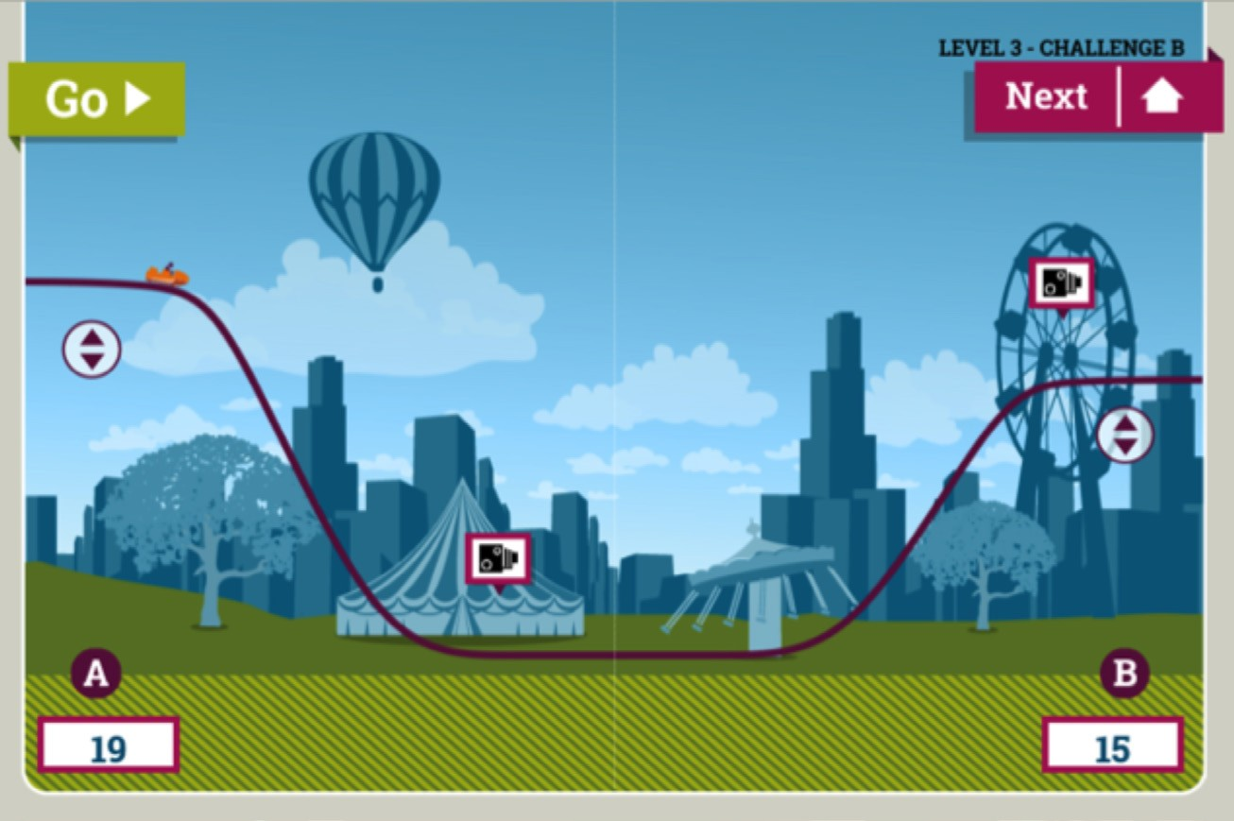

Answer Sheet

**Formula for Thrills**

**3/16**

**Drop and rise**

This means that the train would stall on the approach to the finish, not making it up the slope. It should therefore be re-calculated with a lower height on the final slope.

In association with

h = 5000 x 10 x 19 = 950,000J

KE (for a stationary vehicle) = 0J Total energy = 950,000J

**b.** Energy = 89% x 950,000J = 845,500J

GPE (for an object at ground level) = 0J Therefore KE = 845,500J

Therefore v = 18.4m/s (to 1dp)

**c.** Total energy = 70% x 950,000J = 665,000J GPE = mgh = 5000 x 10 x 15 = 750,000J

KE = Total energy – GPE = 665,000J – 750,000J = -85,000J

**a.** If h = 19m Then GPE = mg



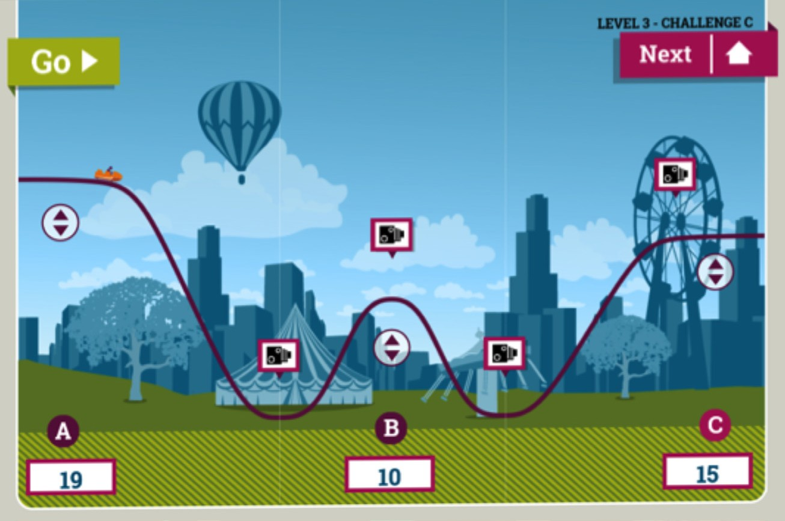

Answer Sheet

**Formula for Thrills**

**4/16**

**Intermediate rise**

In association with

h = 5000 x 10 x 19 = 950,

KE (for a stationary vehicle) = 0J Total energy = 950,000J

**b.** Energy = 89% x 950,000J = 845,500J

GPE (for an object at ground level) = 0J Therefore KE = 845,500J

Therefore v = 18.4m/s (to 1dp)

**c.** If h = 10m.

Energy = 82% x 950,000J = 779,000J GPE = mgh = 5000 x 10 x 10 = 500,000J

KE = total energy – GPE = 779,000 – 500,000J = 279,000J

Therefore v = 10.6m/s (to 1dp)

000J

**a.** If h = 19m Then GPE = mg





Answer Sheet

**Formula for Thrills**

**5/16**

**Intermediate rise (continued)**

This means that the train would stall on the approach to the finish, not making it up the slope. It should therefore be recalculated with a lower height on the final slope.

In association with

**d.** Energy = 74% x 950,000J = 703,000J

GPE (for an object at ground level) = 0J Therefore KE = 703,000J

Therefore v = 16.8m/s (to 1dp)

**e.** Total energy = 66% x 950,000J = 627,000J GPE = mgh = 5000 x 10 x 15 = 750,000J

KE = Total energy – GPE = 627,000J – 750,000J = -123,000J



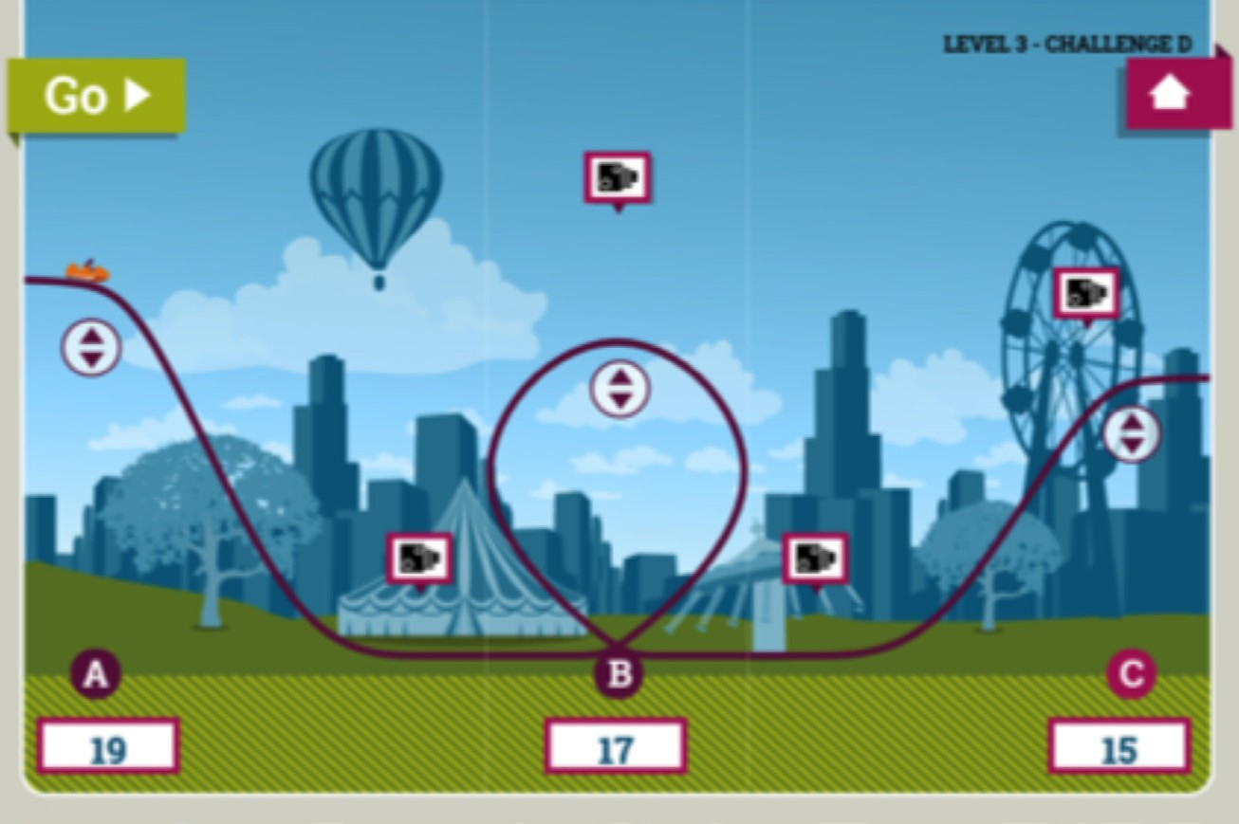

Answer Sheet

**Formula for Thrills**

**6/16**

**Loop the loop**

This means that the train would stall on the approach to the loop, not making it up the slope. It should therefore be re-calculated with a lower height on the loop.

In association with

h = 5000 x 10 x 19 = 9

KE (for a stationary vehicle) = 0J Total energy = 950,000J

**b.** Energy = 89% x 950,000J = 845,5

GPE (for an object at ground level) = Therefore KE = 845,500J

Therefore v = 18.4m/s (to 1dp)

**c.** Energy = 70% x 950,000J = 665,000J GPE = mgh = 5000 x 10 x 17 = 850,000J

KE = total energy – GPE = 665,000 – 850,000 = -185,000J

50,000J

00J

0J

**a.** If h = 19m Then GPE = mg



**Extension Activity 1 -** Shape and structure

**Formula for Thrills**

**7/16**

**Design a ticket booth - suggested solutions**

**1.**

There are a number of such shapes but typical responses might include:

**a.**

**Cube** – easy to combine with other shapes to produce other structures but lacks rigidity.

**b.**

**Cuboid** – easy to combine with other shapes to produce other structures and can be rotated to produce variety but lacks rigidity.

**c.**

**Tetrahedron** – interesting shape and rigid but harder to combine to produce larger structures suitable for buildings.

**2.**

Any of these could be selected. It might be that the cuboid is selected as it can be used in various ways to make stable structures but with a diagonal piece added to each side to make it more rigid.

**3.**

The window should be low enough for children, shorter people and wheelchair users to see in.

It should be high enough for tall people to see in. It should be wide enough for a group of people to see in at once. It should allow enough light in to make the inside pleasant to work in. However, unless it is double-glazed it will allow heat to escape, so too large a window could cause excessive energy loss in cold weather and it would need ventilation to avoid excessive solar heating on sunny days. A good answer will include suggested dimensions, justified as above.

**4.**

This can be explored by taking measurements of class members, such as maximum height, minimum height and upper leg length.

**5.**

Any plans should include dimensions and these should be related both to figures from Q4 and considerations about reasonable working space. It might be very eye-catching, for example, to have

a tetrahedral ticket booth but if this means that for a tall person their head nearly touches three of the sides when they stand up it could be claustrophobic and it could also mean that on a hot day it quickly becomes unbearable.

**6.**

Calculation of outside surface needed. Allow for discounting floor as this will need a different kind of treatment and for including inside surface area (possibly including floor) if to be painted as well.

**7.**

Calculation of volume needed.

**8.**

Suggestion of location of booths needed, along with space allocated for queueing. Allow for position in relation to entrance (think about ease of finding them and whether to have separate queues or one combined queue).

In association with



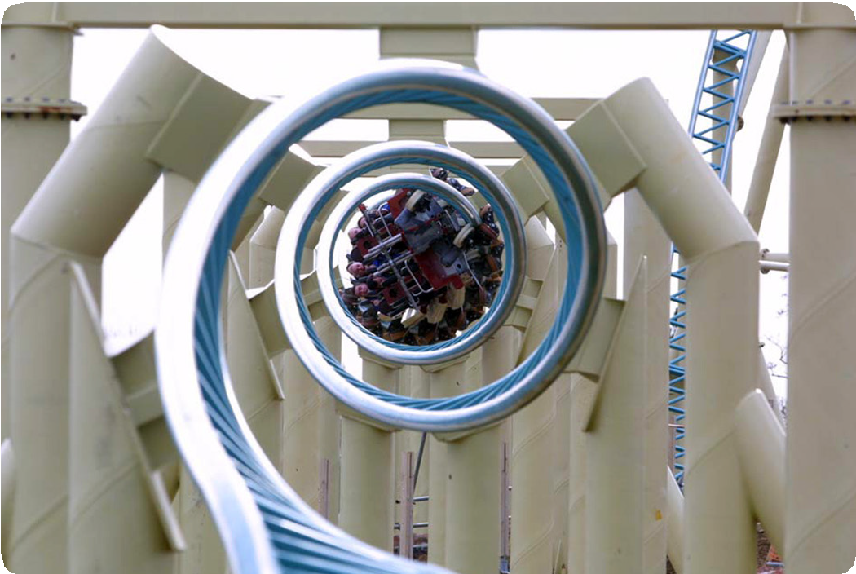

**Extension Activity 2 -** Structures and strength

**Formula for Thrills**

**8/16**

**Design a rigid shape - suggested solutions**

**1.**

The shape will soon deform, becoming a parallelogram and with the corners no longer being right angles.

**2.**

The triangle is more rigid.

**3.**

The cross bracing should improve the rigidity of the square.

**4.**

The cube lacks rigidity.

**5.**

The tetrahedron is much more rigid.

**6.**

A cube with cross struts is more rigid in that the faces won’t deform.

**7.**

A square-based pyramid is also rigid – as long as the square is the base.

**8.**

This makes a rigid structure.

**9.**

Other polygons tend to lack rigidity if the corners flex, though they can be strengthened with cross bracing (especially if this produces triangles).

In association with



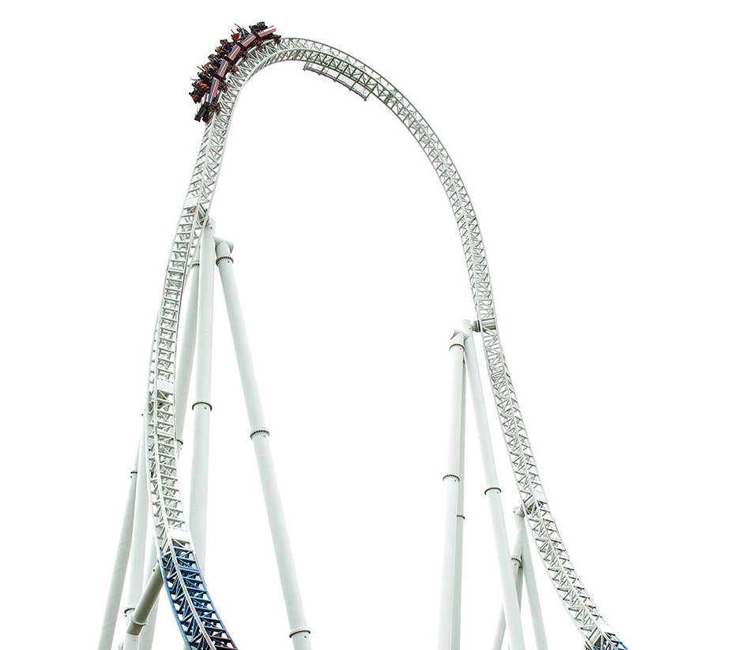

**Extension Activity 3 -** Planning a business

**Formula for Thrills**

**9/16**

**Aiming for profit - suggested solutions**

**1.**

Income = £2.50 x 8,500 x 360 = £7,650,000

Outgoings = £5,000 + £60,000 + £2,183,546 = £2,248,546

Therefore profit = £7,650,000 - £2,248,546 = £5,401,454

**2.**

Break even means generating enough income to cover the outgoings:

£2,248,546/(360 x £2.50) = 2,499 visitors.

**3.**

If the ticket price was £3:

Income = £3 x 8,500 x 360 = £9,180,000

Therefore profit = £9,180,000 - £2,248,546 = £6,931,454 Break-even: £2,248,546/(360 x £3) = 2,082 visitors.

**4.**

•

Christmas Eve, Christmas Day, Boxing Day, New Year’s

Eve, New Year’s Day – or similar plausible answers.

•

It could be, for example, the month of August. This would generate £2.50 x 8,500 x 31 = £658,750 (around 30% of the total annual outgoings).

**5.**

These might be from November through to February, which cover 120 (or 121) days.

**6.**

Plausible suggestions about having different expectations for different times of the year. This might lead to, for example, monthly targets that are quite different to each other but which would combine to give a healthy situation overall.

**7.**

Check that students can get to this answer.

**8.**

At 4% the annual repayments become £2,246,272. Finance plan then becomes: Income = £2.50 x 8,500 x 360 = £7,650,000

Outgoings = £5,000 + £60,000 + £2,246,272 = £2,311,272

Therefore profit = £7,650,000 - £2,311,272 = £5,338,728

Break even means generating enough income to cover the outgoings:

£2,311,272/(360 x £2.50) = 2,569 visitors.

**9.**

If the period of time is increased then the figures alter again. For example, at 3% p.a. for ten years the annual repayment is £1,172,306. Finance plan then becomes:

Income = £2.50 x 8,500 x 360 = £7,650,000

Outgoings = £5,000 + £60,000 + £1,172,306 = £1,237,306

Therefore profit = £7,650,000 - £1,237,306 = £6,412,694

Break even means generating enough income to cover the outgoings: 1,237,306/(360 x £2.50) = 1375 visitors.

In association with



**Extension Activity 3 -** Planning a business

**Formula for Thrills**

**10/16**

**10.** There are a number of points that could emerge from this:

•

If the interest rates go up, then either the visitor numbers have to be increased, or the profit falls per year or the repayment period has to be increased.

If the repayment period increases then the annual profit is increased and each year’s break-even point is reached sooner.

However, increasing the repayment period increases the total amount repaid, so although the annual profit increases for each year during the loan, the total profit decreases over the total life of the ride.

Increasing the repayment period carries other risks; the ride may become more expensive to maintain as it ages, meaning that the overheads will increase and visitors may become bored by it, affecting the ticket sales.

•

•

•

In association with



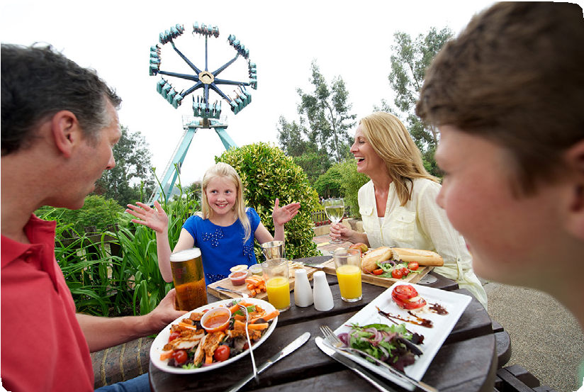

**Extension Activity 4 -** Running a business

**Formula for Thrills**

**11/16**

**Organising the staff - suggested solutions**

**1.**

There is no business in the first period as the park has only just opened and visitors haven’t had time to reach the kiosks.

**2.**

Business increases from zero to a peak. The Slush Station reaches this around 11.30, after which it stays steady. The Juice Bar reaches this around 12.45, after which it stays fairly steady. Yummy Sandwiches reaches this around 12.30, after which it stays fairly steady.

**3.**

Staffing the slush station - how many staff will you need and when will you start and finish each of them? There is more than one possible solution to this, but

a typical example is:

•

•

•

•

Staff member A: works 10.00 – 2.00, breaks at 11.00 and 1.15

Staff member B: works 10.00 – 2.00, breaks at 11.15 and 1.30 Staff member C: works 11.00 – 2.00, break at 12.00

Staff member D: works 11.00 – 2.00, break at 12.30

**4.**

Staffing the juice bar – plan your staffing needs. There is more than one possible solution to this, but a typical example is:

•

•

•

Staff member A: works 10.00 – 2.00, breaks at 11.30 and 12.30

Staff member B: works 10.00 – 2.00, breaks at 11.45 and 1.00 Staff member C: works 11.30 – 2.00, break at 12.00

**5.**

Sharing staff between the slush bar and juice bar at quiet times - Yes. For example in the first hour the Juice Bar could run with one member of staff.

**6.**

Staffing the Sandwich bar - there is more than one possible solution to this, but a typical example is:

In association with



**Extension Activity 4 -** Running a business

**Formula for Thrills**

**12/16**

**7.**

Contactless credit and debit cards - there are various possible responses but points might include:

•

At quiet times it will reduce profitability – there are no more customers to serve, staff are underused and it reduces the profits.

At busy times it will help as it will enable customers to be served more quickly, though it depends on how many customers have (and are prepared to use) contactless cards.

It will be especially useful in the sandwich bar where the sales are likely to be of a higher value (and therefore the 20p represents a lower proportion), where the work is more labour intensive and where there are more sales per minute.

•

•

**8.**

Weather cooling - if the temperature is lower there might be less demand for cold drinks (slush and juice) and more for hot drinks and food, so staff might need to be moved from the slush and juice outlets to the sandwich bar.

**9.**

Staff break allowances - more staff will need to be employed to cover staff breaks and the breaks will need to be staggered so that not too many staff are off at peak times. Another solution is to have more staff doing shifts of up to five hours from mid-morning to mid-afternoon.

**10.** Set up time - neither the slush station nor the juice bar do any business before 10.15 and the sandwich bar does no business until 10.30. They could therefore delay their opening times to allow for setting up without losing business.

In association with

**Period of day**

**Works**

**Breaks**

A

10.00 – 2.00

11.00 and 1.00

B

10.00 – 2.00

11.30 and 1.15

C

11.00 – 2.00

12.00

D

11.00 – 2.00

12.00

E

11.00 – 2.00

12.30

F

11.00 – 2.00

12.45

G

11.00 – 2.00

12.45

H

11.00 – 2.00

12.45

I

12.00 – 2.00

J

12.00 – 2.00

K

12.00 – 2.00

L

12.00 – 2.00

M

12.30 – 2.00

N

12.30 – 2.00

O

12.30 – 2.00



**Extension Activity 5 -** Plans and maps

**Formula for Thrills**

**13/16**

**Setting out amenities - suggested solutions**

**1.**

Suitable sketch map should be produced with key distances marked such as distance from key attractions to toilets and to catering outlets.

**2.**

Suitable scale selected.

**3.**

Drawing produced.

**4.**

Important features marked on.

**5.**

4km/hour is 4000m/hr or 67m/min. A distance of 100m could therefore be covered in one and a half minutes. For most people this is reasonable, as long as they know where they are going. Groups with young children might take longer, as might visitors with impaired mobility.

**6.**

**a.**

Use map and scale to suggest plausible answer

**b.**

Use rate of 67m/min to suggest how many minutes to reach destination.

**c.**

See if this comes in at less than five minutes.

**7.**

Use same approach to suggest answer.

**8.**

Plausible and justified response.

**9.**

This depends upon the method of estimation used as the lake is an irregular shape. However an answer for the area in the vicinity of 1,500m2 is acceptable. Assuming an average depth of 1m this gives

a volume of 1,500m3, but the estimation technique and calculations are more important than the actual answers.

**10.** Stealth reaches a height of 62.5m and is the tallest.

**11.** Plausible responses.

In association with



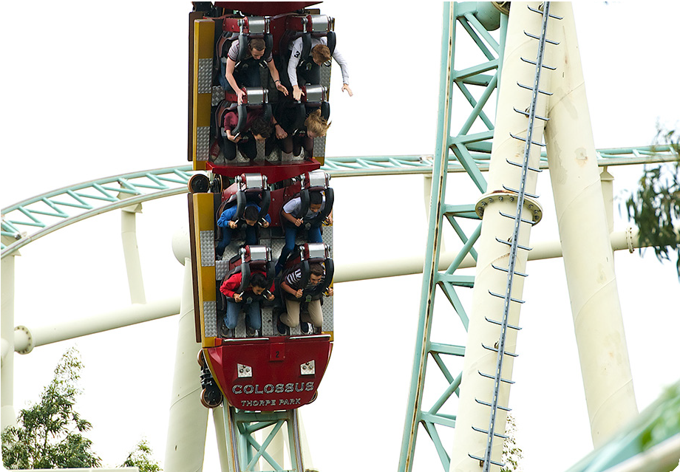

**Extension Activity 6 -** Running a theme park

**Formula for Thrills**

**14/14**

**Managing the rides - suggested solutions**

**1.**

To maximise the use and keep the waiting time shorter.

**2.**

Stopping the first train outside is not a problem because it can be re-started just by releasing the brakes, thus running it into the station when clear. Stopping the second train

is more problematic as it can’t be easily re-started from its stopping point and passengers have to be brought down from a high level on foot.

**3.**

A number of possible reasons, including:

**a.**

people who are too large trying to fit the safety harness on

**b.**

someone who came in on the previous ride not clearing the area

**c.**

people not clear about where to go

**d.**

other plausible responses

**4.**

So that the two groups are both moving in the same direction and don’t get in each other’s way.

**5.**

It can be argued either way. With effective staff, clear instructions and a quick response to any problems it can work well (tube trains have a shorter stop time, often with more passengers, fewer staff and exits also being entrances). However there is always a possibility that the time can’t be met and a ‘second train stoppage’ means passengers climbing down from a high level. Even though they are escorted and the route is safe, for some people this may be a negative experience.

**6.**

A fourth train would mean shorter turnaround times which would lead to a greater likelihood of ‘second train stoppages’ which would not be good for customer satisfaction.

In association with