Exploring the body

Exploring digestion

Resources required:
Small banana

Digestive biscuit or Weetabix
Funnel
Small container of water
Small container with very small amount of food colouring in it (preferably green)
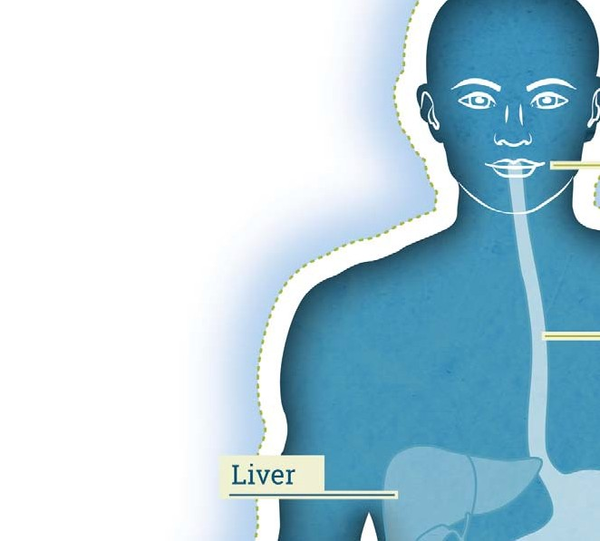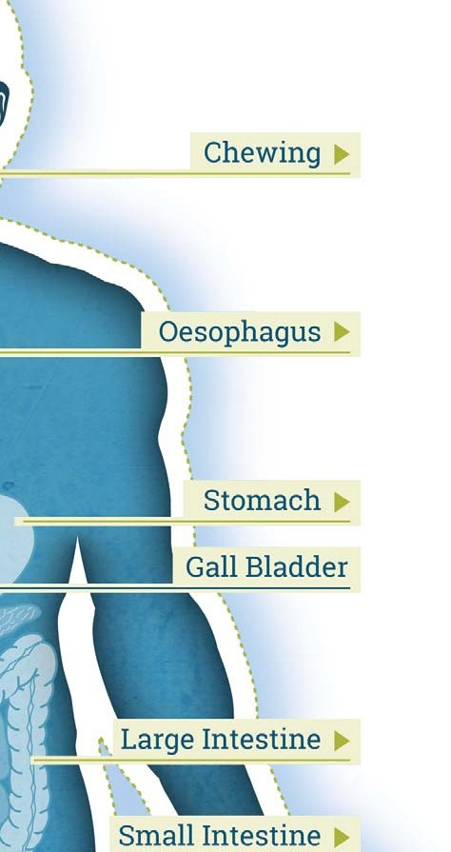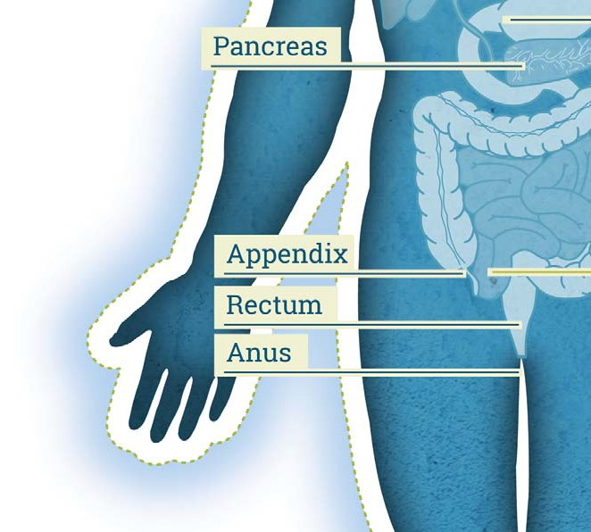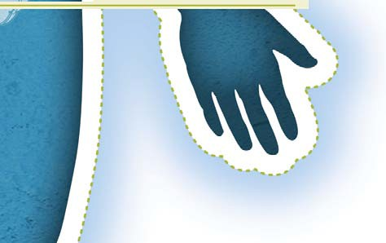Small cup of water

Pipette or syringe
Plastic bag rolled and taped to form a tube
(with the bottom cut off) Plastic sealable bag Stocking or leg from tights
Small plastic bag with a small hole cut in the bottom
Kitchen towels, plastic bin bags, scissors.

The digestive system

In this activity you will be making a model showing how our digestive system processes food that we eat.

You will need to do the following:

- Cover the floor in front of you with newspaper or large bin bags, taped to the floor.

2. You are going to construct a human digestive system. Everyday materials will represent each main part, so you will need to use your imagination. You are going to follow the journey that a banana (moist food) and a biscuit (dry food) would take as they travel through your body, starting at the mouth.

3. The biscuit needs to be squashed and ground up to represent chewing. A few drops of water (representing saliva) should be added. This will end up with a ball of food (bolus) just as we do in our mouths.

4. The banana needs to be chopped up with scissors (representing teeth). The biscuit and chopped banana need to be pushed with a finger (representing the tongue), through the funnel and into the plastic bag tube (representing the oesophagus).

5. The food should then be gripped and squeezed hand over hand, down the ‘oesophagus’ into the sealable bag (representing the stomach). Pour the water from the cup (representing the stomach acid) into the bag.

6. The bag should then be sealed (representing closing the valve to the stomach) without much air in the bag. Ask what happens if there is too much air in the bag (stomach)? They burp/belch from their mouths. [Note: Wind from their other end is what happens when they have gas in their intestine!]

7. The food and water should be squeezed in the ‘stomach’ until it is fairly liquid and smooth. While doing this think about what is happening; this is how digestion takes place. If food escapes from the top seal (valve) this is what happens when a person vomits. However, normally food stays in the stomach for around 6 hours.

8. Next a small hole should be cut in the bottom of the bag (representing the pyloric sphincter) and (with assistance) pour the ‘food’ into only the top 1/3 of the stockings/tights leg (representing the small intestine). This will take two people. Whilst one cuts the hole, the other holds the leg open at the top and uses their other hand to squeeze the material together a bit lower down, in order to prevent the food from immediately going down the whole leg!

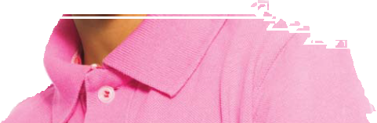

9. When the food is in the top 1/3 of the leg, use the pipette to squirt the water with the food colouring (representing bile) in. This represents bile which breaks down fats. [Note: This part is particularly messy!]

10. Then squeeze the food through the stocking (the small intestines). The water coming out through the walls represents the nutrients going to the rest of the body.

11. At the end of the stocking leg is the foot (large intestine). There are ‘good’ bacteria here and last bits of water and nutrients are absorbed into the body. Cut a hole in the end as the food approaches.

12. Finally squeeze the remaining food into the small plastic bag with a small hole cut in the bottom (representing the rectum and the anus). Squeeze their waste through the hole in the cup into a bowl (toilet).

13. When you’ve finished, make sure everyone is clean and all the mess is on the covered part of the floor to be disposed of.

Now look at a picture of the digestive system and compare your model with the diagram, identifying the stages.
?

• What did your model show well?
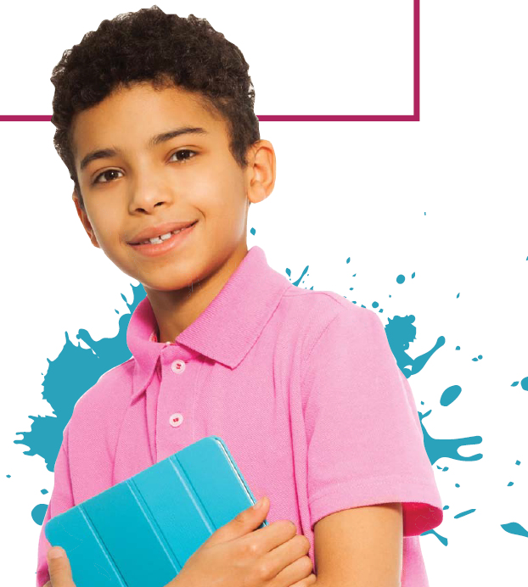
• What was not very good about your model?

• How could your model be improved?

