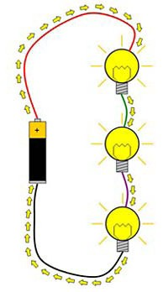
Series and parallel circuits

In this activity we are going to be finding out what happens if we add more bulbs to a circuit.

This kind of circuit is called a series circuit. If we connect bulbs in series they are one after the other, like a series of TV programmes. The electricity flows through one first then another, and so on.

You need to set up series circuits with different numbers of bulbs in. Each time, notice how bright the bulbs are and note this in the table.

You need to set up series circuits with different numbers o bulbs in.
Each time, notice how bright the bulbs are and note this in the table.
Number of bulbs in the series circuit | How bright the bulbs are
1
2
3
4

Series and parallel circuits

Now we are going to investigate a different type of circuit. This is a parallel circuit. Instead of the electricity going through one bulb after another, it goes through one or another.

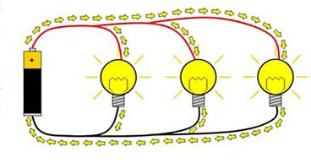

Try setting up parallel circuits and seeing how bright the bulbs are.
Number of bulbs in parallel circuit | How bright the bulbs are
1
2
3
4

Series and parallel circuits

1. What is the difference between a series circuit and a parallel circuit?

2. Do you think the lights in your classroom are wired in series or in parallel?

3. Why do you think this?

