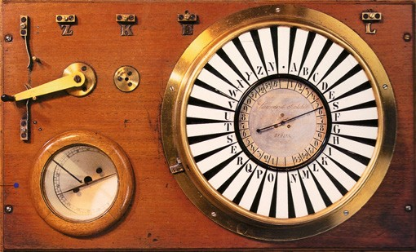The Siemens pointer telegraph

Page 2 of this sheet enables you
to make a model of a Siemens
pointer telegraph. The real one
would be operated by electricity
but this model will show you
how the display worked.

Instructions:
You will need page 2 of this sheet printed on thin card. You will also need a pair of
scissors and a paper fastener (the sort with two metal tabs that open out).

- Cut out the dial and the pointer.
2. In the centre of the dial make a small slot, big enough for the tabs of the paper
fastener to go through.
- In the centre of the pointer make a circular hole. This should be big enough for the tabs of the paper fastener but not the head to pass through.
4. Then put the pointer on the dial, pass the paper fastener through and open up the
tabs. This should hold the pointer in place but allow it to be turned.
Operation:
To make this model work as a real pointer telegraph you would, start off with the pointer pointing to the blank section. It would then turn clockwise to the letter needed, and then continue to turn clockwise to the blank section. Then the next letter could be selected.

The Siemens pointer telegraph

Z N . A B
Y C

X 52 53
B
W 51
V 0
1 2 3 D
4 E
5 S

9 6
U 8 7 F
T 7 8 G

6
S
5
F 4 3
R 2 1
9
0 H
31 I
33 32 K

Q L P O N M

