The formula for calculating speed is
$$average speed =\frac{distance travelled (metres)}{time taken (s)}$$

YOU MUST SHOW YOUR WORK. You can use a calculator but you must show all of the steps involved in doing the problem.

Speed
If a Greenpower Formula 24 car travels 300m in 20 seconds, how fast is it going?
Answer: | 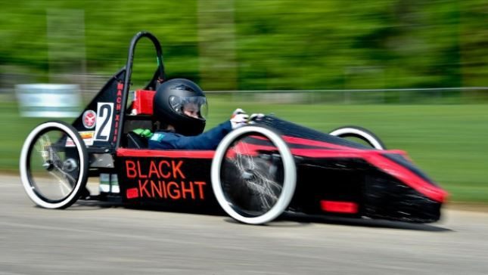
If a member of the pit crew runs 50m in 10 seconds, what is their speed?
Answer: |  | 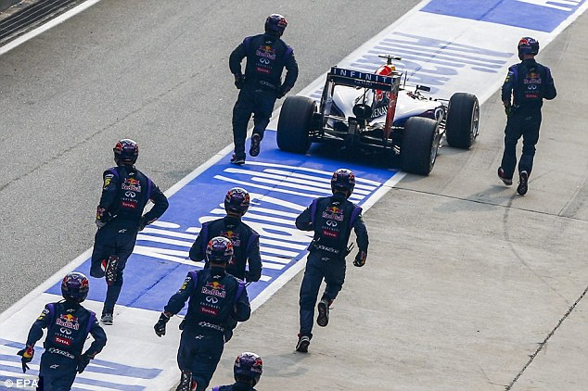
If a Greenpower car enters the pit lane sand is pushed 90m to it’s pit-box in 45 seconds, how fast was it travelling while in the pit lane?
Answer: | 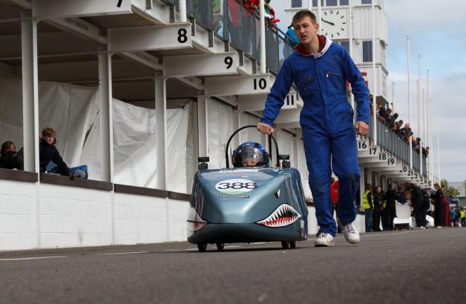

Time
What is the official distance around the Goodwood motor circuit?
  - https://en.wikipedia.org/wiki/Goodwood_Circuit

Distance around the Goodwood motor circuit is ________km

Distance around the Goodwood motor circuit is _________metres

How much time would it take a Greenpower car travelling at an average speed of 40km/h to travel around the Goodwood motor circuit?
Convert 40km/h into m/s

40km/h is _______ metres per second

Answer: | 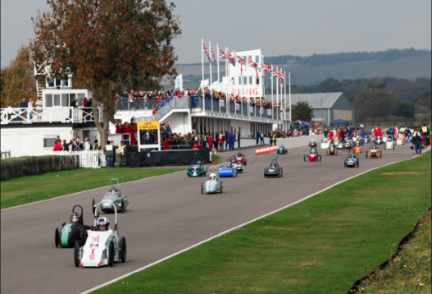

Distance
How far would a Greenpower car travel if it was travelling at an average speed of 67km/h for 50minutes?
- Answer to be given in metres, kilometres, and miles
  - 1km = 0.62137miles

Answers:

Convert 67km/h into m/s

67km/h is _______ metres per second

