Building a water wheel

This is a picture of a water wheel:

Can you see how it works? Water running out of the end of the hollowed log falls on the wheel and lands on paddles. The water pushes the wheel round.

You are going to make and test a model water wheel. You could do this using paddles made of plastic, fixed on to a plastic cotton reel with plasticene. The reel will turn on an axle.

???

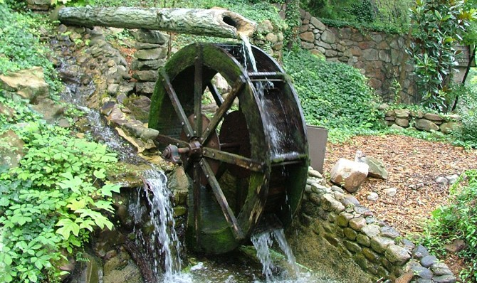

Think about the design of the water wheel.

1. Why is it important that the reel spins easily on the axle?

2. Think about the paddles you are going to attach to the reel. These are going to be pushed around by the water.
a) Why is it important that the paddles aren’t too small?

b) Why might there be problems if the paddles were rather large?

3. Now think about how many paddles to use.
a) Why is it important that there aren’t too many paddles?

b) Why might there be problems if there were very few paddles, say only two or three?

