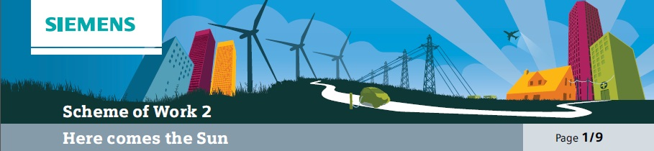

Overall learning objectives

• Gathering data and applying it to justify arguments.
• Understanding the process of energy transfer, explaining the operation of internal combustion and photovoltaic cells and applying understanding to propose how clean technologies can be promoted.
• Understanding technical and social systems and comparing alternative solutions.
• Evaluating solutions to identify fitness for purpose.
Overall learning outcomes

• Gathered evidence and justified recommendations for different energy supplies.
• Proposed how a move to the use of more sustainable energy sources can be encouraged.

Curriculum learning objectives
Students should be able to: Maths
• Apply suitable mathematics accurately within the classroom and beyond.
• Use their existing mathematical knowledge to create solutions to unfamiliar problems and work logically towards results and solutions, recognising the impact of constraints and assumptions.
• Calculate accurately, selecting mental methods or calculating devices as appropriate, and record methods, solutions and conclusions.
• Estimate, approximate and check working, and consider the assumptions made and the appropriateness and accuracy of results and conclusions.
• Communicate their findings effectively.

Science
• Critically analyse and evaluate evidence from observations and experiments.
• Explore how the creative application of scientific ideas can bring about technological developments and consequent changes in the way people think and behave, sharing developments and common understanding across disciplines and boundaries.
• Plan and carry out practical and investigative activities, both individually and in groups, and obtain, record and analyse data from a wide range of primary and secondary sources, including ICT sources, and use their findings to provide evidence for scientific explanations.
• Evaluate scientific evidence and working methods and use appropriate methods, including ICT, to communicate scientific information and contribute to presentations and discussions about scientific issues.
• Explain how energy can be transferred usefully, stored, or dissipated, but cannot be created or destroyed, and how human activity and natural processes can lead to changes in the environment.

Technology
• Understand that designing and making has aesthetic, environmental, technical, economic, ethical and social dimensions and impacts on the world and that products and systems have an impact on quality of life.
• Explore how products contribute to lifestyle and consumer choices, and make links between principles of good design, existing solutions and technological knowledge to develop innovative products and processes.
• Evaluate the needs of users and the context in which products are used to inform design and process.

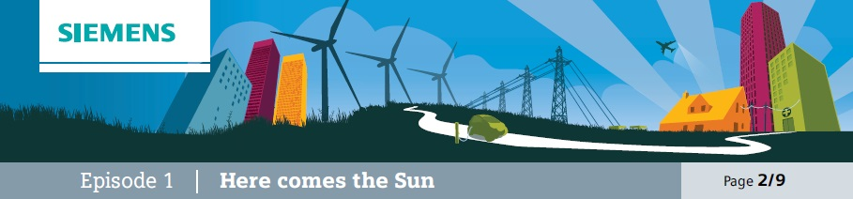

Introduction
The purpose of this episode is to set the scene. The video shows that Buma likes living in Abuja and that he
likes the city itself. However, the power cuts present him with a dilemma: using the petrol generator provides
a reliable energy source but the photovoltaics would be more environmentally responsible.

Learning objective
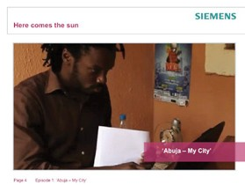• To understand the factors affecting decisions about energy sources.

Learning activities

1. Explain that the group are going to watch a short video which features a young man called Buma. Say that he made this video to say something about his life and one of the key decisions he has to make.

2. Show the video “Abuja - My City” and encourage students to consider the dilemma he faces.

3. Ask students to consider these questions:
a) Why does Buma need to consider alternative energy supplies?
b) What are the advantages and disadvantages of the petrol generator?
c) What are the advantages and disadvantages of the photovoltaics?
d) What would you do in his place, and why?

Outcomes
• Students will have understood the context and the dilemma facing Buma.
• Students will have formed initial views about the merits of each fuel source.

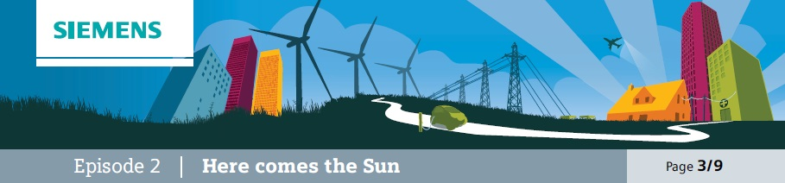

Challenge
Present students with a challenge – whether and how Buma should be persuaded to abandon his petrol
generator in favour of sets of photovoltaic cells.

This episode is about presenting the students with the challenge that Buma faces and identifying what the
significant factors are in this decision. Furthermore there will be a growing emphasis later in the topic about
what will be necessary to persuade more people in Abuja to move to sustainable energy sources.

Learning objectives
• Students identify key factors affecting decisions.
• Students consider how decisions can be influenced to change outcomes.

Learning activities

1. Ask students to work in groups to consider what the key factors are that have influenced Buma to prefer a petrol generator. Ask them also to consider what might influence his choice and encourage him to use solar cells instead.

2. Take feedback and summarise key points about the key factors and the possible ways of influencing choices. Display these so that they can be referred to and modified later in the topic.

Outcomes
• Students will have considered, shared and agreed on key factors in the decision making process.
• Students will have identified some possible ways of promoting the use of photovoltaic cells.

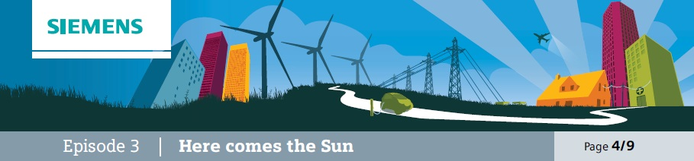

Technologies
The purpose of this episode is for students to explore the nature of the different technologies and evaluate the advantages
and disadvantages of each. It is, therefore, not only about information acquisition but also the identification of key factors that might lead to the adoption or rejection of that technology.

Additional resources required
• Solar cells
• Voltmeter

Learning objectives
• To understand how a petrol generator and photovoltaic cells work and identify their relative advantages and disadvantages.
• To apply the concept of energy transfer to each technology.

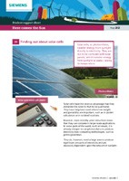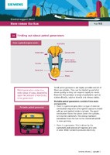
Learning activities

1. Explain that this episode is going to be about comparing two different methods of producing electricity. Remind students that this is a back-up system so that people such as Buma can
continue working if there is a power failure.

2. This part can be organised in two different ways. Students should be organised into groups; one way of delivering this would be for half the students in a group to study one technology and the other half the other. This would promote the importance of the articulation and sharing of
ideas in the group. The other way is for all students to study both technologies.
a) Finding out about the petrol generators: student support sheet 2A and (ideally) a demonstration or (alternatively) a video clip. Students should understand the fuel is burned and energy transferred as kinetic energy to drive a generator, which produces electricity. It is portable and reliable but releases polluting gases.
b) Finding out about photovoltaic cells: student support sheet 2B and an experiment to investigate, using one or more solar cells and a voltmeter to show that a potential difference is produced when light falls on it. Students should understand that energy from light is converted to electrical energy and that the output is related to the amount of light and the area of the cells. This can be shown by altering the intensity of the light and the number of cells.

3. Students should then work in groups to identify key points about the advantages and disadvantages of each technology and summarise these.

Outcomes
• Students can explain the operation of each technology with reference to energy transfer, the fuel needed and waste produced.
• Students will have compared the advantages of each with respect to the required application.

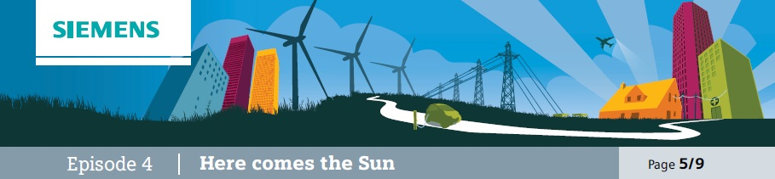

Using data
Students to use data on generated power to compare outputs from systems.
The purpose of this episode is to move students’ from qualitative to quantitative. Understanding that photovoltaic cells provide an alternative is important but how viable they are will be influenced by, amongst other factors, size and cost.

Learning objectives
• To identify the key factors about each system, including initial cost, running cost, space requirements, waste products and power output.
• To use these factors to develop an understanding of the comparative merits of the two systems.

Learning activities

1. There needs to be some discussion about what a back-up power supply is required to cover.
If it is only a laptop and a mobile phone charger, then the requirements are quite modest (a typical laptop charger produces around 65W and a mobile phone charger around 1.5W) and much less than even a small petrol generator will produce. This will make the activity quite accessible as an internet search on “solar power laptop charger” and “solar power mobile phone charger”, this will produce a string of results which students will be able to process easily.

2. Students need to consider what the key factors are about using a petrol generator that will determine how attractive an option this is. Ask students to work in groups to discuss and agree on key factors. Take feedback and draw up a list of key factors. These might include:

a) Cost of the generator. b) Cost of fuel.
c) Fuel consumption.
d) Start-up time.
e) Power output.
f) Waste produced. g) Noise level.

3. Then repeat this activity with the photovoltaic cells. In this case the factors might include:
a) Cost of purchase. b) Area.
c) Power output.

4. It may then be worthwhile reviewing the initial assumption about what is to be powered.
As soon as the requirements start to run to space or water heating, the practicalities start to look rather different. Students could explore what a power allocation of, say 3kW would run if used with, for example, room heaters and electric kettles. This would be within the range of a small petrol generator but would need a large area of solar cells (in the UK a typical figure is 7m2/kWp; this would be rather lower in Nigeria) and could easily run to 15m2. This moves the activity to one that is arguably more realistic though is harder to quantify, so it may be necessary to have data available for students to use.

Outcomes
• Students will have explored the factors related to selecting a power source and attempted to put values on these.
• Students will have made some calculations to quantify the scale of the provision.

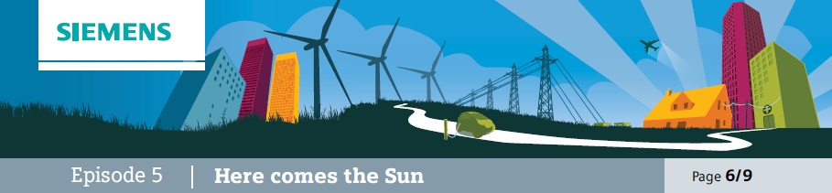
Consider
Students to consider question of storing energy and how, in each case, this can be achieved.
The purpose of this episode is to challenge students to consider how energy can be stored, as this is a key factor. Students should understand that whereas the petrol generator is started up ‘as and when’, needed the photovoltaic cells will only work in the daylight. However, this doesn’t mean that they aren’t a
viable alternative.

Learning objectives
• To consider the importance of storing energy.
• To explore how different systems store energy in different ways.
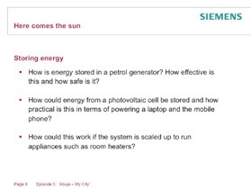• To consider the impact of this on decisions about selecting an appropriate power system.

Learning activities

1. Ask students to consider how the question of energy storage is important in Abuja and how this might relate to the petrol generator and photovoltaic cell options.

2. Ask students to consider these questions:
a) How is energy stored in a petrol generator?
How effective is this and how safe is it?
b) How could energy from a photovoltaic cell be stored and how practical is this in terms of powering a laptop and a mobile phone?
c) How could this work if the system is scaled up to run appliances such as room heaters?

3. Take feedback and draw out these points:
a) Petrol is a practical way of storing energy but there are safety considerations.
b) Photovoltaic cells could be used to store rechargeable batteries, which can then be used to power devices such as laptops and mobile phones (which, of course, have them installed already) but could be used as a backup supply, especially at night-time. Cells, batteries, laptops and mobile phones all run at low voltages.
c) However, room heaters need a higher voltage and considerably more power. The batteries would need to be much larger and would take up a lot of space, (there would also need to be an inverter fitted to convert the low voltage DC to higher voltage AC, which would add to the installation costs and complexity).

Outcomes
• Students will have considered how energy can be stored in each system and how practical it is.
• Students will have used this to inform their views about the advantages of each system.

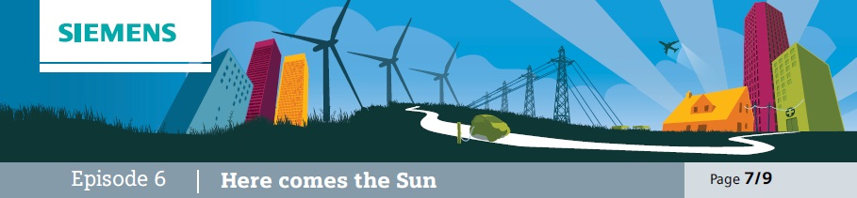
Consider
Students to consider suitability of photovoltaics for a variety of situations.
By this stage students will probably have come to the conclusion that photovoltaic cells are a more practical and viable alternative in some situations than others. This episode is designed to support students in identifying immediate applications and more challenging ones.

Learning objectives
• Students will apply their understanding from this topic to identifying applications in which photovoltaic cells have an immediate application.
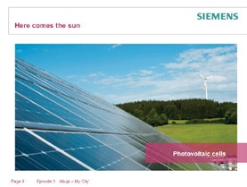• Students will be able to back up their recommendations with reasons.

Learning activities

1. Explain that photovoltaic cells have a more immediate and obvious application in some contexts than others. Say that the purpose of this episode is to support them in identifying what the factors are.

2. Present the students with a range of applications and ask them to work in groups to suggest how electricity should be produced and why they have suggested that method. They might select from mains supply, petrol generator or photovoltaic cell. The contexts include:
a) Remote weather station.
b) Running washing machine on remote island with no mains supply. c) Garden lighting.
d) Hospital operating theatre back-up system. e) Heating system for a marquee.
f) Funicular railway.

3. Take feedback and discuss decisions. Draw out from this why students decided on certain methods. These factors might include:
a) Proximity to mains supply. b) Amount of energy needed.
c) Impact of certain methods, such as noise and exhaust. d) Reliability.

Outcomes
• Students will have applied their understanding of power systems to a range of applications and justified their decisions.
• Students will have identified the factors that might influence why one power system is preferred to another.

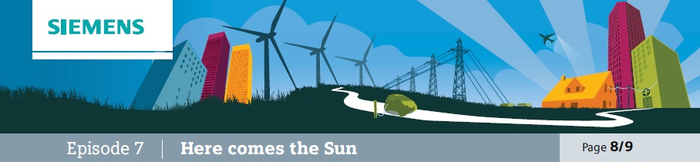

Explore
The purpose of this episode is to explore the applications of power systems and to emphasise that failures can have particular implications for commercial organisations.
Use videos “The Last Flower” and “Photovoltaics”.

Learning objectives
• To understand how the reliable supply of power is not only useful and desirable but has commercial implications for some organisations.
• To suggest what appropriate responses are to such challenges.

Learning activities

1. Explain to students that for some organisations the reliable supply of power is critical.
This would include medical services, communication systems and a variety of commercial operations. Ask students to suggest other examples.

2. Show the video “The Last Flower”. Ask students to work in groups to suggest whether the provision of petrol generators in this situation
is an over-reaction.

3. Now show the video “Photovoltaics”. Ask the students to suggest how this might alter their perspective on the potential role of photovoltaic cells in large scale energy provision and whether they are ever likely to be a total solution.

Outcomes
• To explain how reliability is a key feature of power systems.
• To understand how photovoltaic cells may be a significant part of a large scale system but may not be a total provider.

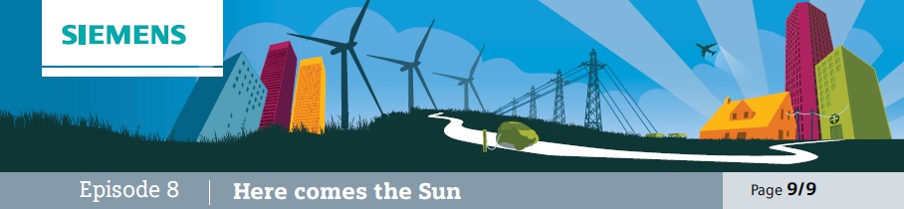

Conclusion
Students work in teams to develop and present a case as to how (and whether) Buma should abandon his generator in favour of photovoltaic cells.
This episode is designed as the culmination of the topic, in which students draw together various ideas from different activities to present a view, justify it and propose a way forward.

Learning objectives
• To present key ideas about the role of photovoltaics in developing sustainable energy supplies.
• To suggest ways of promoting their use and encouraging people to make more use of them.

Learning activities

1. Explain to students that their task is to identify ways in which the use of photovoltaic cells can be promoted, not necessarily as a total solution but as a significant part of reducing pollution.

2. Ask students to work in groups and identify: a) The advantages offered by photovoltaic cells. b) The kinds of situations in which they are
particularly useful.
c) How they could be used more widely in situations such as Abuja.

3. Now ask students to prepare a presentation, lasting no more than 60 seconds, which could be used to persuade people such as Buma to give photovoltaic cells a greater role.

Outcomes
• To prepare and present a presentation identifying how photovoltaic cells could have a significant role in ensuring a reliable source of energy.

