6A Fairground ride story

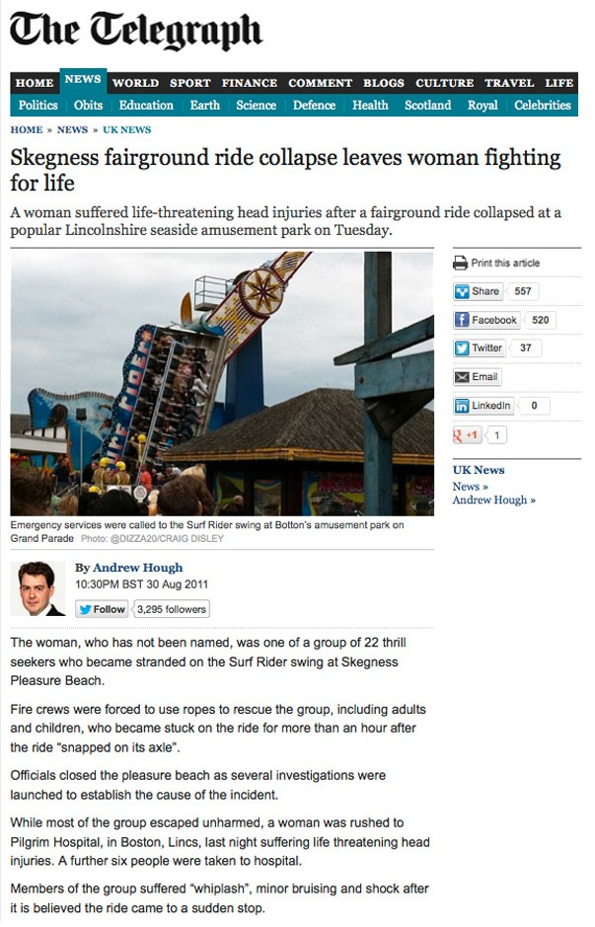
Think about the safety aspects of a fairground ride and how the ride might become unstable and dangerous.

6B Sequencing activity

Cut the blocs out and place them in the correct order of sequence.

Button pressed

Traffic lights green

Traffic lights green and pedestrian light red Pedestrian light green and bleeper turned on Bleeper turned off
Traffic lights amber Traffic lights red & amber Pedestrian light red
✁
Traffic lights red

